Teaching Aid – Space Planning #3
Library Building Program Checklist

This material was adapted from Designing a Fine Library, published by the Kansas State Library, written by Shannon Roy and Roy Bird, 2001.

Task | Steps | Who’s Responsible | √
PRELIMINARY PHASE  Before a library board employs an architect, it must determine if there are sufficient funds to complete the program and maintain the facility. This includes an accurate accounting of cash on hand, availability of local funding and other funding options.  The site of the public library should be chosen to provide maximum convenience for library users. It should be located on or close to a major thoroughfare, convenient to any local transportation and in an area that attracts a large number of people in the course of their daily activities. The determination of the location should be based on authoritative predictions of community growth and expansion. Space for adequate parking should be available.  The building committee must have a definite plan for obtaining the site: by purchase, lease, donation etc. There should be clear and specific identification of title and ownership to the site and the library facility. | Recognition of the need.  Obtain community demographic  information.  Alternatives considered:  Expand present facility.  Rent additional space.  Renovate.  Build new library.  Investigate financial status.  Appoint building committee.  Outline proposed program and write  case statement.  Investigate possible sites.  Visit other libraries. | Board/Director  Needs Assessment Committee  Needs Assessment Committee  Needs Assessment Committee  Needs Assessment Committee  Needs Assessment Committee  Needs Assessment Committee  Board/Fund Raising Consultant  Board  Building Committee  Building Committee  Building Committee
Task | Steps | Who’s Responsible | √
SURVEY OF COMMUNITY NEEDS  Library staff prepares summary report for Building Committee | Review library’s long range plan.  General characteristics of community.  Projected population growth.  Relationship to educational community.  Relationship to cultural community.  Relationship to region.  Relationship to recreational community.  Future needs and general trends.  Special community needs. | Building Committee reviews summary report
Task | Steps | Who’s Responsible | √
DECISION TO BUILD  The library board should have contractual agreements reviewed by an attorney to ensure that interests of the board are adequately represented | Retain legal counsel.  Hire library consultant.  Delegate specific responsibilities to  individuals or groups.  Work out time schedule for building program.  Review time frame monthly and revise as necessary. | Board  Board  Library Consultant with input from the Library Director  Library Consultant  Library Consultant with aid of Director
Task | Steps | Who’s Responsible | √
WRITTEN BUILDING PROGRAM  All building designs should include maximum flexibility for future automation needs. There should be a generous allotment of electrical outlets, phone jacks and data outlets; some of these should be floor outlets. It should be assumed that extensive future automation will occur. | Statement of the library’s history.  Library mission and service responses.  Future needs. Growth for at least 20  years should be planned for.  Specifications for complying with the  Americans with Disabilities Act.  Specifications for future automation.  Library functions to be included and a  description of each.  Square footage necessary for each  function.  List of special features and built-in  equipment.  Relationship of departments.  Develop list of architects. | Library Consultant with input from the Library Director
Task | Steps | Who’s Responsible | √
HIRING OF THE ARCHITECT  Among the criteria to evaluate an architect are:  * Experience with library building design  * Willingness to listen to library staff and to respond to the unique needs of the building program  * Willingness to specify how they will handle potential trouble spots such as roofs, heating and air conditioning, windows, carpets, storage and acoustics.  * Willingness to specify how they will administer and oversee the construction  * Review of the credentials of the firm and their willingness to specify the exact personnel that will be working with the project  * Design approach of the project personnel and the firm  * Compatibility of the project personnel and the building committee  It is strongly suggested that the building consultant be present when architects are interviewed. One member of the library staff, usually the library director, should be assigned by the Library Board of Trustees to serve as the major liaison with the architect during the entire design and construction period. Available trustee experience should be utilized. | Interview architects  Become familiar with architect’s work  Check on references by contacting recent clients, especially libraries | Building Committee completes steps and makes recommendation to Board
Task | Steps | Who’s Responsible | √
DEVELOPMENT OF PLAN FOR FINANCING  Many individuals are involved in this part of the building program including:  The Board  The Building Committee  The Architect  The Library Consultant  The Fund Raising Consultant | Site purchase.  Architect’s fees.  Library consultant fees.  Fundraising Consultant fees when  applicable).  Other special consultant fees (when  applicable).  Legal fees.  Operating budget.  Mortgage.  Bonds sale and related fees.  Appointment of Clerk of the Works.  Estimate of project costs.  Site boundary and topographic survey.  Test borings.  Construction testing.  Reproduction of bidding documents.  Construction costs.  Site improvements.  Building construction, including  mechanical and electrical system costs.  Demolition (when applicable).  Landscaping.  Furniture, fixtures, and equipment (less  usable existing equipment).  Probable income sources.  Gifts.  Grants. | Board with input from Building Committee  Board  Board  Board  Board  Architect  Architect  Architect  Architect  Architect  Architect  Architect  Architect  Architect  Architect  Library Consultant  Fundraising Consultant  Fundraising Consultant  Fundraising Consultant
Task | Steps | Who’s Responsible | √
ACQUISITION OF SITE | Check for accessibility.  Relationship to existing city plan.  Visual prominence.  Traffic patterns.  Subsurface conditions.  Zoning.  Parking space  Centralized location.  Clear title.  Cost of appraisals.  Fair price.  Site survey (information such as legal  description of the site, and review of  easements, setbacks, topography and  soil testing. | Building Committee with input from Architect and Board
Task | Steps | Who’s Responsible | √
SCHEMATIC DESIGN | Proposed floor plan.  Probable construction costs.  Probable total project costs.  Project schedule.  Proposed elevations.  Compare with written program.  Approval by board. | Architect
Task | Steps | Who’s Responsible | √
PRELIMINARY DRAWINGS | Advanced drawings, elevation etc.  Outline specifications for materials.  Cost estimates.  Compare with written program.  Consult staff for suggestions.  Approval of preliminary drawings. | Architect  Architect  Architect  Library Consultant with input from Library Director  Board
Task | Steps | Who’s Responsible | √
CONSTRUCTION DOCUMENTS  DRAWINGS AND SPECIFICATIONS | Preparation of construction documents.  Revised cost estimates. | Architect
Task | Steps | Who’s Responsible | √
EQUIPMENT PROGRAM | Equipment list.  Specifications.  Budget/estimate. | Library Consultant with input from Library Director
Task | Steps | Who’s Responsible | √
BIDDING DOCUMENTS | Preparation of documents.  Determine schedule.  Advertising. | Architect with input from Board and Building Committee
Task | Steps | Who’s Responsible | √
BIDDING AND CONTRACT AWARD | Opening of bids – analysis and  recommendations.  Award of contract for construction. | Board and Building Committee with input from Architect
Task | Steps | Who’s Responsible | √
START OF CONSTRUCTION
Task | Steps | Who’s Responsible | √
CONSTRUCTION PERIOD SERVICES | Change order approval (when  applicable).  Contractor’s pay application approval.  Shop drawing and materials review.  Color selections.  Construction observation. | Board and Architect  Board and Architect  Architect  Architect/Library Consultant  Board
Task | Steps | Who’s Responsible | √
SUBSTANTAIL COMPLETION
AND
PROJECT CLOSE-OUT

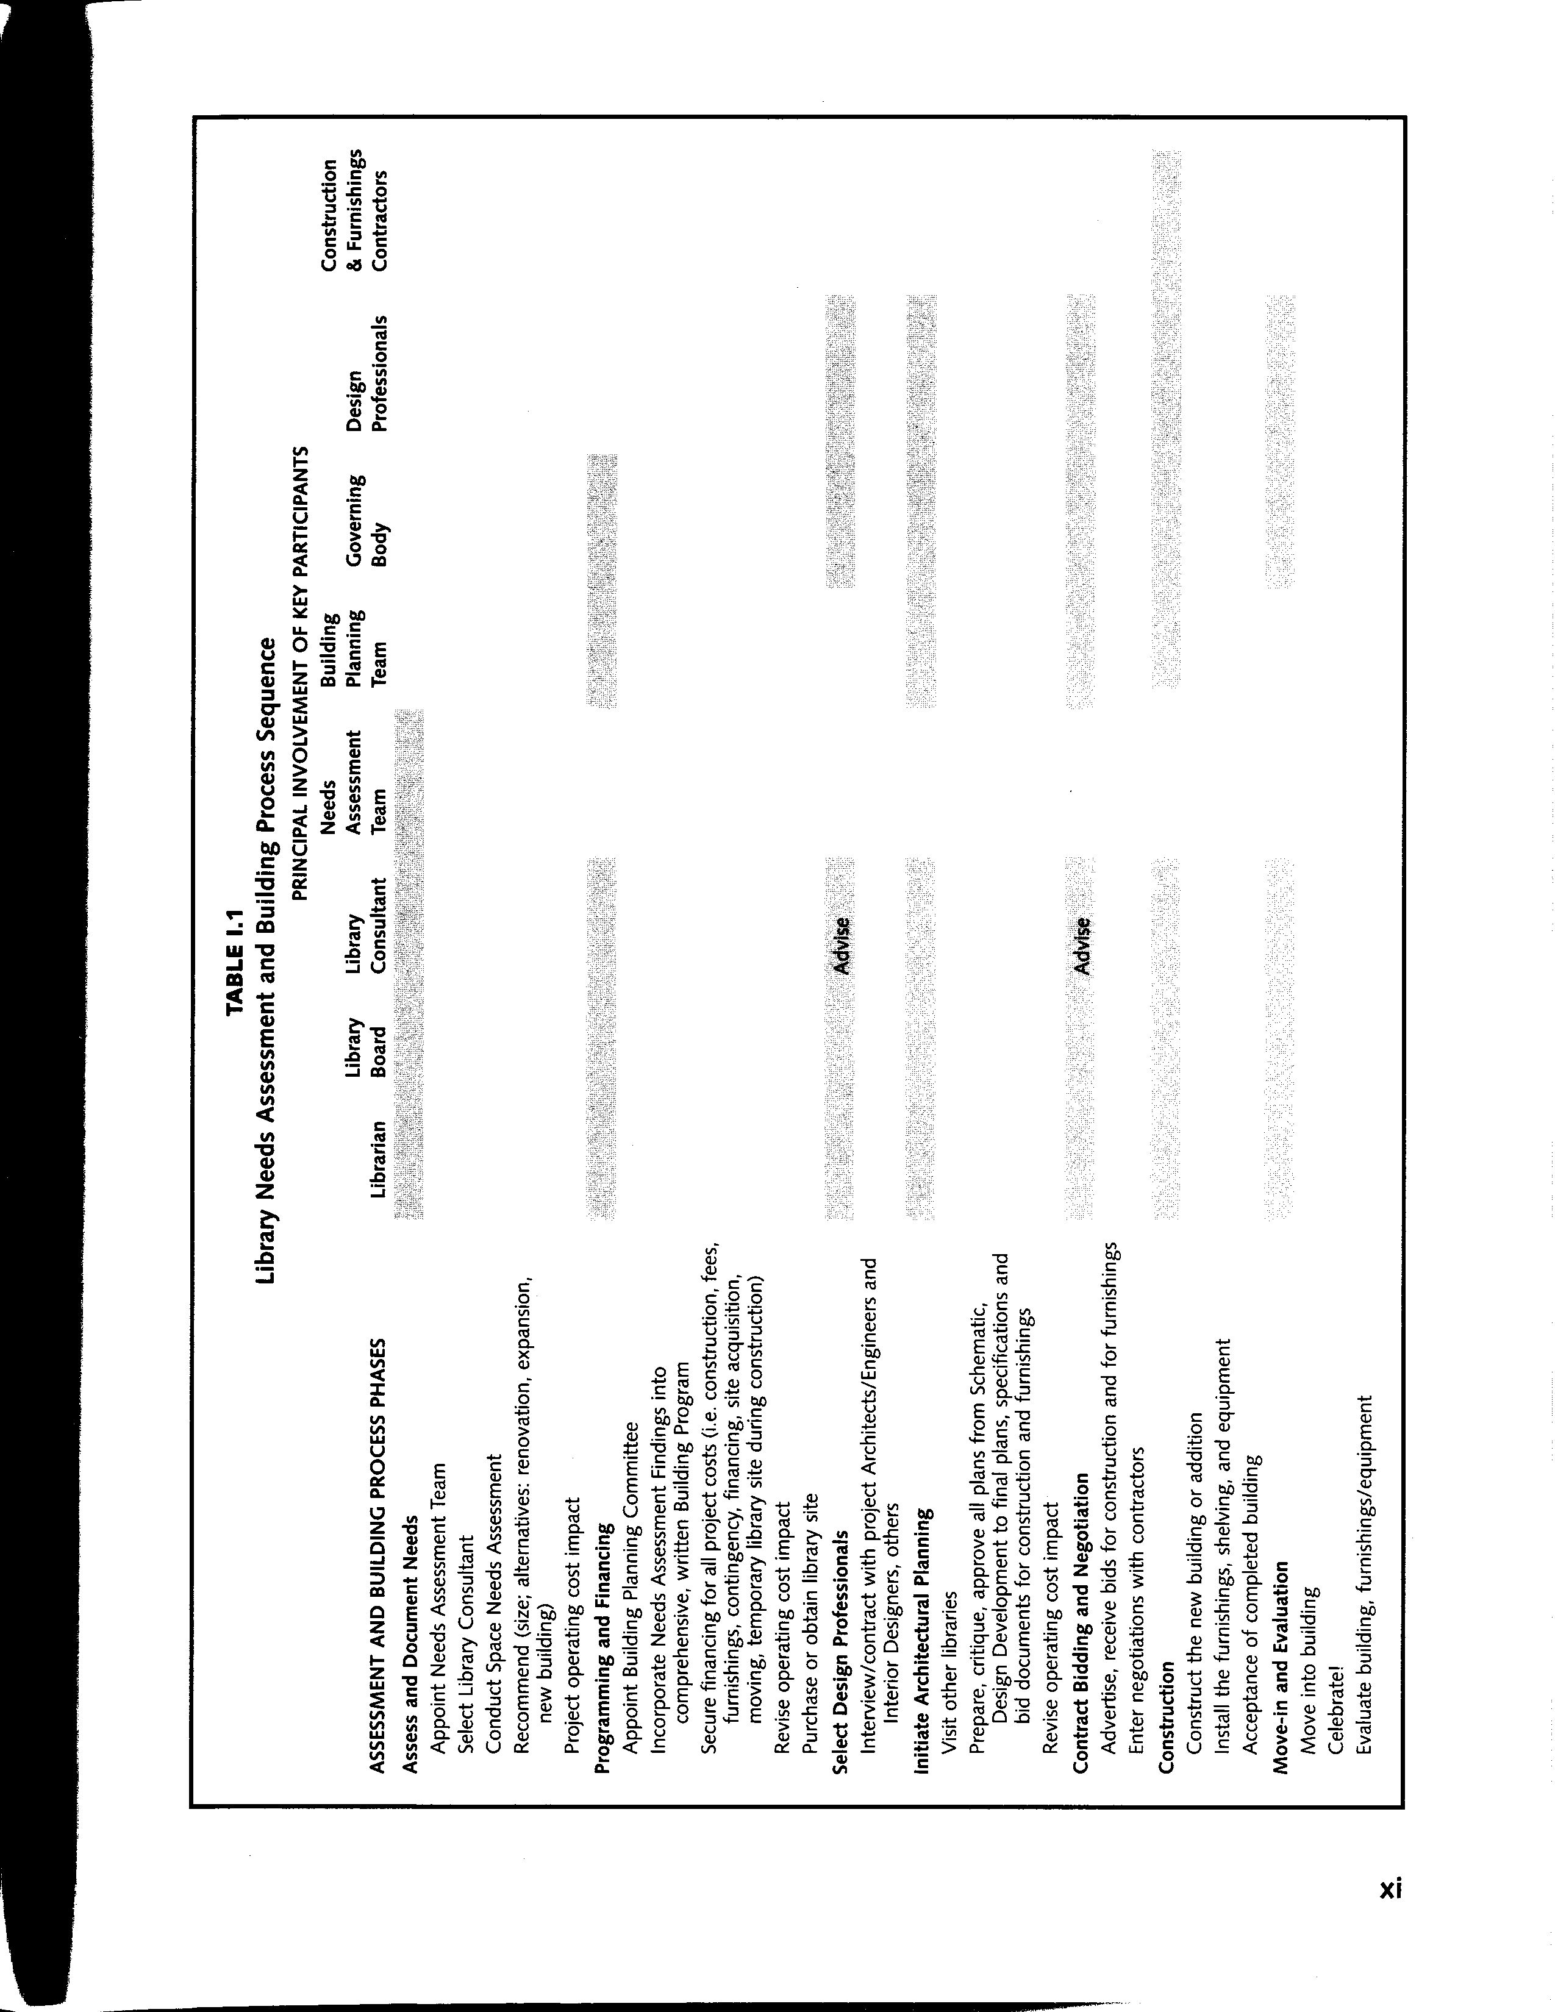
From: Brawner, Lee. B. and Donald K. Beck, Jr. Determining Your Public Library’s Future Size: A Needs Assessment and Planning Model. Chicago: American Library Trustee Association, 1996.

