Teaching Aid – Library Building #9
Shelving Capacity for Children’s Materials 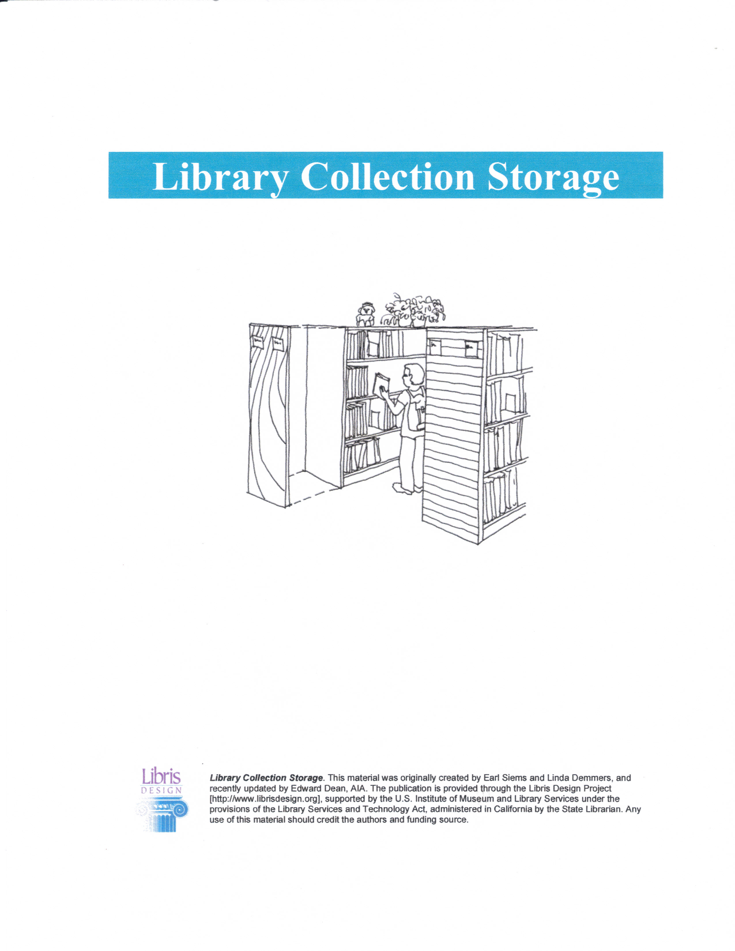
Table 2. Capacity Schedule for Children’s Print Materials ... children’s materials
are typically shelved on 42” and 66” high units and adult and young adult ...
www.librisdesign.org/docs/LibraryCollectionStorage.pdf -
