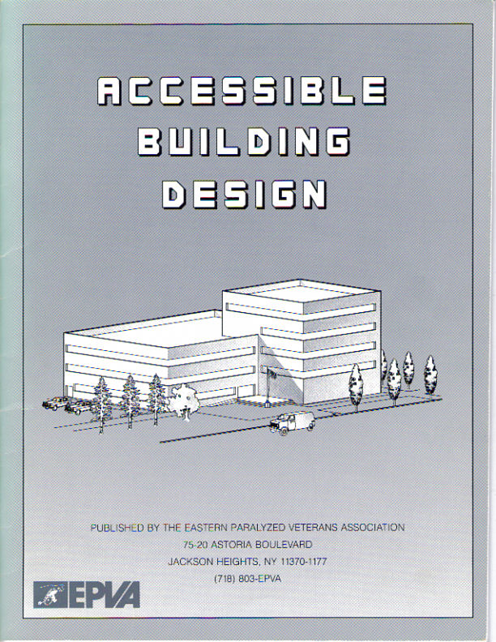

The illustrations that follow are from: Accessible Building Design.
Published by the Eastern Paralyzed Veterans Association, nd. Reprinted with permission.

Teaching Aid – The Americans with Disabilities Act #3
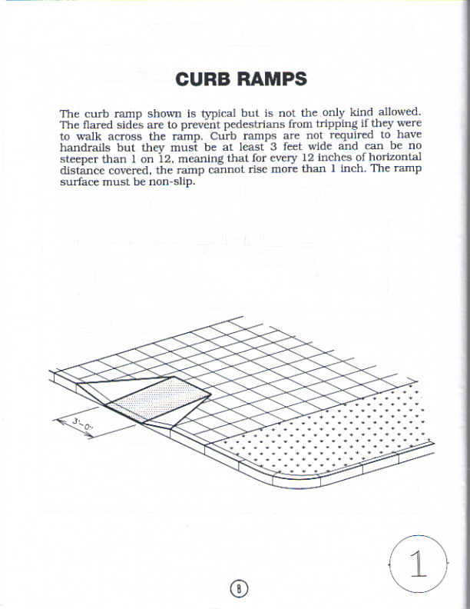

From: Accessible Building Design. Published by the Eastern Paralyzed Veterans Association, nd
Reprinted with permission
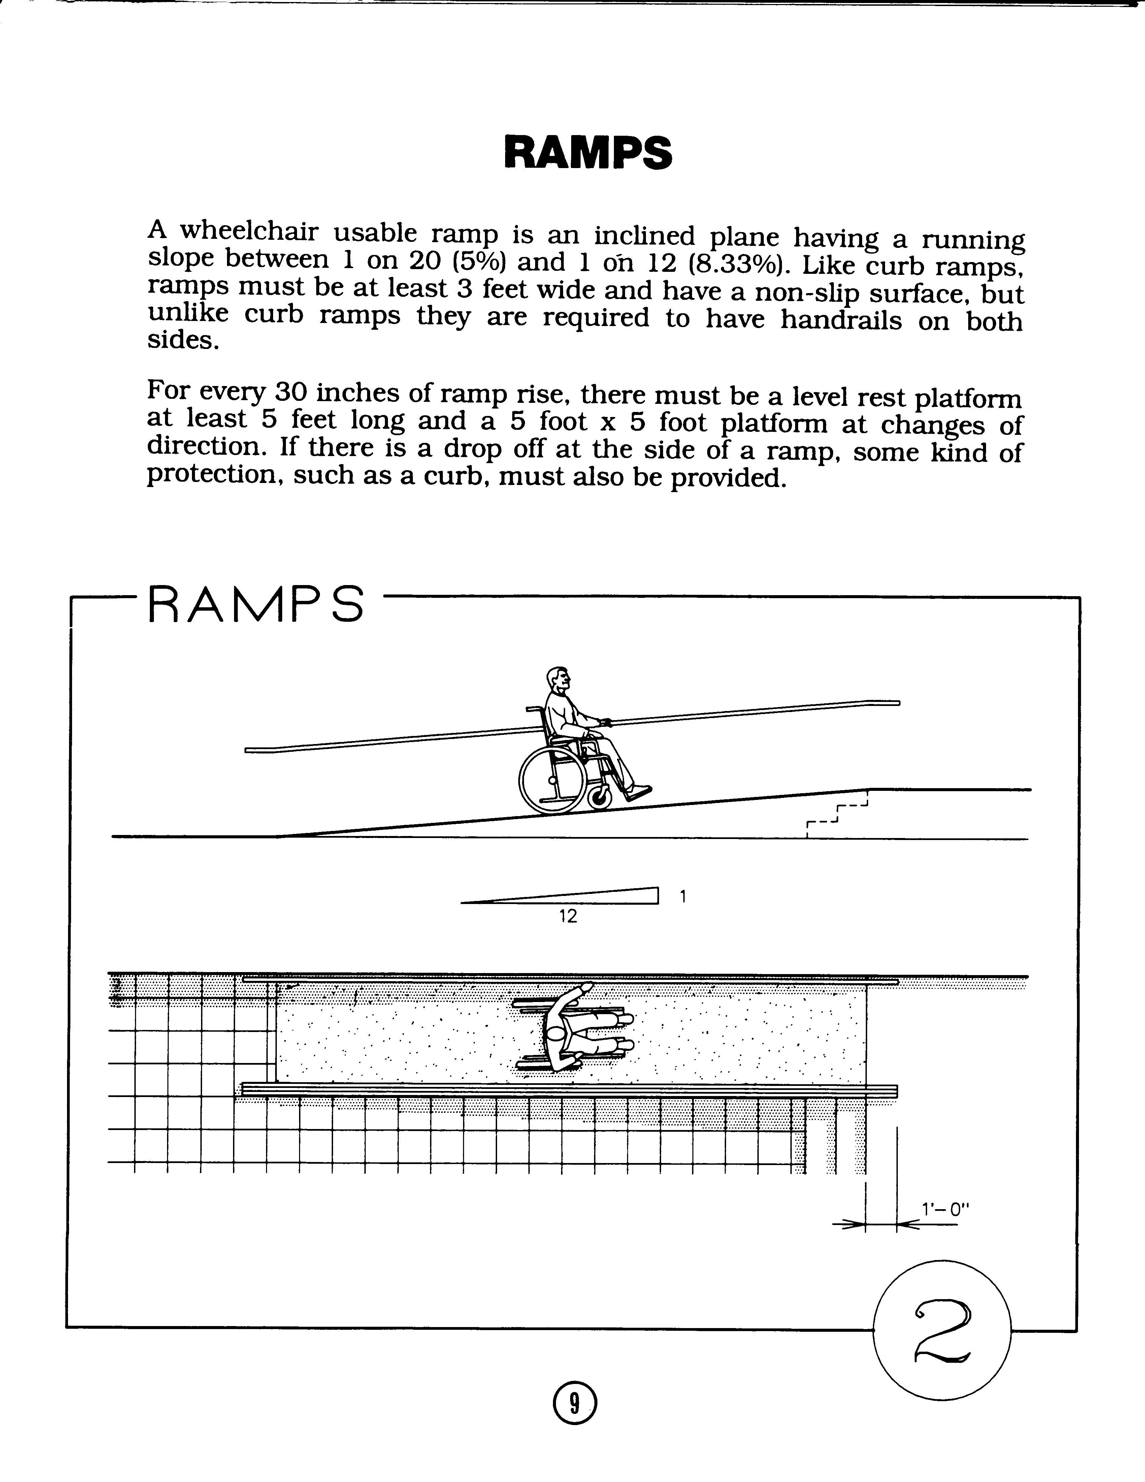

From: Accessible Building Design. Published by the Eastern Paralyzed Veterans Association, nd
Reprinted with permission
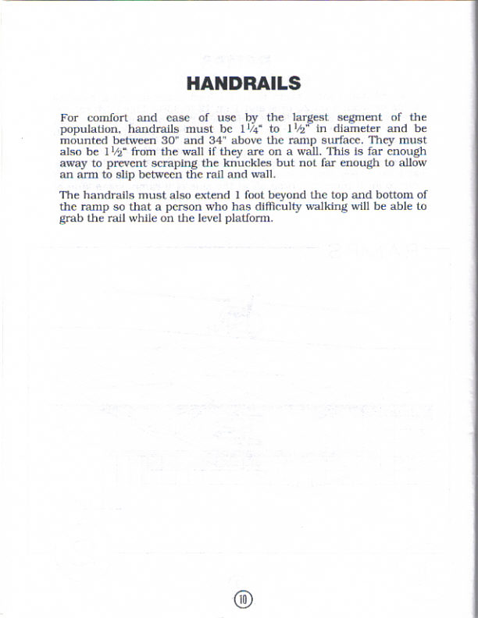

From: Accessible Building Design. Published by the Eastern Paralyzed Veterans Association, nd
Reprinted with permission
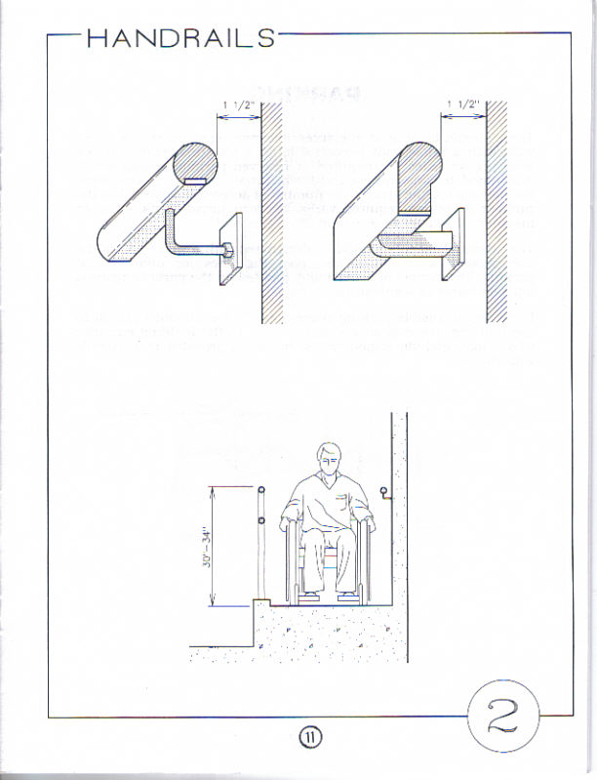

From: Accessible Building Design. Published by the Eastern Paralyzed Veterans Association, nd
Reprinted with permission
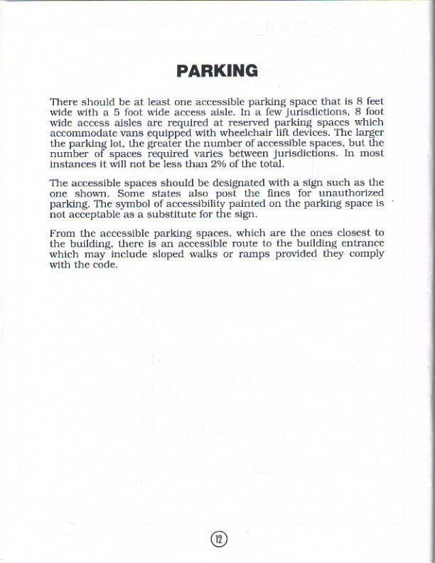

From: Accessible Building Design. Published by the Eastern Paralyzed Veterans Association, nd
Reprinted with permission
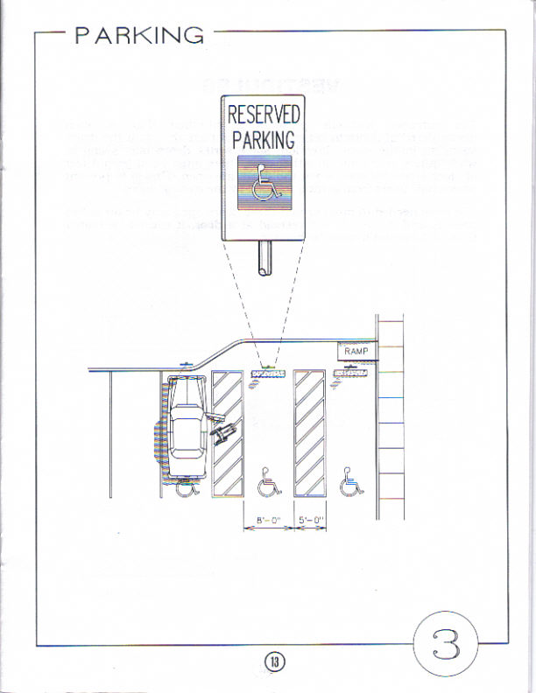

From: Accessible Building Design. Published by the Eastern Paralyzed Veterans Association, nd
Reprinted with permission
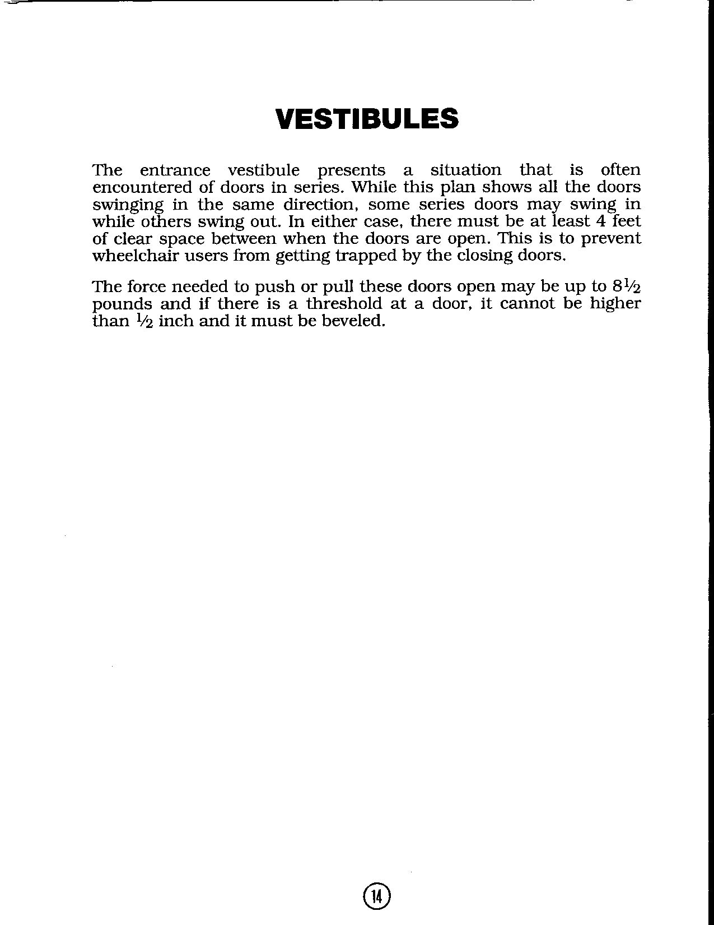

From: Accessible Building Design. Published by the Eastern Paralyzed Veterans Association, nd
Reprinted with permission
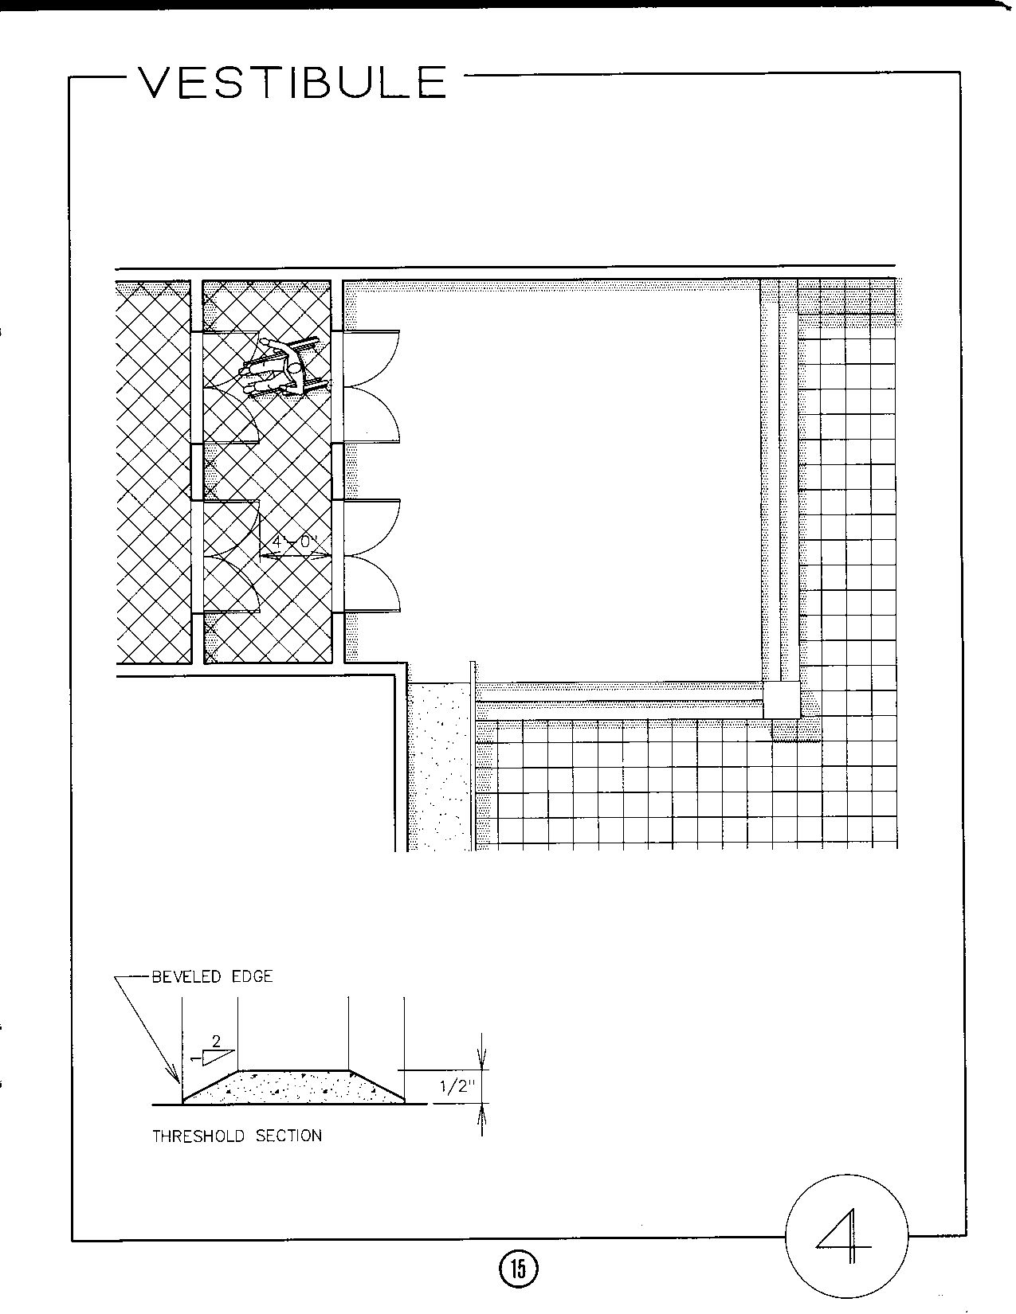

From: Accessible Building Design. Published by the Eastern Paralyzed Veterans Association, nd
Reprinted with permission
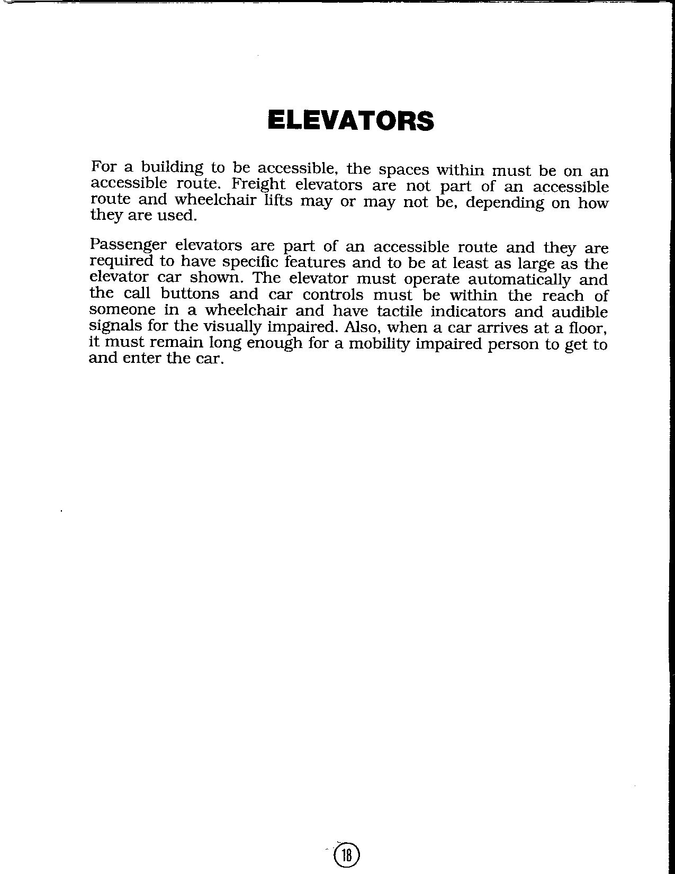

From: Accessible Building Design. Published by the Eastern Paralyzed Veterans Association, nd
Reprinted with permission
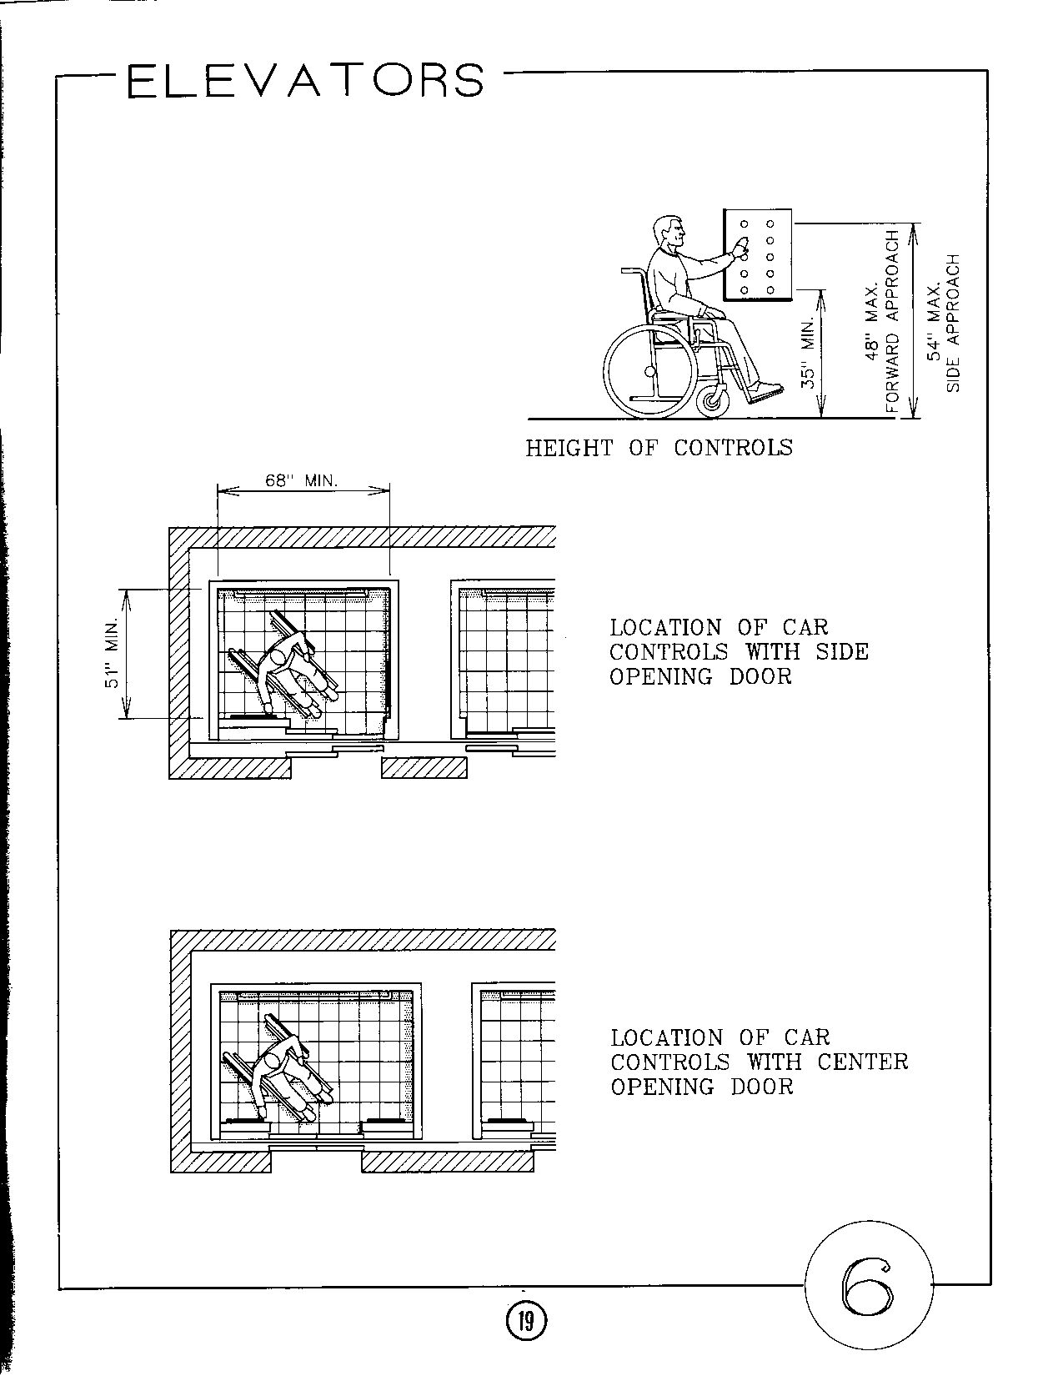

From: Accessible Building Design. Published by the Eastern Paralyzed Veterans Association, nd
Reprinted with permission
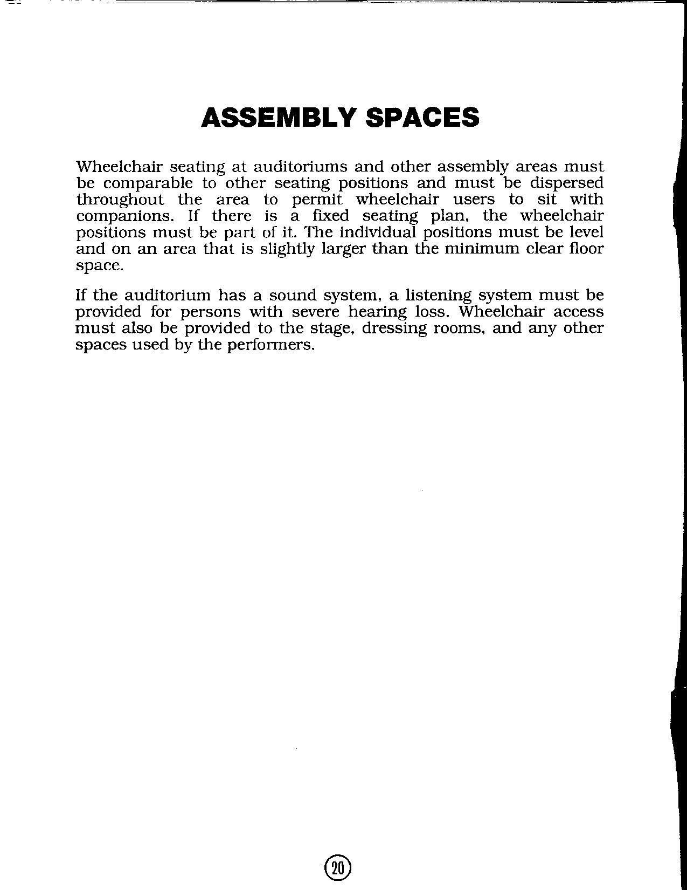
From: Accessible Building Design. Published by the Eastern Paralyzed Veterans Association, nd
Reprinted with permission
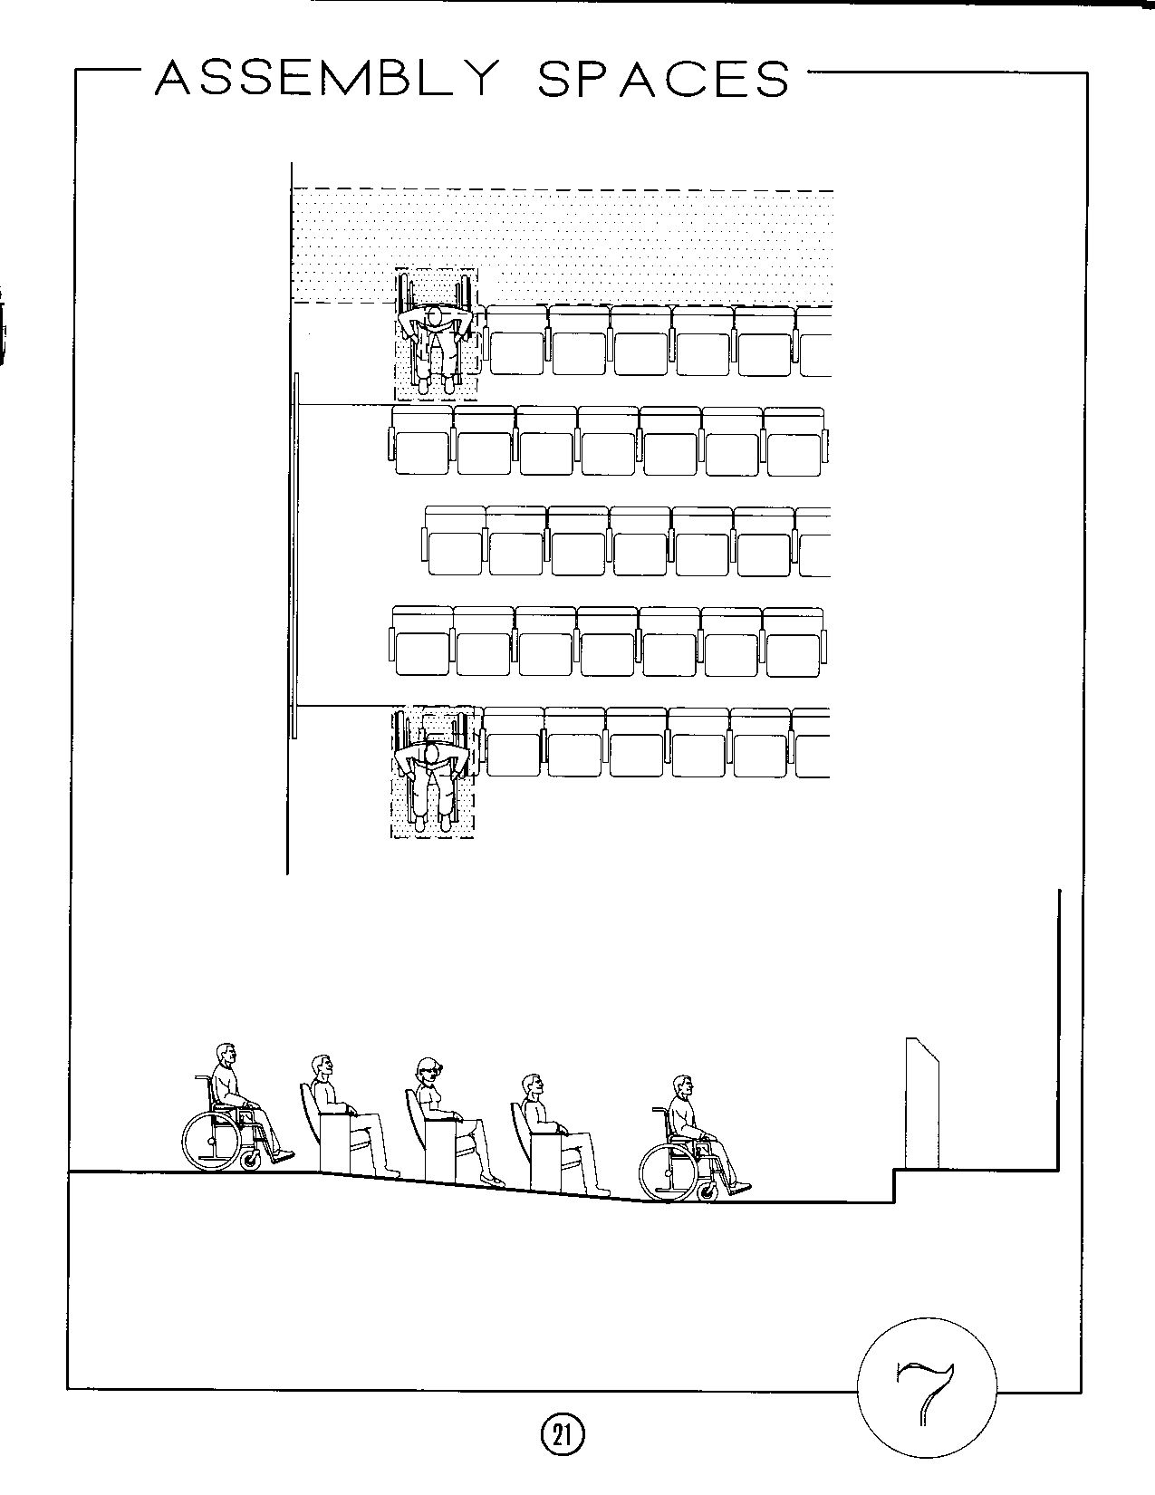

From: Accessible Building Design. Published by the Eastern Paralyzed Veterans Association, nd
Reprinted with permission
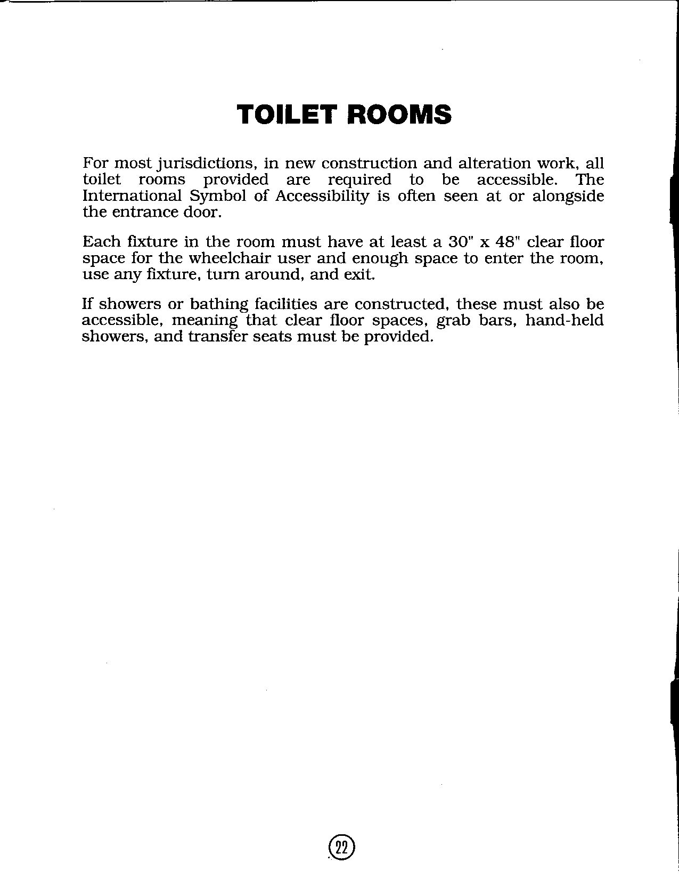

From: Accessible Building Design. Published by the Eastern Paralyzed Veterans Association, nd
Reprinted with permission
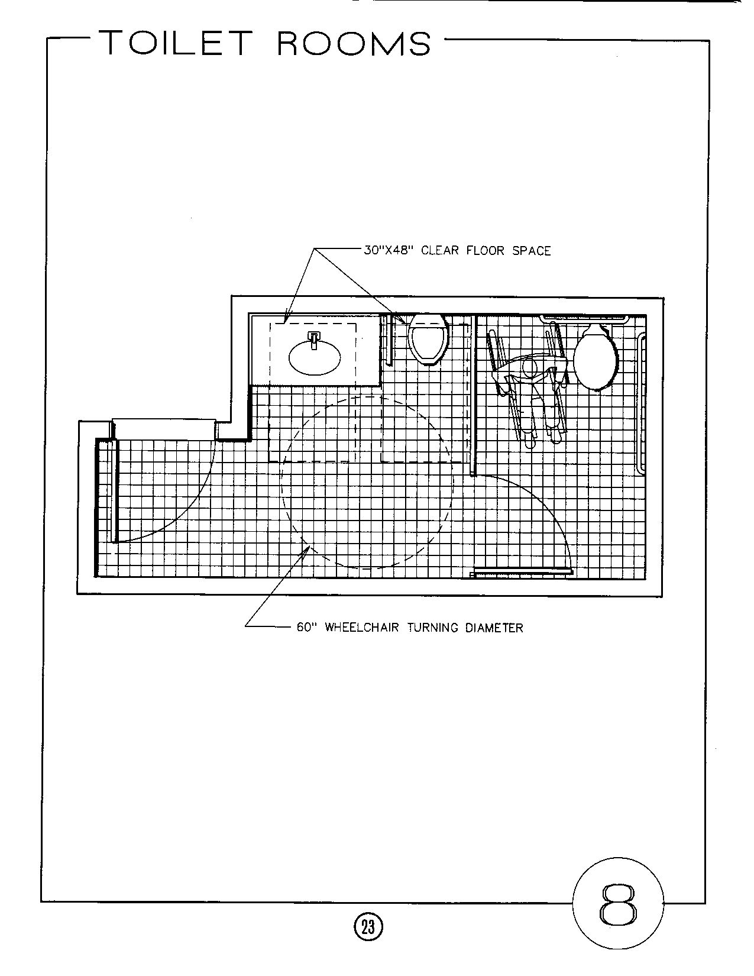

From: Accessible Building Design. Published by the Eastern Paralyzed Veterans Association, nd
Reprinted with permission
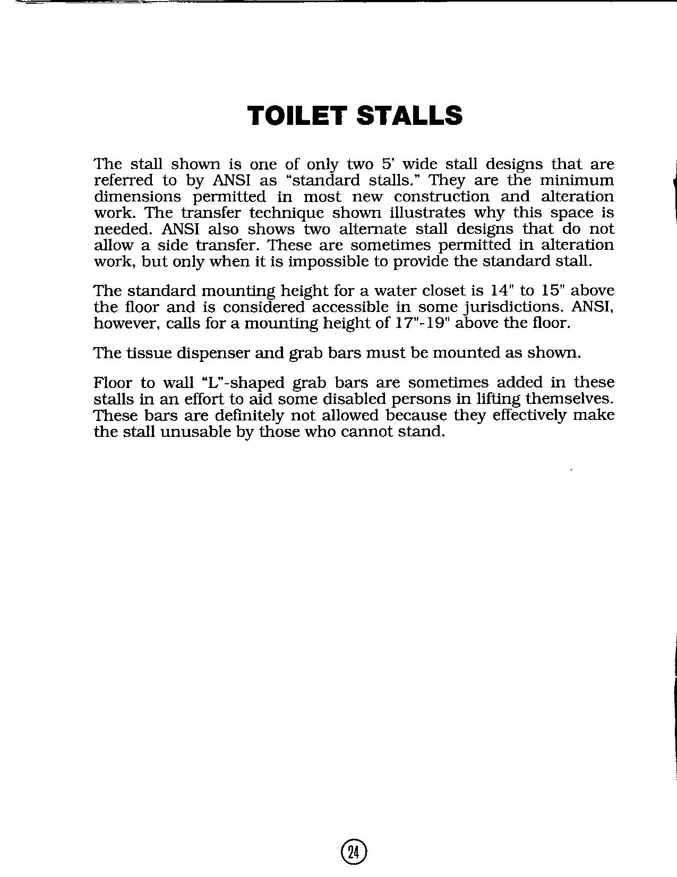

From: Accessible Building Design. Published by the Eastern Paralyzed Veterans Association, nd
Reprinted with permission
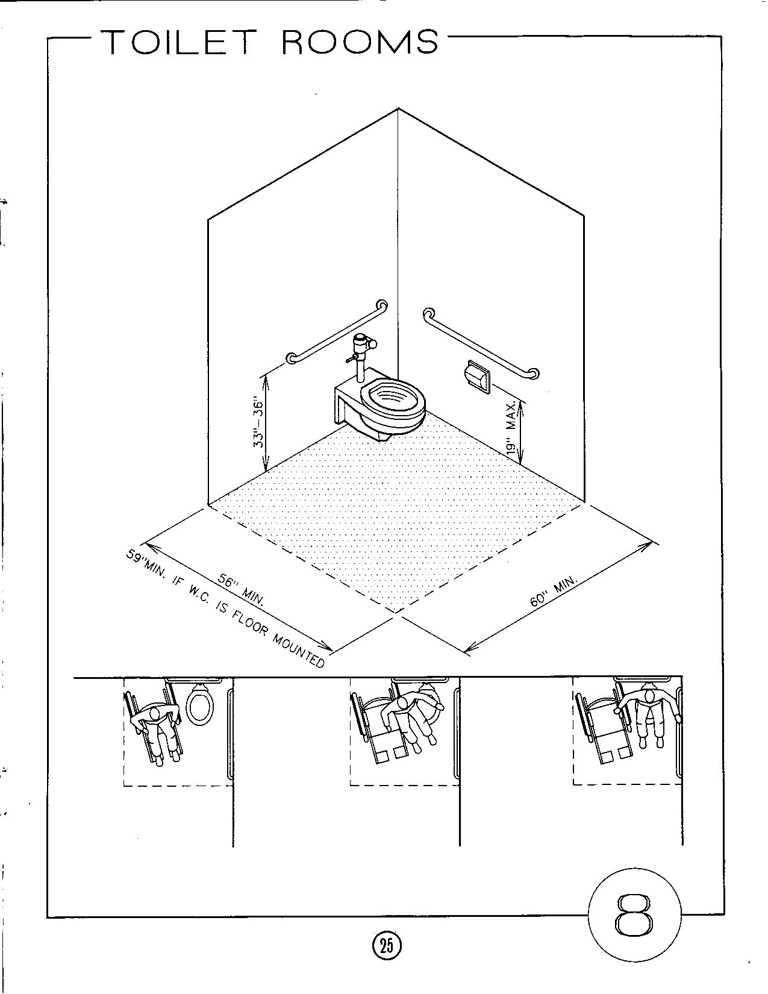

From: Accessible Building Design. Published by the Eastern Paralyzed Veterans Association, nd
Reprinted with permission
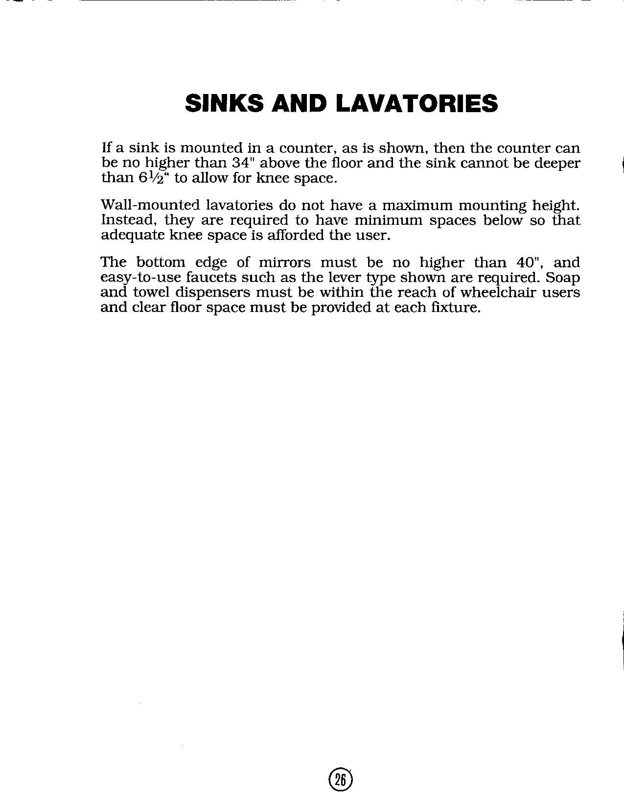

From: Accessible Building Design. Published by the Eastern Paralyzed Veterans Association, nd
Reprinted with permission
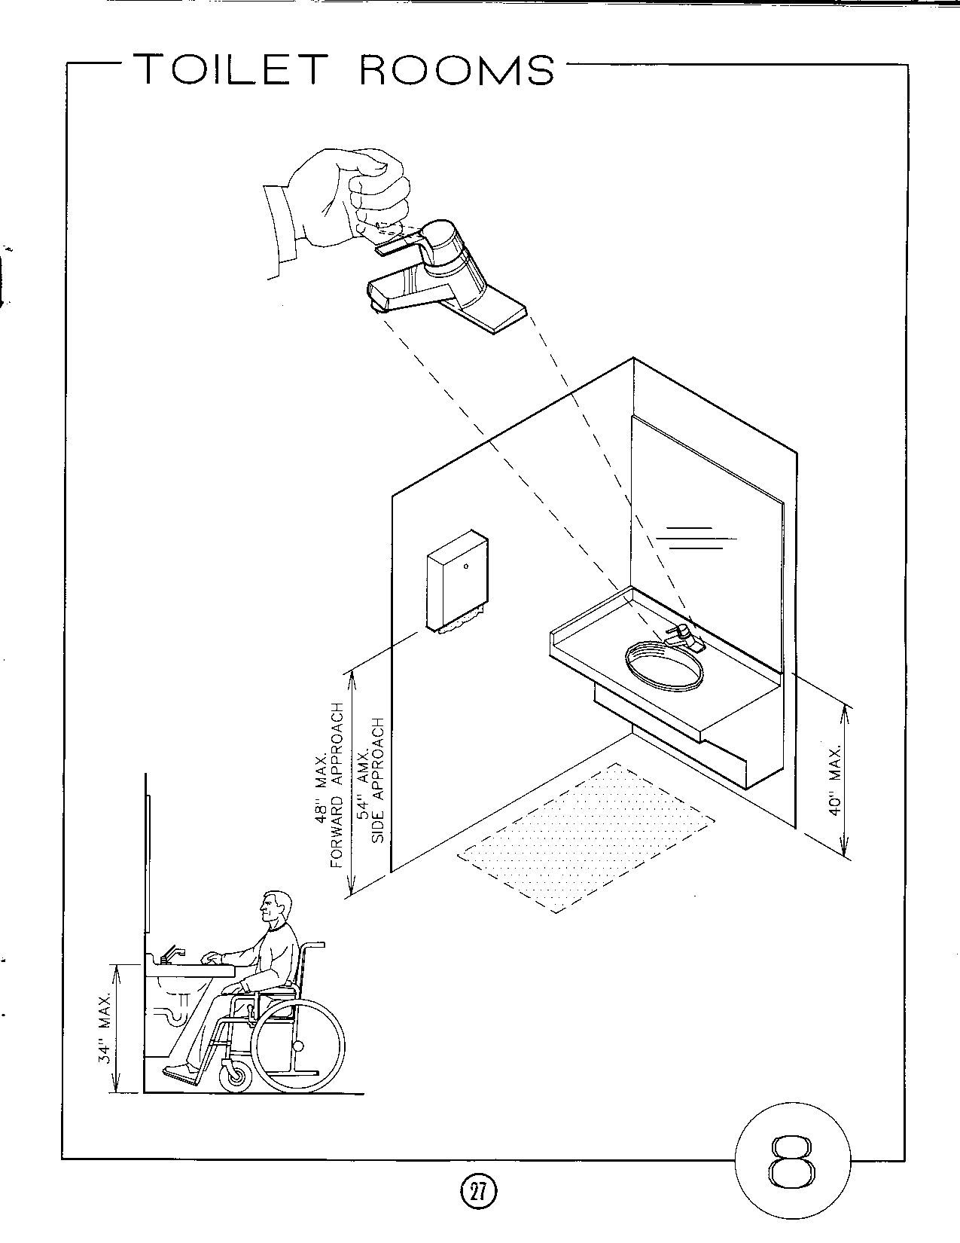

From: Accessible Building Design. Published by the Eastern Paralyzed Veterans Association, nd
Reprinted with permission
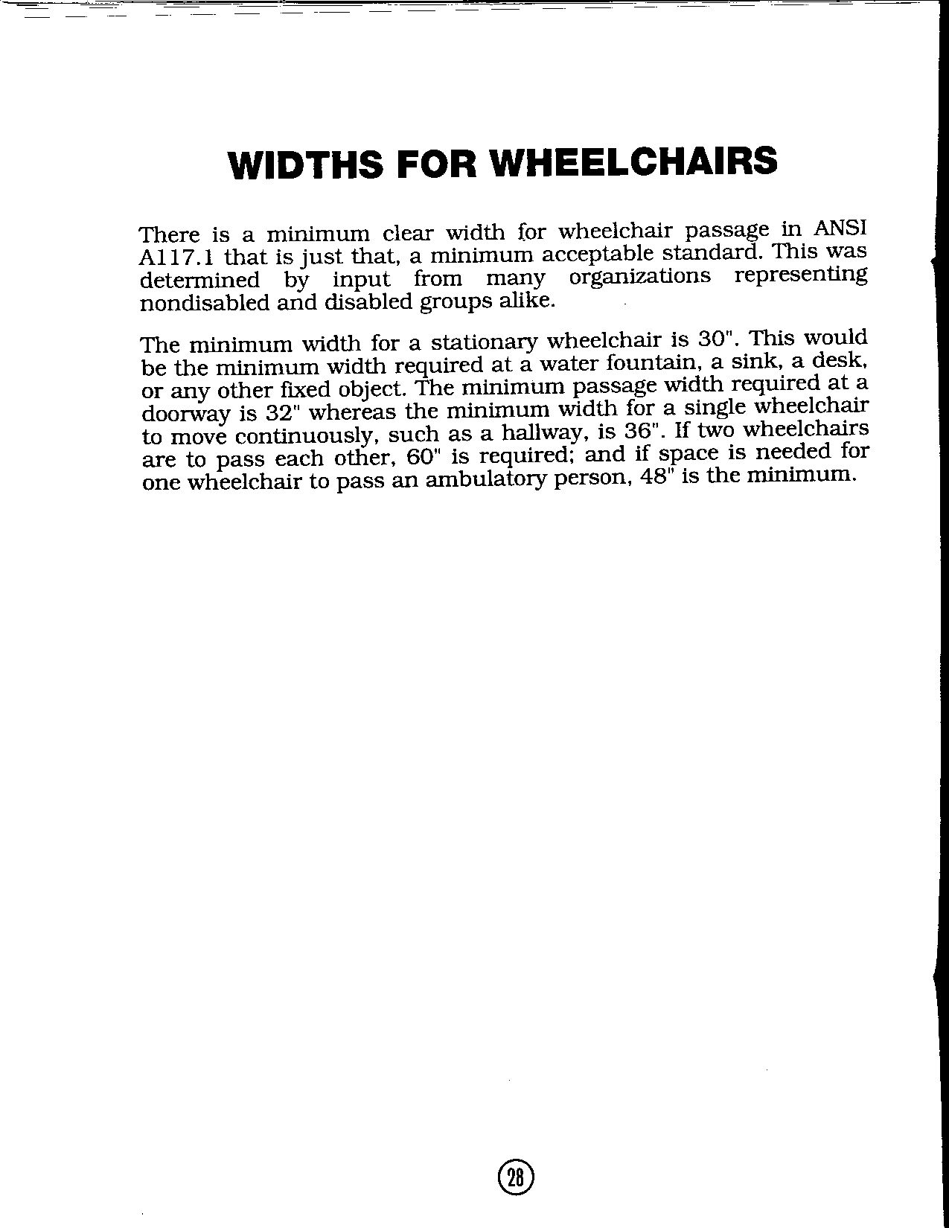

From: Accessible Building Design. Published by the Eastern Paralyzed Veterans Association, nd
Reprinted with permission
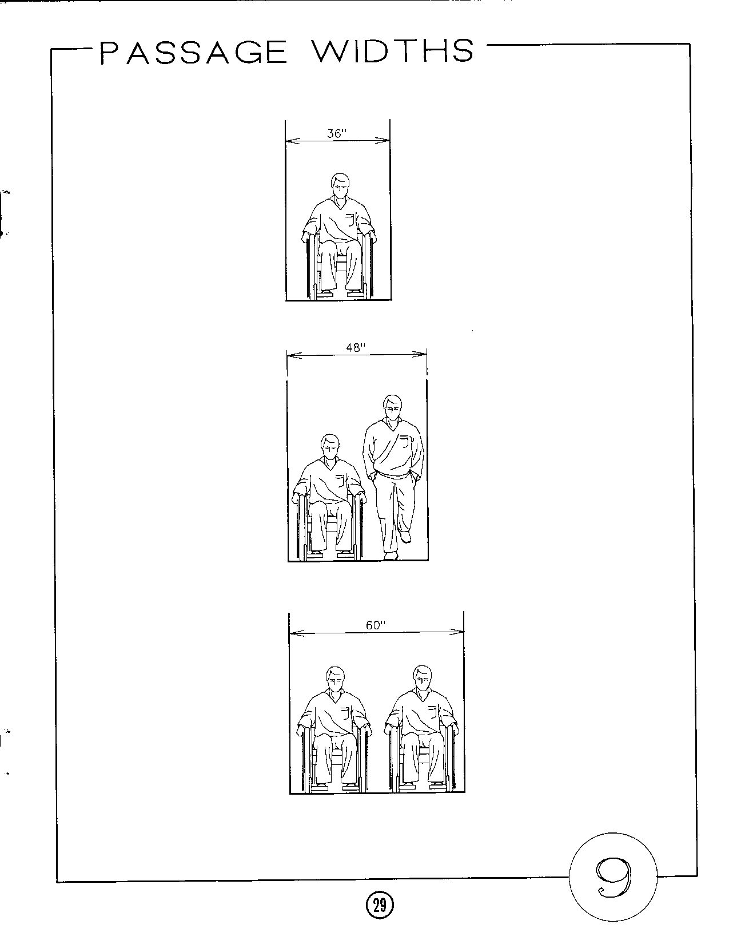

From: Accessible Building Design. Published by the Eastern Paralyzed Veterans Association, nd
Reprinted with permission
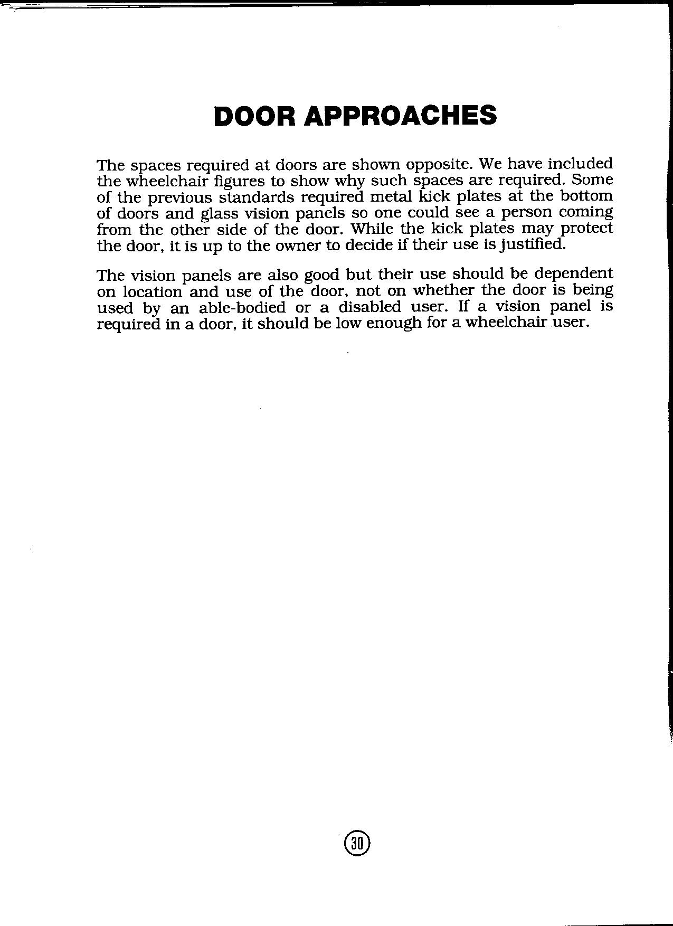

From: Accessible Building Design. Published by the Eastern Paralyzed Veterans Association, nd
Reprinted with permission
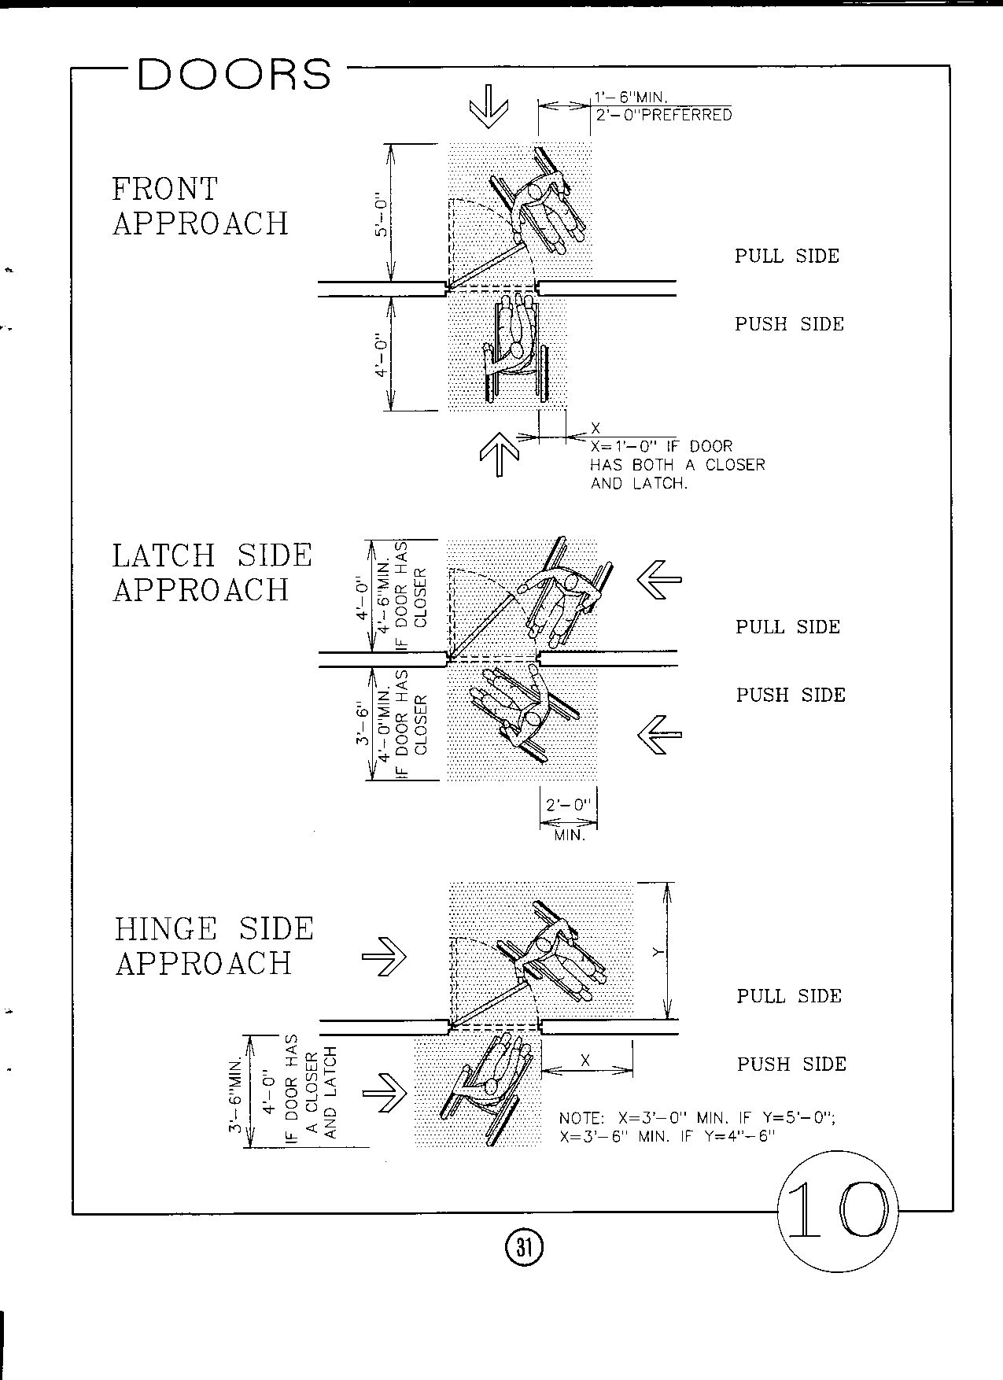

From: Accessible Building Design. Published by the Eastern Paralyzed Veterans Association, nd
Reprinted with permission
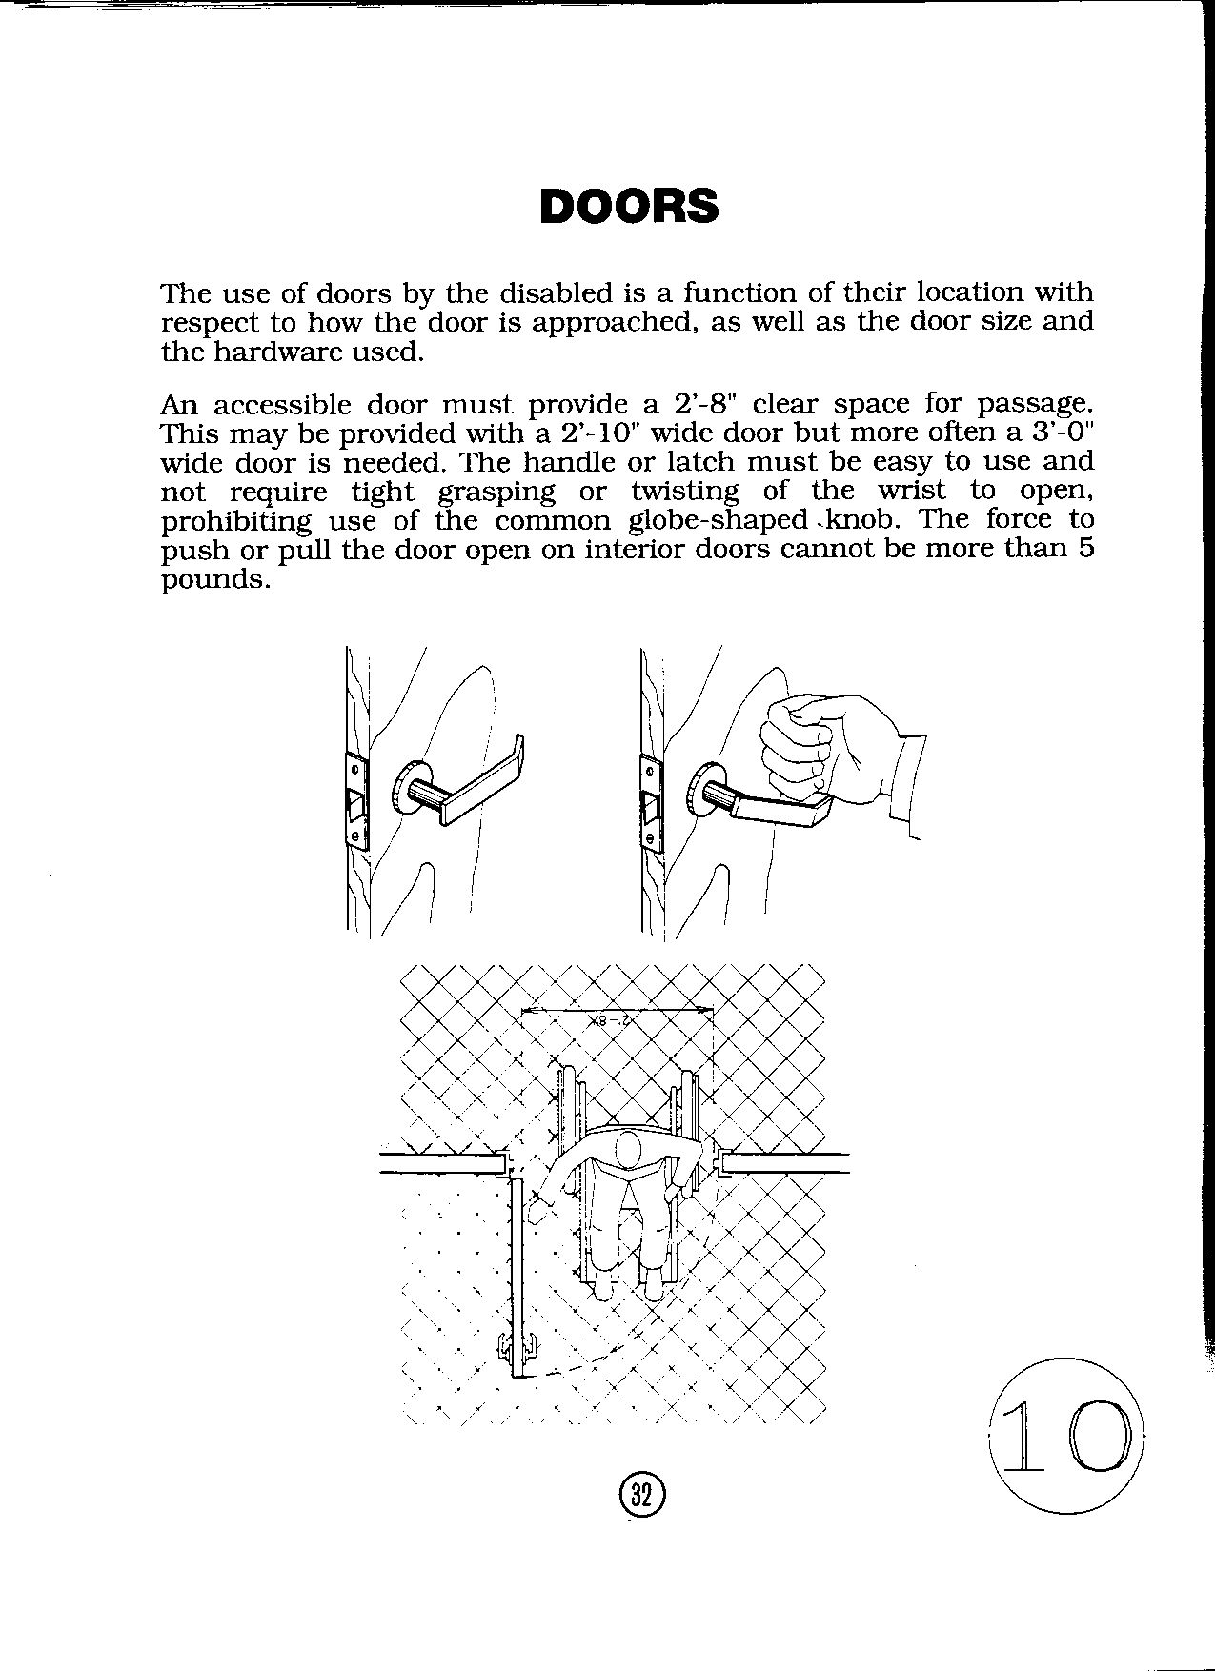

From: Accessible Building Design. Published by the Eastern Paralyzed Veterans Association, nd
Reprinted with permission
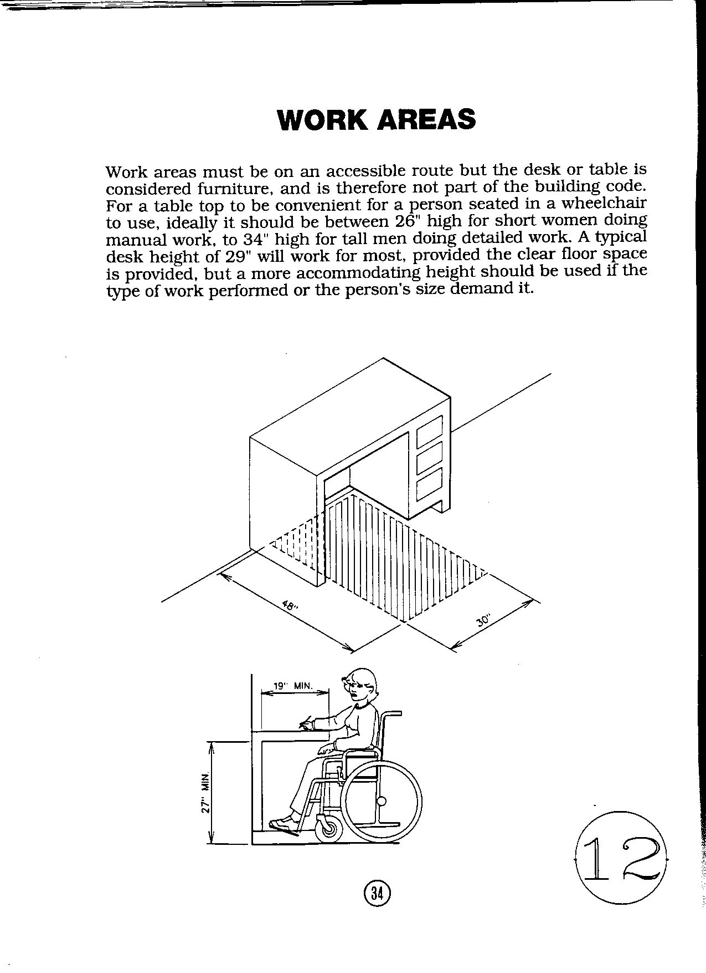

From: Accessible Building Design. Published by the Eastern Paralyzed Veterans Association, nd
Reprinted with permission
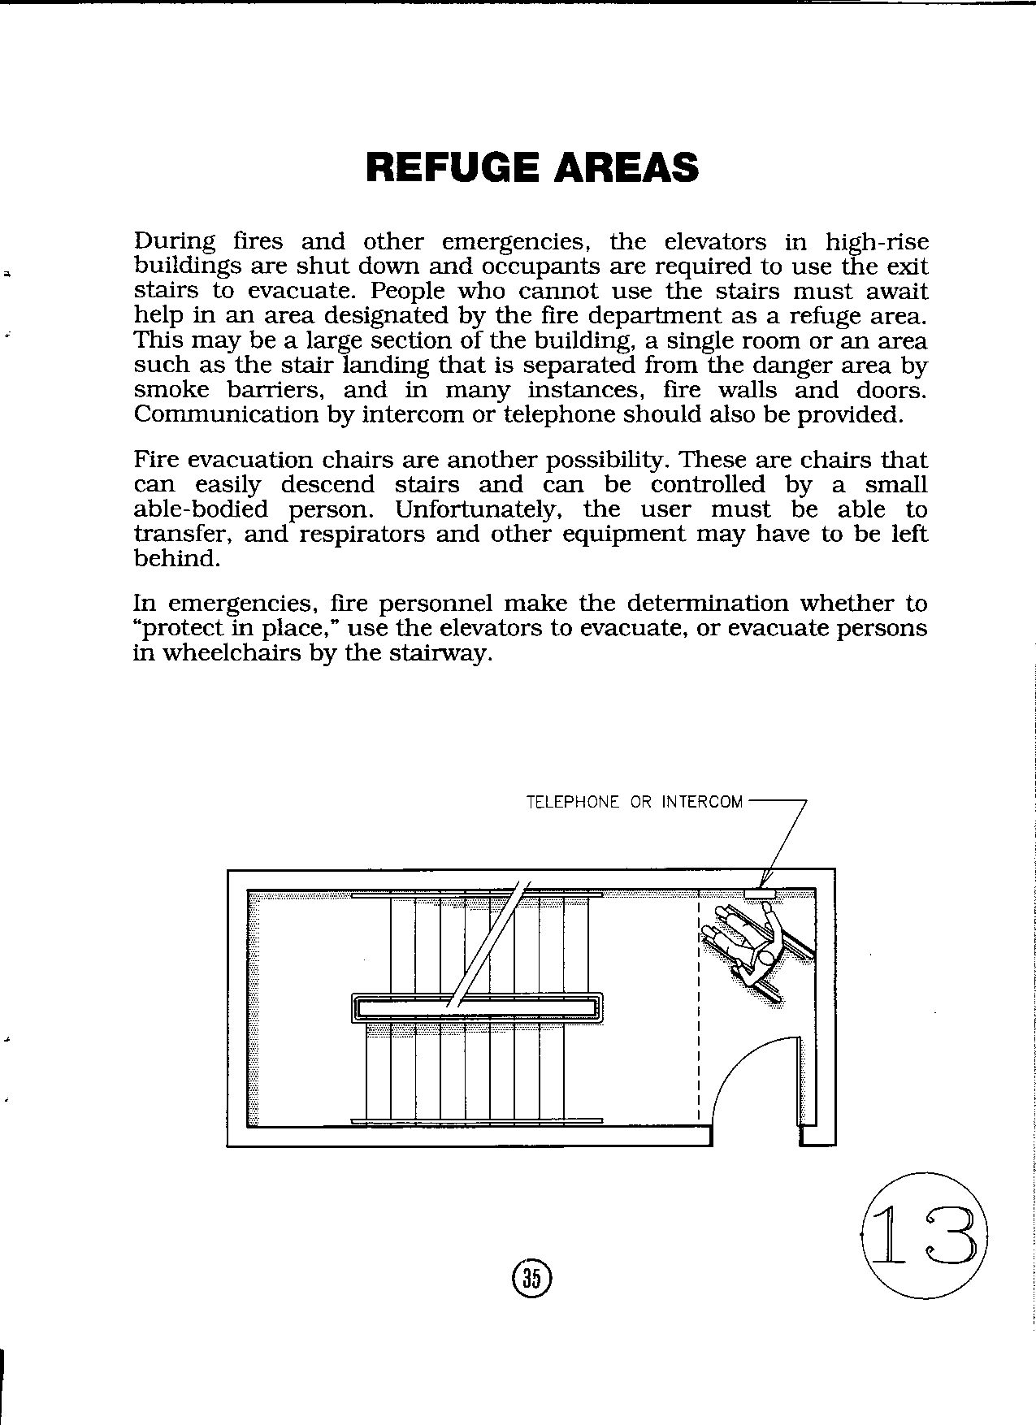

From: Accessible Building Design. Published by the Eastern Paralyzed Veterans Association, nd
Reprinted with permission

