Lecture Notes
The Library Building

Please note: any teaching aids in this document have not been corrected. Please refer to individual files for each teaching aid for the final corrected versions.

CURRENT CONDITIONS

It is sometimes difficult to look at your library with “fresh eyes” – to see the wrinkles that may have developed over time. This part of the workshop will focus on objectively seeing your library building’s strengths and weaknesses – and how to make changes to improve your library’s image.

THE EXTERIOR

Think back to when you had the interview for your job. You prepared yourself to answer potential questions; perhaps carried a portfolio of your work at other jobs and dressed in your best interview outfit. As you walked toward the library, what were your first impressions? Was the grass mowed, shrubbery well-trimmed, parking lot and sidewalks maintained, and wheel-chair accessible? Was there a sign on the exterior of the building indicating that you actually were at the library? Was the building attractive and in good condition? Or did you see evidence of neglect? Little indications that perhaps this building was in need of some attention, that “pride of place” was lacking. Let’s talk about the outside of building; how it can be a critical factor in a library user’s overall impression of the library, and how to improve that user’s general reaction.

The Building and Entrance

Questions a library user might ask themselves:

- Is the entrance clearly identified?
- If the handicap entrance is at another location, are there clear directions to that entry?
- Are the sidewalks and/or ramp into the building in good repair?
- Is there a sign with the library’s name and hours at or near the front door?
- Does the building appear to be in good repair?
- Are the windows clean and the doors free of fingerprints?
- Where is the book drop located?

Refer to Teaching Aid – Library Building #1: Library Exterior Checklist.

In addition to the questions listed above, the Library Board and the Director must also be able to answer these additional questions:

- Does the Board have a “Building and Grounds” or “Facilities” committee?
- Is there a Building and Grounds/Facilities policy that includes clear-cut procedures?
- Are there other policies that the Board has adopted related to Buildings and Grounds such as a “Meeting Room Policy,” a “Display Case and/or Bulletin Board Policy,” or a “Disaster Plan”?
- Does the library employ maintenance staff?
- If there is no maintenance staff, who does the library call or contract with for routine repairs?
- Is there a plan in place for exterior maintenance of the library that includes regular inspections of the roof, windows, siding, and gutters?
- Does the library budget include money for routine maintenance as well as reserve funds for building emergency repairs?

The Grounds

Questions a library user might ask themselves:

- Does this seem like a place I’d like to visit?
- Are the lawns mowed, shrubbery trimmed, and plantings weeded?
- Are trees overgrown or in need of trimming?

In addition to the questions listed above, the Library Board and the Director must be able to answer these additional questions:

- Who is responsible for grounds maintenance?
- Is a regular grounds inspection conducted, and if so, by whom?
- Are there any safety hazards? i.e., overgrown shrubbery that might provide a hiding place for someone with criminal intent or trees that block exterior lighting.
- Is there sufficient exterior lighting? Site lighting at vehicular and pedestrian entrances should be continuous and sufficient to support a secure atmosphere.
- Is there a lit sign with the library’s name and hours on it?

The Parking Area

Questions a library user might ask themselves:

- Where is convenient library parking located?
- Do I park on the street or is there a parking area?
- Is there clearly identified handicap accessible parking?

In addition to the questions listed above, the Library Board and the Director must be able to answer these additional questions:

- Who is responsible for conducting a regular inspection of the parking area?
- If there is a library parking lot, how often is it resurfaced?
- Does the library have the minimum number of handicap accessible parking spots, including appropriate signage?
- Who plows the parking area and shovels the walks?

LIBRARY EXTERIOR CHECKLIST

Question | Yes | No | Action Plan
Does the Library Board have a Buildings and Grounds/Facilities Committee?
Is there a Building and Grounds/Facilities policy with clear-cut procedures?
Is there a plan in place for exterior maintenance of the library including regular inspections of the roof, gutters, windows, siding, gutters, and grounds and parking areas?
Does the library budget include money for routine maintenance as well as reserve funds for emergency repairs?
Does the library employ maintenance staff?
If the library does not employ maintenance staff, does the library have a list of reliable contractors for grounds maintenance such as mowing or plowing?
Does the building appear to be in good repair?
Is the entrance clearly identified?
If the handicap entrance is at another location are there clear directions to that entry?
Are the sidewalks and/or ramp into the building in good repair?
Is there a sign with the library’s name and hours at or near the front door?
Are the windows clean and the doors free of fingerprints?
Where is the book drop located?
Are the lawns mowed, shrubbery trimmed and plantings weeded?
Are trees overgrown or in need of trimming?
Are there any safety hazards? i.e. overgrown shrubbery that might provide a hiding place for someone intent on harm or trees that block exterior lighting.
Where is convenient library parking located? Is it on the street or is there a parking area?
Is the parking area in good repair?
Is there clearly identified handicap accessible parking with appropriate signage?

THE INTERIOR

Now that we’ve spent some time thinking about the appearance of the exterior of the building and grounds, let’s turn our thoughts to the interior of the library. Just as you did when you thought about “first impressions” of the exterior of the building, think now of your reactions as you walk through the front door. Pretend that you have just moved to the community and are “checking out” the library. Do you sense that the library is a welcoming place? Do you have an impression of openness, cleanliness, lack of clutter? Is there good lighting? What about signage – can you easily find where to check out or return materials or locate the restrooms? Are there attractive, face-out displays that make you want to grab something right off the shelf to take home with you? Do you see comfortable places to sit?

Let’s talk about the inside of the building; how first impressions can be a critical factor in a library user’s overall reaction to the library.

Foyer

First Impressions:

- Is the foyer clean?
- Can a person in a wheelchair easily enter the building?
- Are there old displays or a community bulletin board with outdated flyers?
- Can you easily acquaint yourself with the library from the foyer?

The library’s foyer is similar to a home’s entryway and it is here that you want to make a good first impression. Nothing could be more off-putting to a visitor than the sight of a door covered with dirty fingerprints or a display area cluttered with an exhibit about Thanksgiving when it’s the middle of March.

The Interior of the Library

First Impressions:

- Does the library look organized, free of clutter, clean?
- Are there piles of books or magazines on the floor or the window sills?
- Does the carpeting or flooring need to be cleaned or repaired?
- What about the walls? Do they need to be cleaned or repainted?
- What about the color scheme? Is there a color scheme?
- Do signs clearly direct you to other areas of the library?
- Does the seating look comfortable and inviting?
- Are the windows clean?
- Is there good lighting?
- Are the bathrooms clean and fresh?

Once you get in the front door, what is the overall look of the library? The “look” is something that does not have to cost a lot and can often be obtained by paying close attention to detail and indulging in a little creativity. Get rid of clutter. Put those books and magazines where they belong. Remove out-of-date flyers. Paint those walls, think zing, punch up that color scheme. Perhaps a local paint store can donate the paint. Maybe the Friends can do the painting. Do the carpets need cleaning or are they ready for replacement? Either spend the money on a good cleaning or figure out a way to get them replaced – a fund-raiser, a benefactor, or build replacement costs into the budget. Wash the windows both inside and out. Is natural lighting from the windows obscured? Trim shrubbery that has overgrown the windows and the effect will be immediate. Library users should expect to find clean, hygienic, accessible bathrooms. Make sure that bathrooms are inspected several times a day and cleaned routinely.

Way Finding or the Importance of Good Signage

First Impressions:

- As you enter the library, what directional signs do you see?
- Is the lettering on the signs clear, crisp, and large enough to be seen from a distance?
- Is there consistency in the font and the size of lettering on signs?
- Are the signs accurate? Is the 300’s sign where the 300’s actually are located?

Poor signage is more than just frustrating to a library user. It can result in wasting library staff time answering directional questions that could easily be satisfied with a well-placed sign. It can also give the impression that the library doesn’t really care about its image.

What options are there for providing good signage for your library? The first thing to do is to decide what signs you actually need. Only necessary messages should be displayed as signs. Library signs should look professional even if they have not been professionally prepared. Consistency in terms of font, colors, and size of lettering give the impression that this is a place that knows what it’s doing and takes pride in its service.

- A signage or graphics business could help you make those decisions and provide the signs you need – probably at considerable cost. Check the yellow pages of your local telephone directory under “Signs.”
- Library supply catalogs such as Demco, Gaylord, and Highsmith may offer less expensive signage alternatives.
- An artistically talented staff member might be able to produce computer generated signs that could be laminated.

Some other things to think about when planning for new signs:

- Use a simple, direct, familiar type style such as Ariel or Helvetica.

- When choosing font size, consider distance. One-inch high letters are visible for approximately fifty feet. Similarly, a sign a hundred feet away requires two inch high letters.

- Use capitals and lower case rather than all upper case.

- Coordinate colors so that they don’t clash with the color of the walls and flooring.

- Outdoor signs should be lighted and include the hours the library is open. Outdoor signs should be perpendicular to traffic for optimum visibility.

- Wording of signs should be specific. Use simple words or phrases such as “Check Out,” “Return,” “Information,” and “Restroom” with directional arrows when needed.

- Plan signs by categories, i.e., user category, user destination, traffic flow, decision points.

Whatever you do, don’t hand print signs. It looks amateurish and does not provide the professional image that the library needs.

An especially useful resource for a variety of building issues is Libris Design, a library facility planning information system which includes a website with recent information on facility planning topics developed with Library Services and Technology funds and administered by the California State Library. The website information is comprehensive, current, and includes wide-ranging subject matter related to library facilities. Let’s take a brief look at a few pages of the “Wayfinding and Signage in Library Design” information available at http://www.librisdesign.org/docs/WayfindingSignage.pdf

Refer to Teaching Aid – Library Building #2: Wayfinding and Signage in Library Design.
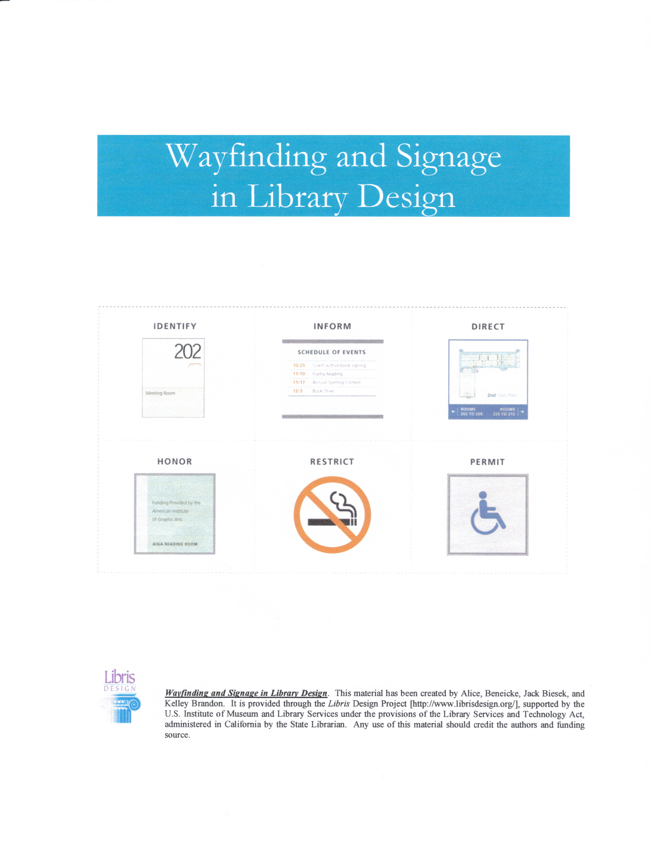
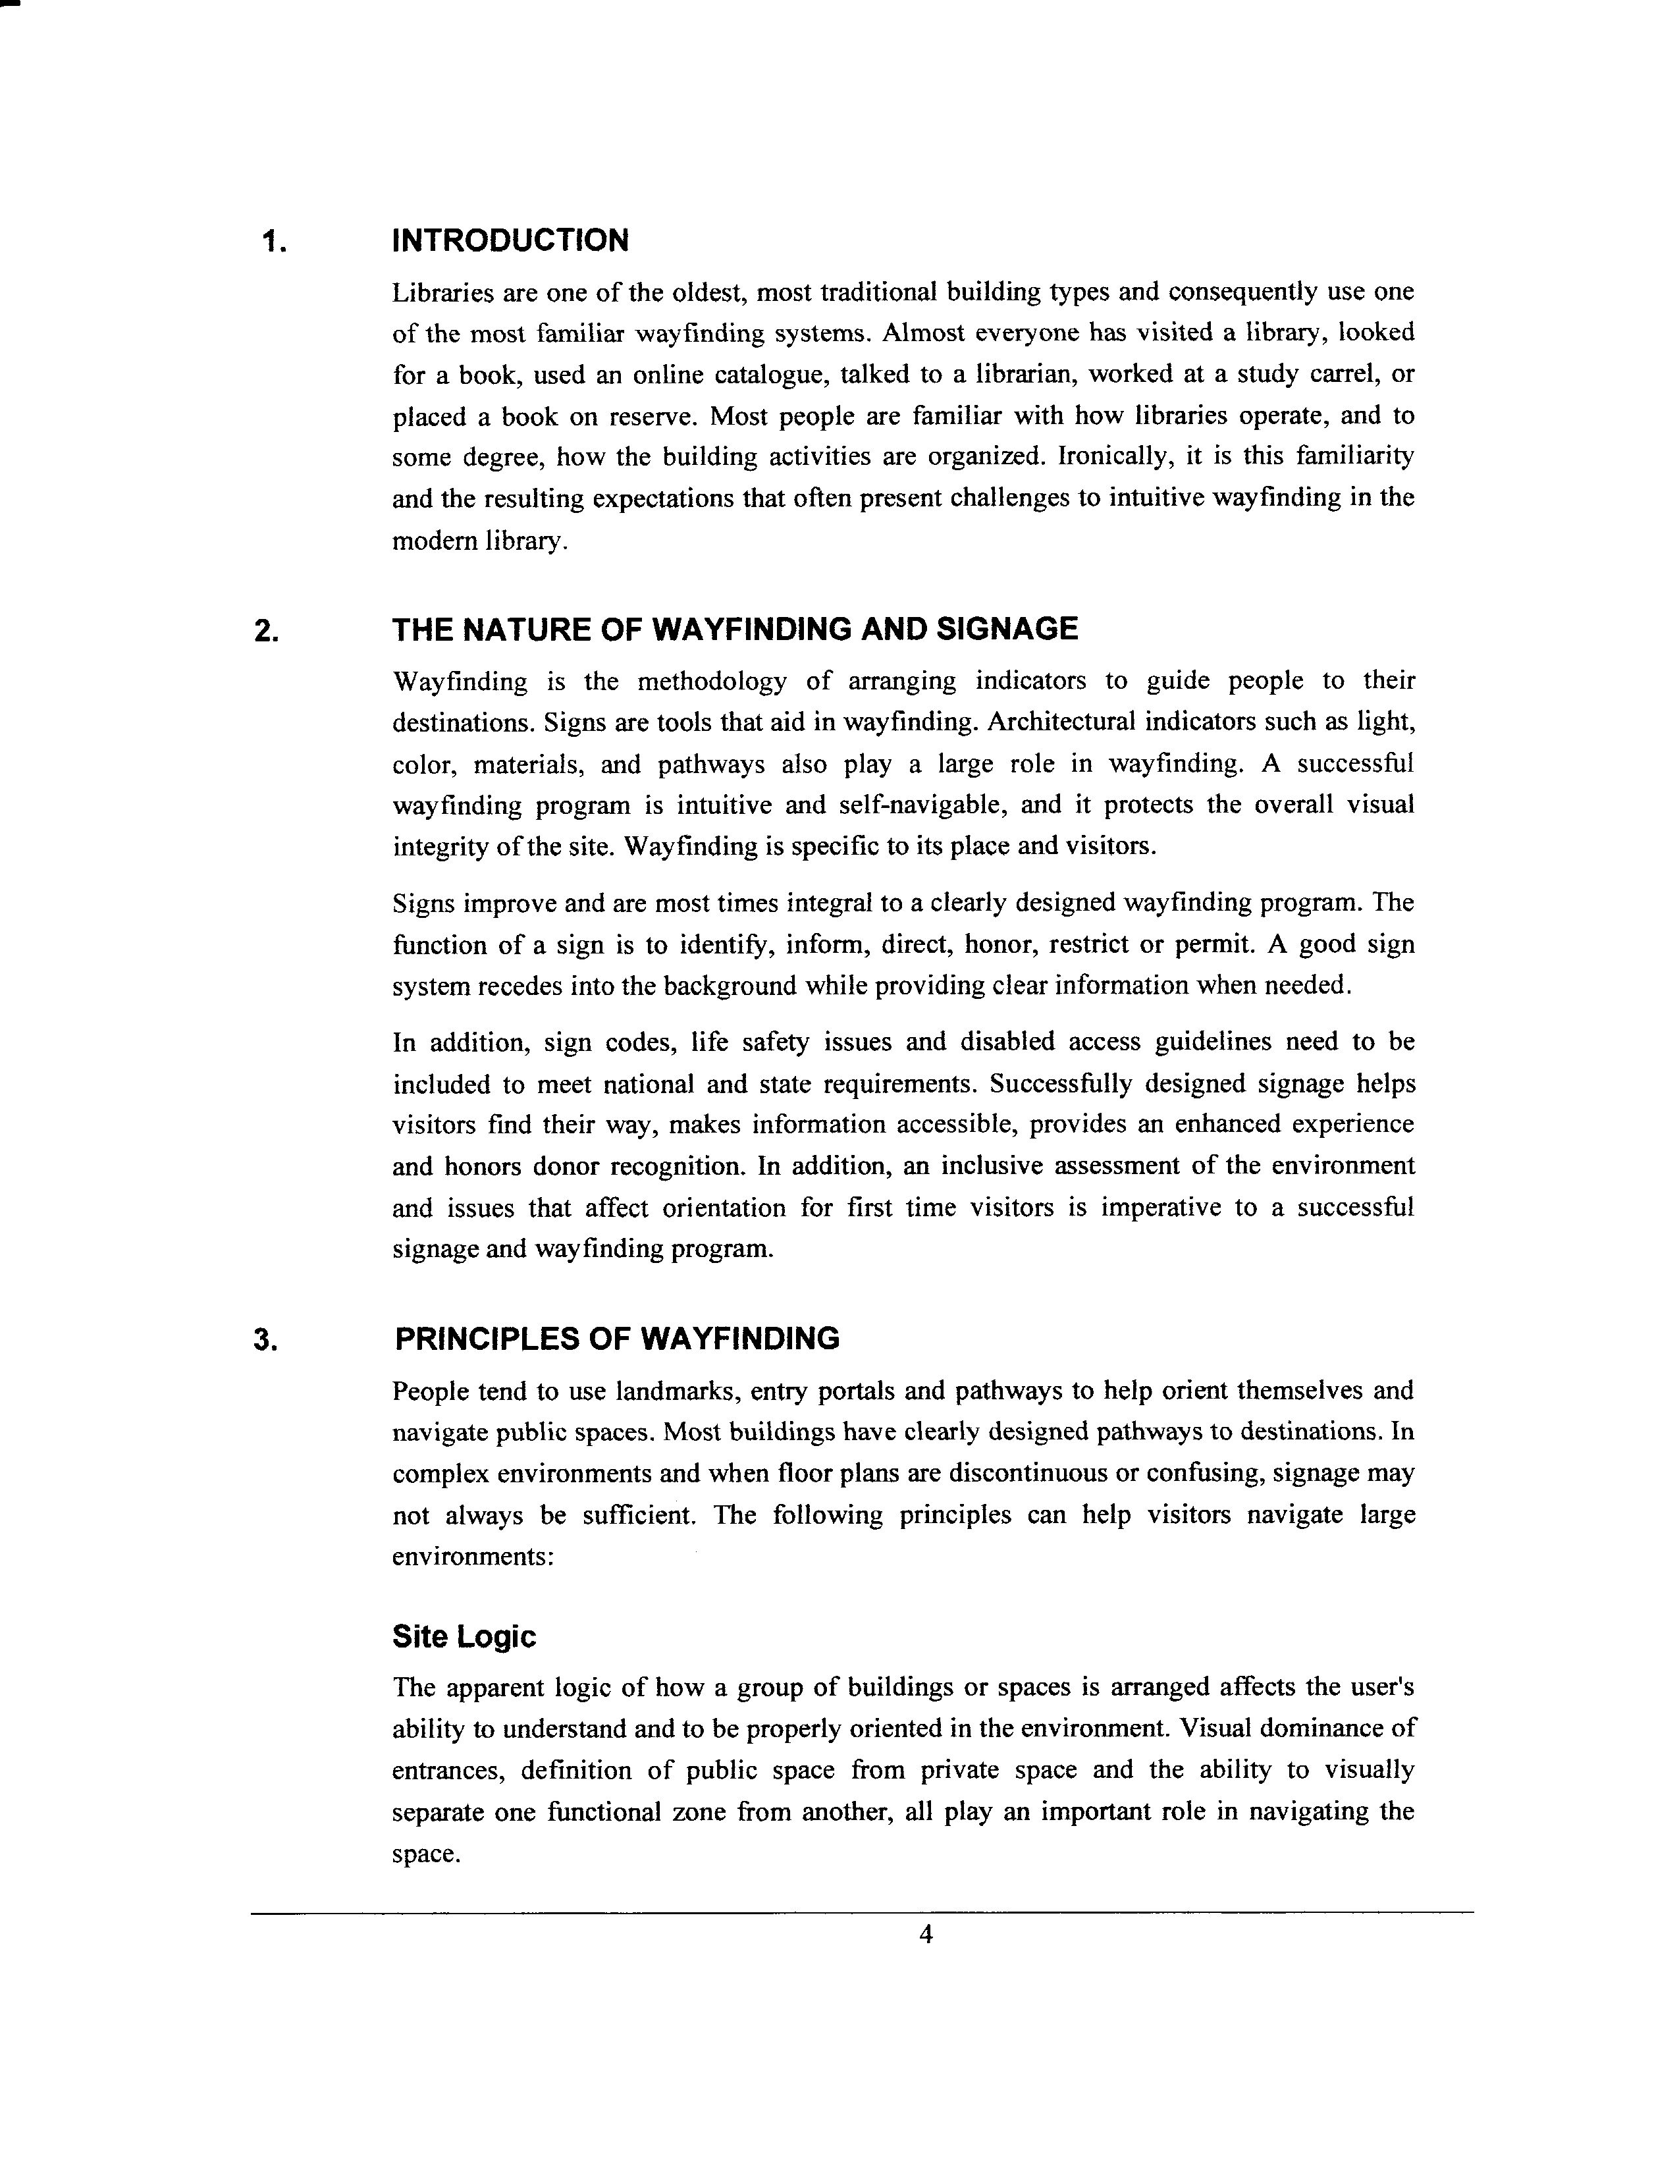
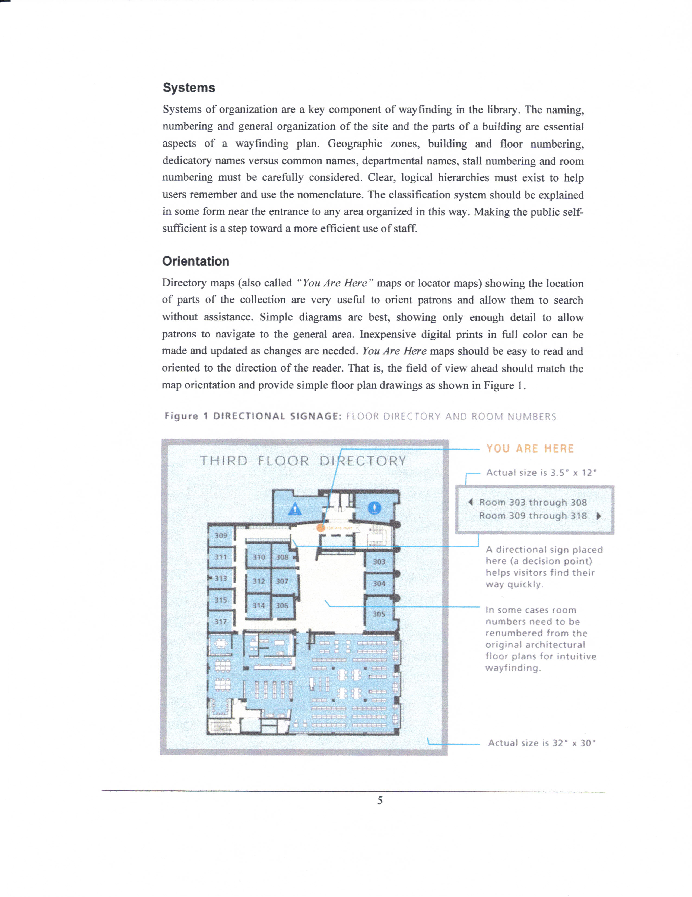

Displays and Bulletin Boards

First Impressions:

- Where are displays and bulletin boards located?
- Are library display materials continually restocked as things are borrowed or does the display look sparse and poorly attended to?
- Are there glassed-in and/or locked display units for special displays that might feature collections of one sort or another?
- Are items on the bulletin board current? Are flyers attractive and colorful? Is there a community bulletin board and if so, what are the criteria for inclusion?
- How often is the content of the bulletin board updated?

Libraries need a policy that specifies how the public may use display and bulletin board space. Two sample policies are included in the appendix. Let’s take some time to review them now. Note that in both samples the policies are regularly reviewed by the Director and the Board of Trustees and revised as needed.

Refer to Teaching Aid – Library Building #3: Sample Display Policies.

Walworth-Seely Public Library

Use of Display Space

- Display space in the Walworth-Seely Public Library will be provided as available for the interest, information, and enlightenment of the Walworth community. Individuals and community organizations will be encouraged to provide exhibit materials of a civic, cultural or educational nature, rather than for commercial or political purposes.

- Exhibit topics are at the discretion of the Library Director and each item must meet the library's standard of value and quality.

- The Library Director reserves the right to reject any part of an exhibit, or to change the manner of display.

- All items displayed in the library are done so at the owner's risk. The Board of Trustees and the employees of the Walworth-Seely Public Library assume no responsibility for the preservation, protection or possible damage or theft of any item exhibited. Transportation, mounting and dismounting of the exhibit is the sole responsibility of the owner. Items for the display will not be accepted without a waiver (see forms on next two pages) signed by the owner, absolving the Walworth-Seely Public Library and the Town of Walworth for loss or damage to the property on display.

- Effective August 2003, the Friends of the Walworth-Seely Public Library have assumed responsibility for securing items to be displayed in the children’s display case. However, responsibility for final approval and required paperwork remains with the Library Director.

Note: This Walworth-Seely Public Library policy conforms to “Exhibit Spaces and Bulletin Boards” policy of the American Library Association.

Board of Trustees, Walworth-Seely Public Library
Policy adopted: 1/12/93
Policy reviewed: 2/10/94, 3/8/95, 2/14/96, 4/10/97, 2/11/98, 2/11/99, 6/7/01, 03/24/05
Policy revised: 10/09/03, 03/24/05


Display Space/Exhibit Waiver Form (page 1 of 2) See Policy 6.17

Owner of item on display _________________________________________
Please Print
Address ______________________________________________________

Phone Cell Phone

Date received ____________E-Mail Address

Description of items received: (note number and kind)

Condition of items: (note any damage, etc.)

Name of person installing exhibit __________________________________

Dates of exhibit _________________________________________________

The above information is correct. I absolve the Board of Trustees, the employees of the Walworth-Seely Public Library and the Town of Walworth of the liability for loss or damage to the property on display.

Signature of owner ______________________________________________
Date _________________________________________________________

Signature of receipt by ___________________________________________
Staff Member Name Date
Continued on next page

Display Space/Exhibit Waiver Form continued (page 2 of 2)
(For Internal Library Use Only)

When exhibit is removed ___________________________________________

Number of items returned ___________________________________________

Condition of items returned __________________________________________

Note any discrepancies between number and condition of items loaned and returned:

The above information is correct.

Signature of owner ________________________________________________

Date ___________________________________________________________

Signature of person removing items __________________________________

Date ___________________________________________________________

Signature of acknowledgement by _________________________
Staff Member Name Date

Board of Trustees, Walworth-Seely Public Library
Policy adopted: 1/12/93
Policy reviewed: 2/10/94, 3/8/95, 2/11/98, 2/11/99, 2/11/00, 6/7/01, 10/09/03, 03/24/05
Policy revised: 03/24/05

Williamson Free Public Library

POSTING OF MATERIALS IN THE LIBRARY

Because the Williamson Free Public Library is a public institution, discretion must be exercised in the quantity and nature of posters and other promotional materials posted in the library.

In line with constitutional rights and privileges and the library Bill of Rights, the Board of Trustees of the Williamson Free Public Library does not discriminate toward any group or individual or the purpose they represent.

A bulletin board is located near the front entry in the library proper. Posting of materials will be limited to library items, materials of the Friends of the Williamson Free Public Library, and items of special community interest.

Policy Adopted: 2/18/87 Board of Trustees
Revised: 8/18/2005 Williamson Free Public Library

Williamson Free Public Library

DISTRIBUTION OF FREE PUBLIC SERVICE MATERIALS

The Board of Trustees recognizes that the public library has a role in the community to disseminate information which is community oriented and which residents of Williamson and/or library users will find useful. The Board recognizes that many civic, social, cultural, recreational, educational, and health-related agencies and organizations view the library as a place for publicizing activities and concerns.

In line with constitutional rights and privileges and the Library Bill of Rights, the Board does not discriminate toward any group or individual or purpose they represent.

Space is provided in the library for free distribution of brochures and flyers provided by agencies and organizations and which provide information of interest and/or use to the community and to library users.

Materials which are to be freely distributed must meet the following criteria:

1. Materials must be confined to the Information Rack or other display areas.
- Material of a commercial nature will not be accepted.
- Petitions will not be accepted because library employees can’t assume responsibility for verification of eligibility.
- Library employees will not be responsible for contacting agencies, organizations, or individuals with regard to the disposal or replacement of materials left in the library for free distribution.
- All materials must indicate on each copy the name of the agency or organization responsible for the flyer or brochure.
- Materials should in no way imply connection to the Williamson Free Public Library, unless an official connection does exist.
- All material is left with the understanding that library staff may discard the materials based on space considerations, current nature of the material, and apparent lack of interest in the material.
- The Library Director may decide on the quantity of materials to be left for free distribution.

Policy Adopted: 2/18/87 Board of Trustees
Williamson Free Public Library
Meeting Rooms

Most libraries have meeting rooms or space that can be used for library purposes, i.e., story hour, summer reading, film series, etc. Often those meeting rooms or spaces are also used by public organizations, clubs, or groups. Libraries often see themselves as community centers and encourage outside groups to use their facilities. The question is how to ensure that a meeting room is available for the library when it is needed and what kinds of limitations are necessary for outside organizations. The first step is to have a clear, up-to-date policy in place regarding the use of library meeting space. We’ll have a chance to look at a couple of sample policies in a moment. The second step is to devise a scheduling mechanism so that the space is not double-booked. This can be as simple as a notebook that lists the date(s) of use, the organization, a contact person, and a way to reach that person (phone or e-mail), number of people anticipated, and the library staff member who booked the room. As an alternative, a computer Word file could contain the same information.

The Connecticut State Library’s Library Space Planning Guide suggests that “the increasing use of meeting rooms for technological training requires interconnection of computer equipment and peripherals, plus two-way access to outside resources, such as Internet, local and wide-area networks and other online resources.” Meeting rooms should also be equipped with a sound system or induction loop for those who are hard of hearing. The Library Space Planning Guide indicates that the number and size of meeting rooms should be determined by the library’s roles as defined in its long-range plan, anticipated programming activities, and by the availability of similar rooms elsewhere in the community for use by other local groups.

Other factors to consider regarding meeting rooms include:
- Is there an outside entrance to the meeting room?
- Is there a kitchen in or close to the meeting room?
- Are there restrooms close to the meeting room?
- Can the meeting room, kitchen, and restrooms be used when the library is closed?
- Is there a storage area in or adjacent to the meeting room for craft supplies, equipment, and chair or table storage?

Let’s take a look at a couple of Meeting Room Policies now.

Refer to Teaching Aid – Library Building #4: Sample Meeting Room Policies.

Walworth-Seely Public Library

Library Meeting Space

The meeting space shall be available to programs and/or groups whose activities support the mission of the Walworth-Seely Public Library as determined by the Board of Trustees. Groups of three or more people must submit a written request prior to room use. First priority is given to library activities and library related use. When the meeting space is available, activities sponsored by the Friends of the Walworth-Seely Public Library are given first priority. Further use of the meeting room is determined on a first come, first serve basis.

Requirements of meeting space use:
- Meetings should cause no interruption or inconvenience to on-going library activities.
- Meeting space is available only during regular library hours.
- The Board of Trustees reserves the right to limit organizations which hold periodic meetings in an effort to encourage the broadest use possible.
- No fee or required donation may be charged. The sponsor of a group or meeting may request a fee from participants only to the extent that such a fee covers the cost of materials furnished to the participants. Such charges should not be construed as an admission fee.
- Application for the use of the meeting space should be made at least 1 week in advance, in writing (see form on next page). It should be made by a person over 18 who will be responsible for the meeting adherence to the rules and regulations.
- The library must be notified promptly of any cancellations. Failure to do so may be grounds for declining future meeting space use.
- For group with members under age 18, a responsible adult must fill out the application. Adequate adult supervision must be provided by the group.
- The meeting space is not available for non-library social functions, including but not limited to showers, parties, etc.
- There will be no unauthorized access to the library network.
- Smoking and alcoholic beverages are prohibited.
- Non-alcoholic drinks and/or light snacks may be provided and served in the meeting space by the group. The library is not responsible for providing refreshments.
- Meeting space should be left in an acceptable, uncluttered condition. Tables and chairs should be returned to their original positions. Any equipment should be returned to its proper placement.
- Groups are responsible for any damage and cleanup to the meeting space or its contents during their use of the room.
- The use of the meeting space does not constitute an endorsement of an organization’s policies or beliefs. Except as a designation of location, the name of the Walworth-Seely Public Library may not be used in any publicity related to the use of the meeting space.
- The organization assumes the responsibility for accommodations and specific articles of compliance as required by the Americans with Disabilities Act.
- The Board of Trustees reserves the right to cancel or suspend any permission granted to a group or organization that violates the rules and regulations of the meeting space or library.

Note: This Walworth-Seely Public Library policy conforms to “Meeting Rooms” policy of the American Library Association.

Board of Trustees, Walworth-Seely Public Library
Policy adopted: 10/09/03
Policy reviewed: 03/24/05
Policy revised: 03/24/05

Use of Meeting Space Agreement Form

See Policy 6.20

Name of Group____________________________________________________

Contact __________________________________________________________
Please print Phone number

Address

Cell Phone E-Mail

Date(s) of use_____________________________________________________
month day year

Purpose of the meeting _____________________________________________

________________________________________________________________

I have read the Use of Meeting Space Policy and agree to abide by all aspects of
this policy. I understand that any misuse may result in our not being able to
use the room again.

________________________________________________________________

Signature Date signed

Board of Trustees, Walworth-Seely Public Library
Policy adopted: 10/09/03
Policy reviewed: 03/24/05
Policy revised: 03/24/05
WILLIAMSON FREE PUBLIC LIBRARY

PROGRAM / MEETING ROOM USE AND AGREEMENT
The Williamson Free Public Library makes available to the public its program/meeting room as an additional service rendered by the library under conditions set forth below by the Library’s Board of Trustees.

TERMS OF USE
The room may be used by groups, committees, boards, etc., nonprofit in nature, at the discretion of the Library Board. It may be used ONLY DURING LIBRARY HOURS unless it is for a library function, or there is a library staff member who is present and responsible for supervision. It has capacity for 75-100 persons (seated). Refreshments may be served. The kitchen equipment may be used, but kitchen supplies are intended for use by library personnel only. Each group must furnish its own supplies and refreshments.

First priority is given to library activities or library-related use. Other groups may use the room on a first-come, first-serve basis. The board reserves the right to limit periodic meetings in an effort to encourage the broadest use possible by many agencies and organizations. The room is available as arranged with the Library Director or a staff member. A certificate of insurance naming the library as an additional insured is required if a group is so covered and must be on file in the meeting room reservation folder. The library will not charge a fee for the use of its meeting room.

Meetings will be free and open to the public. Reservations for use of the room must be made by calling the library. The library must have the name of the organization and the name of the person in charge and the phone number where s/he may be reached. The library should be notified promptly of any cancellations. Children’s groups may use the meeting room provided they are supervised by an adult. Groups must comply with ADA (Americans with Disabilities Act) and are responsible for providing qualified interpreters or auxiliary aids.

The room must be left in proper order when meetings are over and groups are held responsible for any damage to the room and contents while they are meeting. The Library Director is authorized to deny permission to use the library room to any group that is disorderly or that violates these regulations. No smoking and/or alcoholic beverages are permitted.

Policy adopted: 10/14/80
Revised: 11/23/92; 11/01/96; 11/15/01
WILLIAMSON FREE PUBLIC LIBRARY

MEETING ROOM AGREEMENT

We agree to leave the room in proper order when the meeting closes and to be responsible for any damage to the building and contents. The room is to be clean of all litter. All display material must be removed. The kitchen, if used, is to be clean. Chairs and tables are to be replaced as found. No smoking and nonalcoholic beverages are permitted. The library staff member on duty is to be notified when the meeting closes.

NAME OF ORGANIZATION/GROUP _________________________________

___________________________________________________________________

SIGNATURE________________________________________________________

DATE ________________________________

WILLIAMSON FREE PUBLIC LIBRARY

PROGRAM/MEETING ROOM BOOKING SLIP

Name of
Organization________________________________

Person in
Charge____________________________________

Telephone
Number_____________________________Daytime

___________________________________Evenings

How booked:
In person___________
By telephone________

Date ______________________________________

By________________________________________

The Collection

We’re still talking image here. Sagging shelves filled with too many books are simply unattractive. Weed your collection. Place books face out – they’ll fly off the shelves. Use book supports so that books stand straight up and don’t lean. Get rid of anything that is torn, dirty, or in disrepair. It’s probably not circulating anyway and speaks volumes about the library’s attitude and appearance. Make sure that mysteries or westerns or romances are under the signs that say “Mystery” or “Westerns” or “Romance.” Find creative ways to add some fun, color, and interest into the collection area. Slatwall display units could be attached to the endcaps to provide extra display area for materials you’d like to see in circulation. Inexpensive posters can be purchased from vendors specializing in library publicity. Cool teen furniture found on clearance or neon fixtures might be all that’s needed to spice up an area.

First Impressions:

- Does the shelving look well-maintained?
- Are there display units for audio, video, DVD, software, and other materials that can be easily browsed and accessed?
- Is there room at the end of each shelf or are books jammed into the entire space or laying on the tops of other books?
- Are the materials attractive and in good repair or are they dirty, torn, or yellowed?
- Is the height of the shelving appropriate? Shelving in the children’s area, for instance, should be specifically designed for young readers – browsing bins for picture books or baskets for board books. Comfy beanbag chairs to lounge on. A rocking chair for a parent with their infant or toddler.

Sight lines are an important consideration when locating your shelving for a number of reasons. Safety and the ability to adequately supervise all areas of the library are of utmost importance. How tall are the shelving units? Can you clearly see library users who are browsing in the stacks? Are mirrors or other supplementary viewing devices installed in hard-to-see areas? Is there enough staff on duty at all times to provide necessary supervision?

Returning to Libris Design, let’s take a look at the kind of detailed information you can find on this website. We’ll review a few pages of the 29 page “Library Collection Storage” document available at: http://www.librisdesign.org/docs/LibraryCollectionStorage.pdf

Refer to Teaching Aid – Library Building #5: Library Collection Storage.

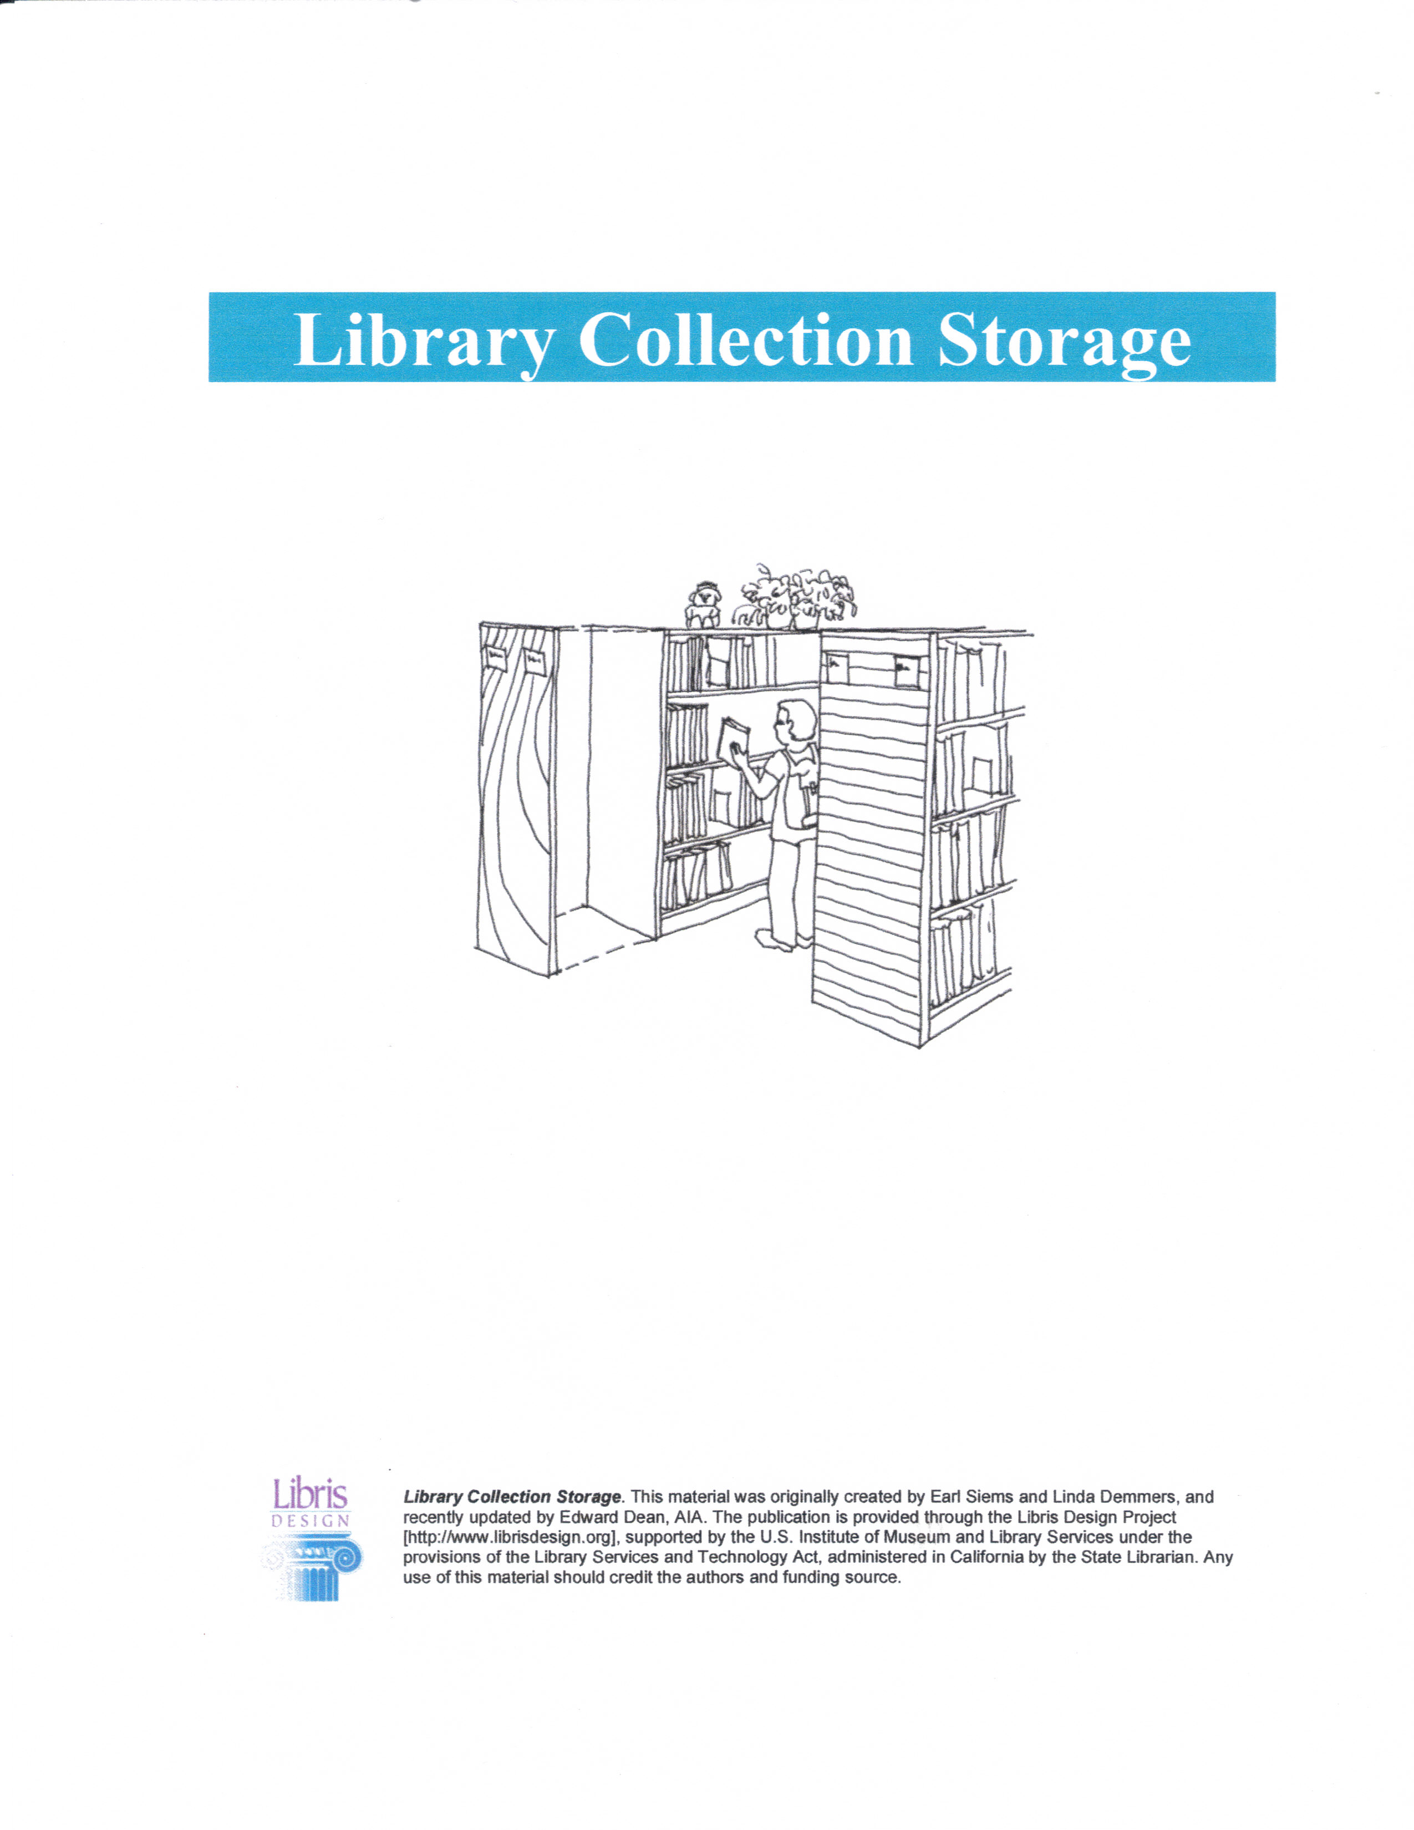
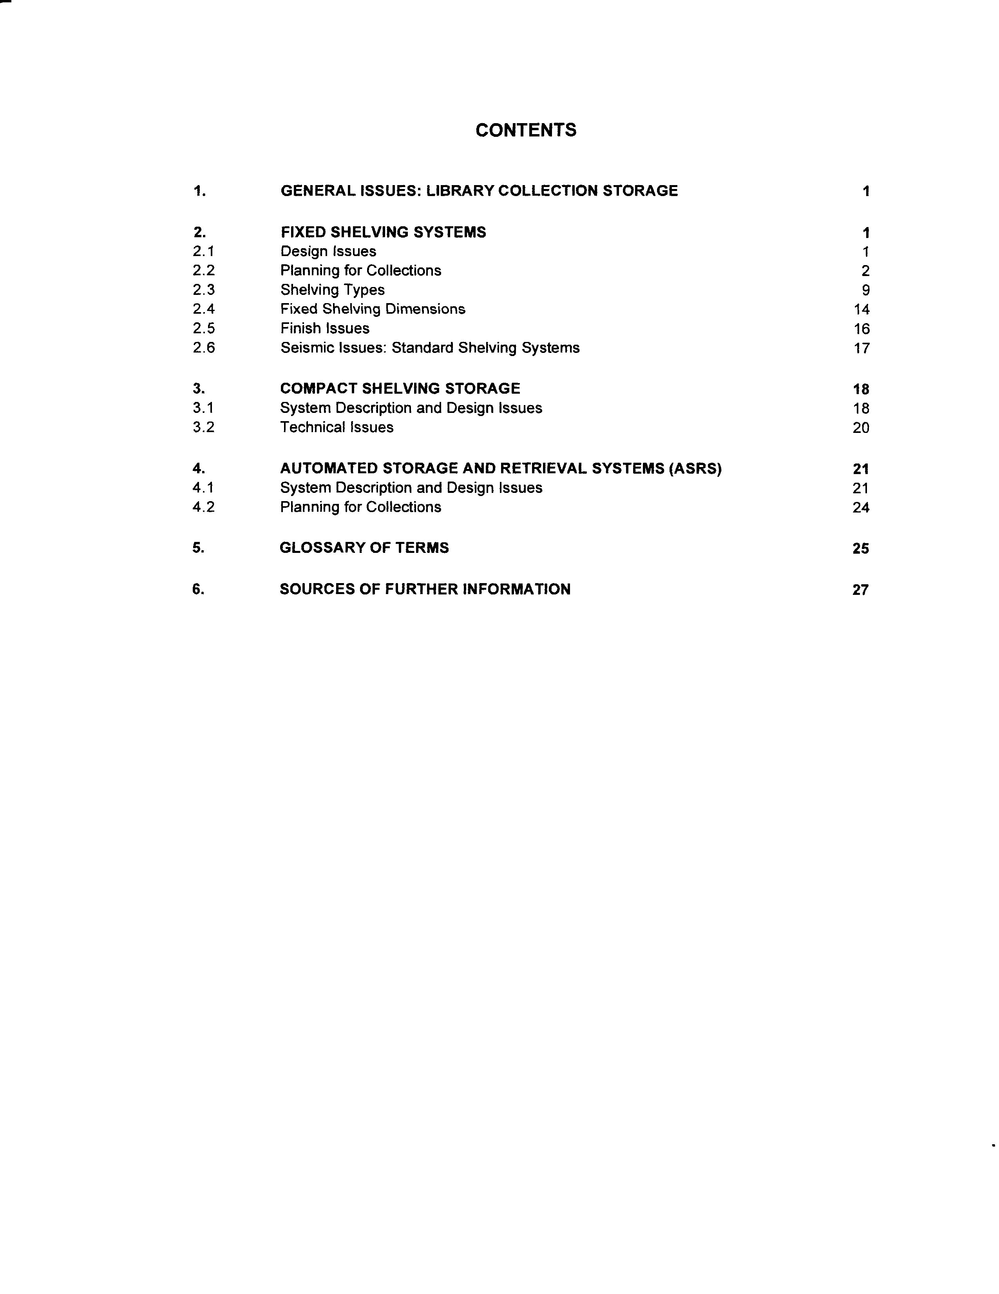

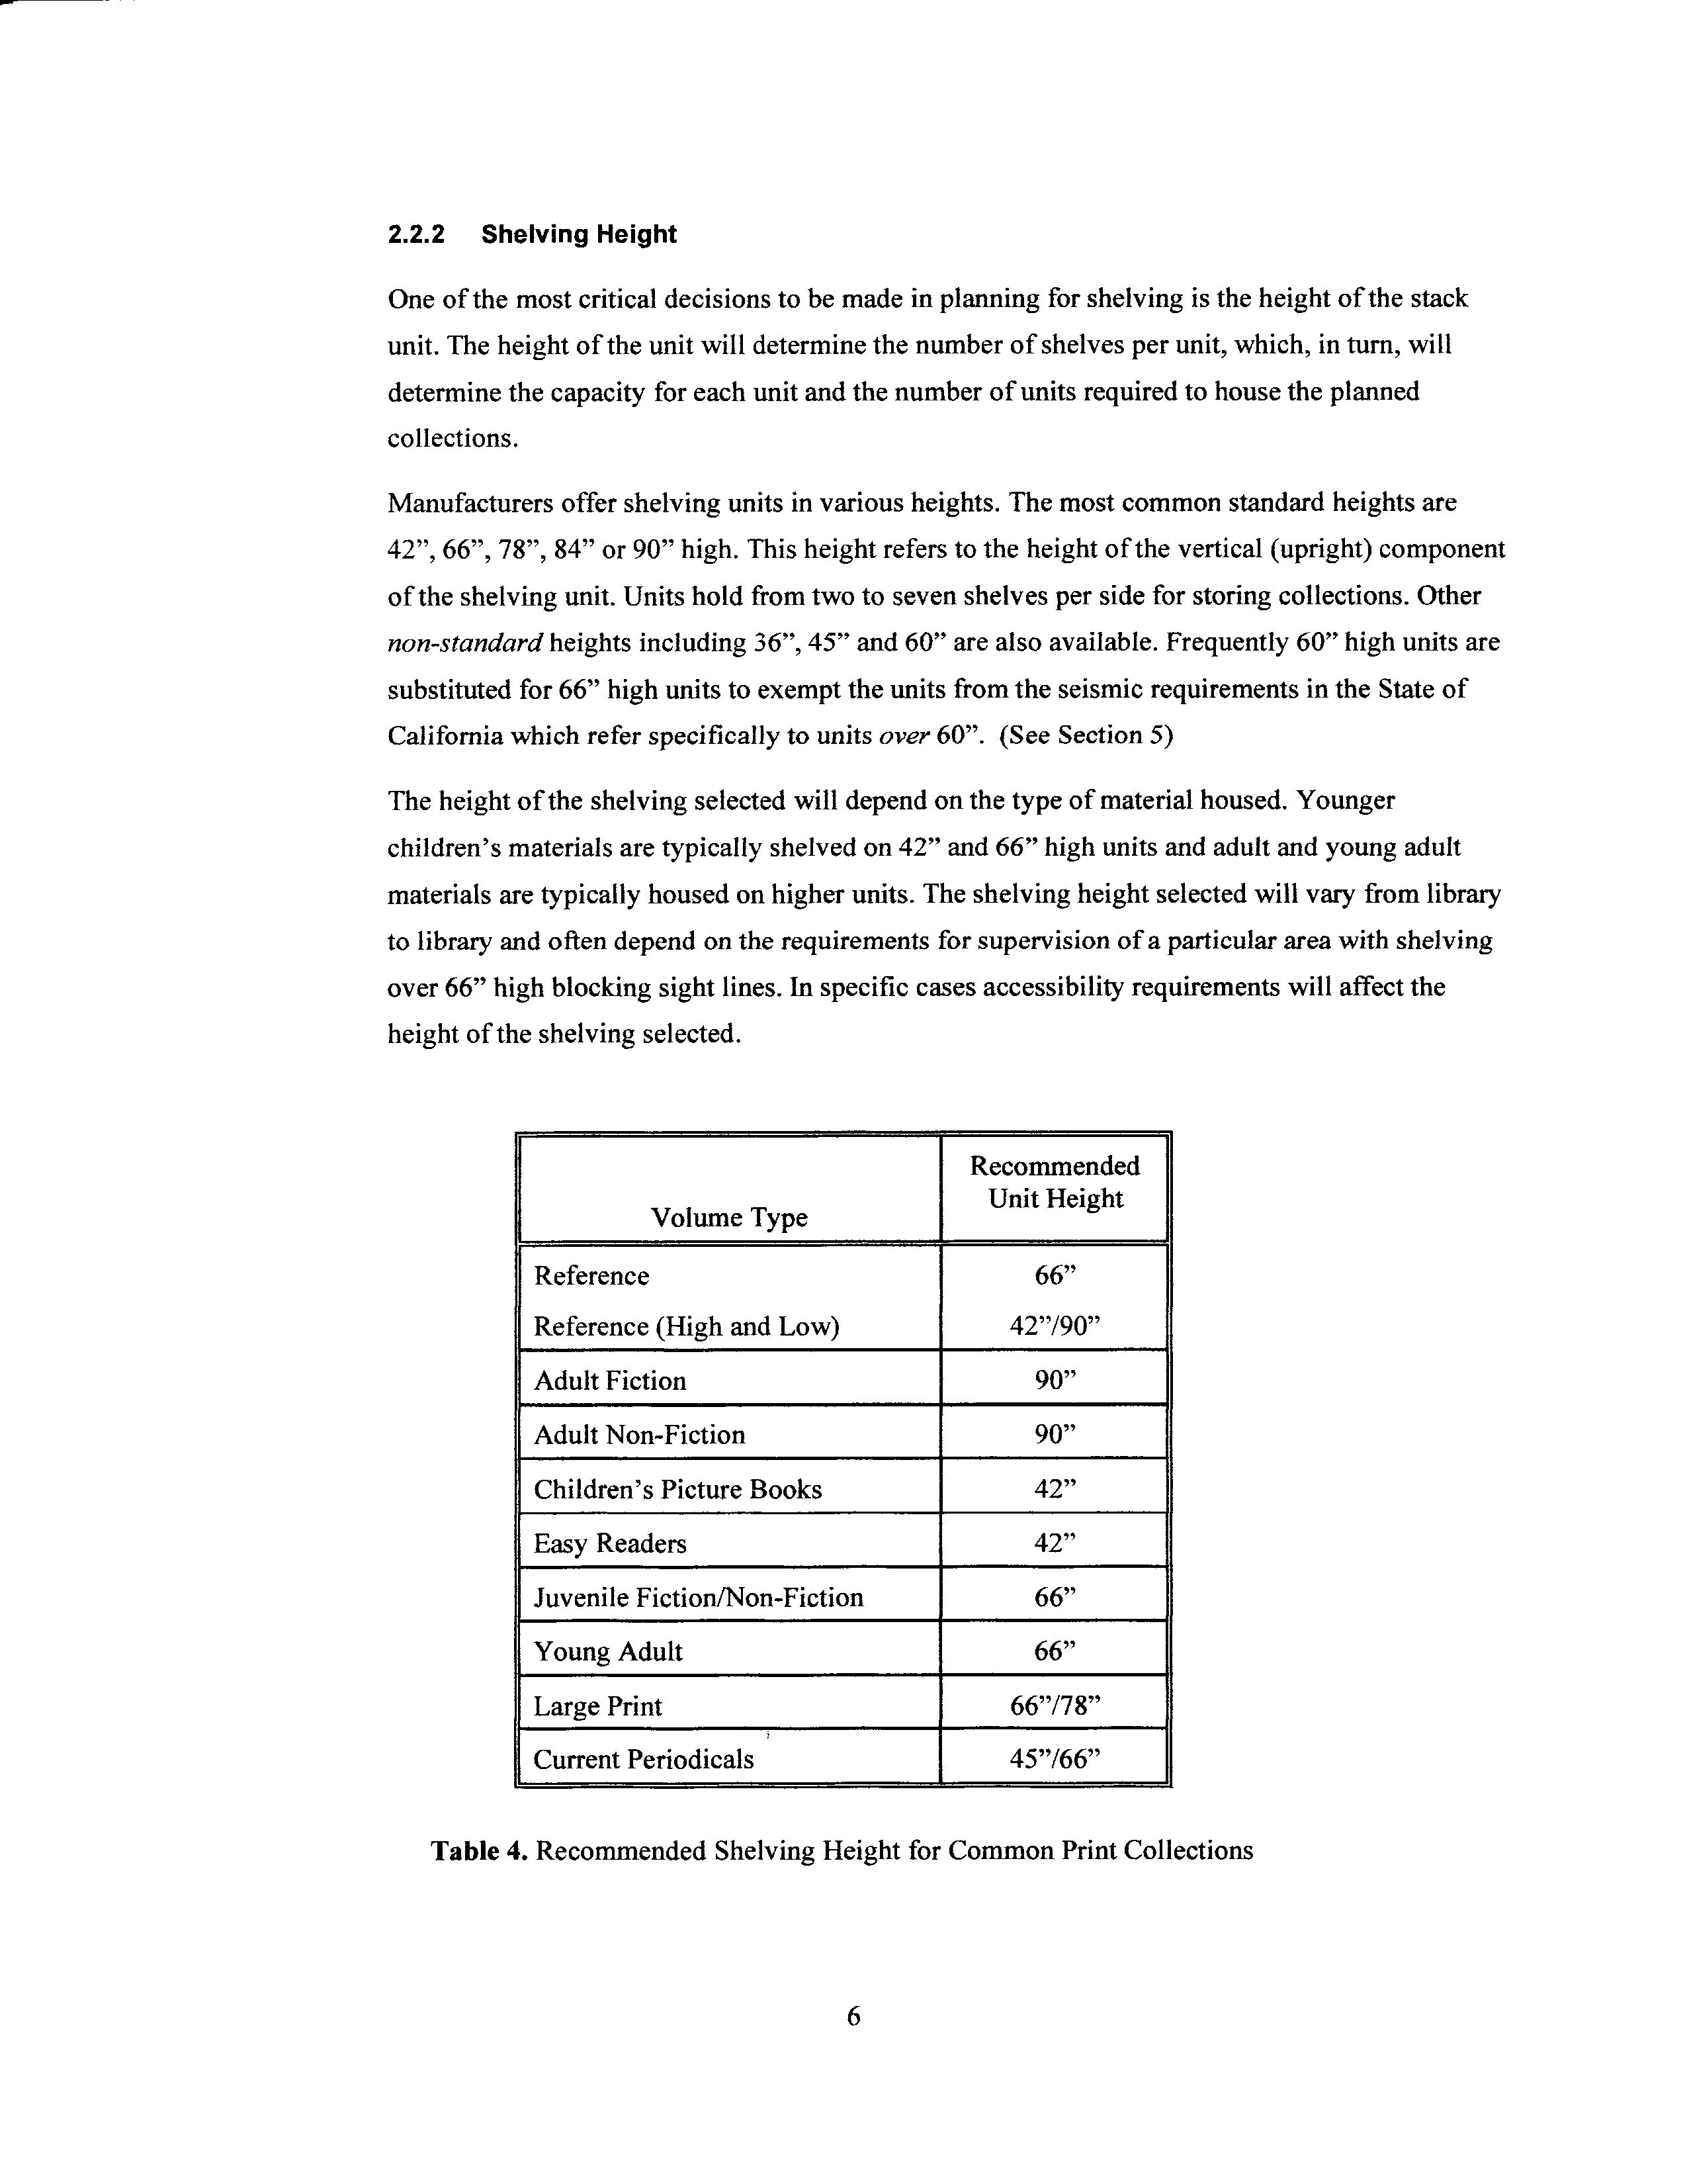
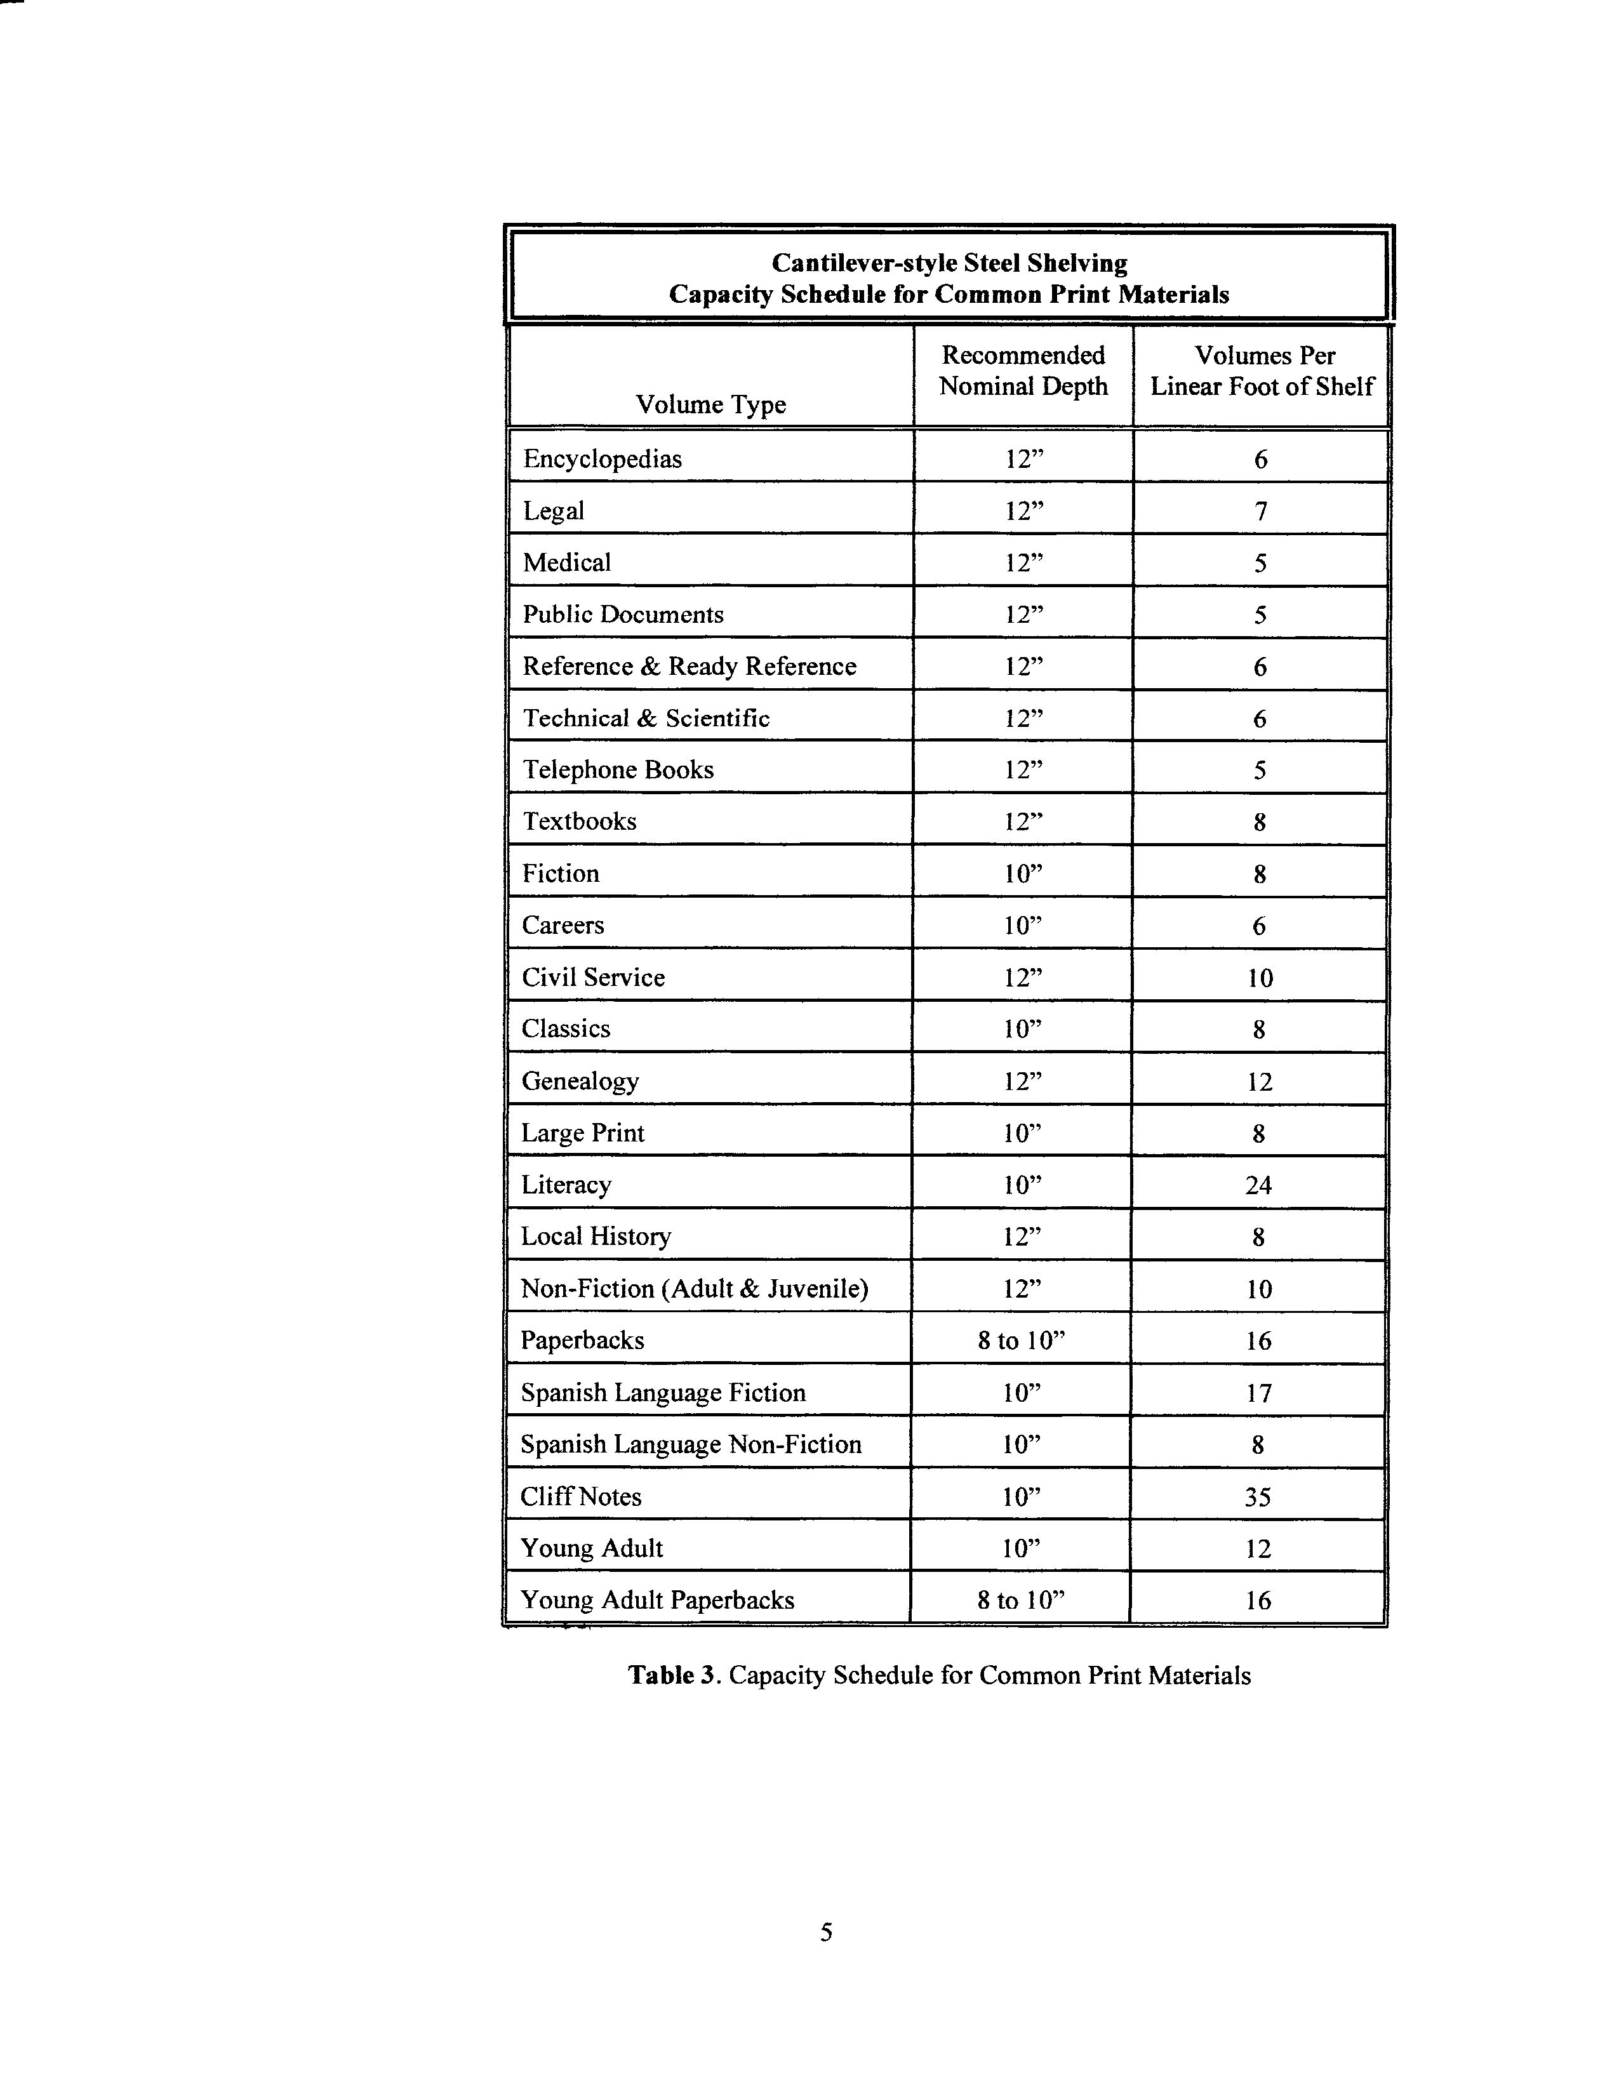

Seating Space

As we continue our imaginary tour through the library, what kind of seating areas do you find? Every library needs appropriate seating space; some for relaxation and leisure reading, some for quiet study or research; and some for computer use. The Connecticut State Library’s Library Space Planning Guide recommends that libraries provide 5 user seats for every 1,000 people in the service area. Libraries serving less than 10,000 residents should provide 7 to 10 seats for every 1,000 residents.

Purchase comfortable, ergonomically designed chairs if possible, particularly in the areas where library users may spend more time. Buy sturdy, easily cleaned furniture, the best quality that your library can afford, since the use of those chairs, tables, or carrels is often considerable. No matter how terrific your collection and service are, if you don’t have a library that is welcoming and inviting, your library users will probably not want to stay.

Lighting

Have you ever been in a library that seemed dark and gloomy? Was it because of the color of the walls? The type of lighting that was used? Too few windows, most of which are dirty? Lighting can affect both staff and users and create an airy, open atmosphere. Here are some suggestions to improve the ambiance in your library:
- Paint the walls and ceilings white or some other light color. Save the deeper shades for accent walls or trim.
- Wash the windows. We’re back to cleanliness here, but the importance of a clean building can’t be stated too often.
- Locate lighting fixtures to minimize ceiling brightness and reflection.
- Use lighting for specific purposes; low intensity light in non-reading areas such as traffic areas; task lighting for concentrated work; warm white fluorescent lamps in stack areas.
- Think about maintenance. Are the light bulbs energy efficient? Can they be easily replaced? Can the fixtures be cleaned with little difficulty? What is the cost and the life of light bulbs?
- Hire a lighting consultant to make recommendations for improvements if you decide to change the lighting system.

There are numerous factors to consider when it comes to lighting – too many to go into an in-depth discussion in this presentation. To give you an idea of the variety of areas to consider we’ll return to Libris Design’s “Lighting for Libraries” at http://www.librisdesign.org/docs/LightingLibraries.pdf and review the table of contents. Refer to Teaching Aid – Library Building #6: Lighting for Libraries.
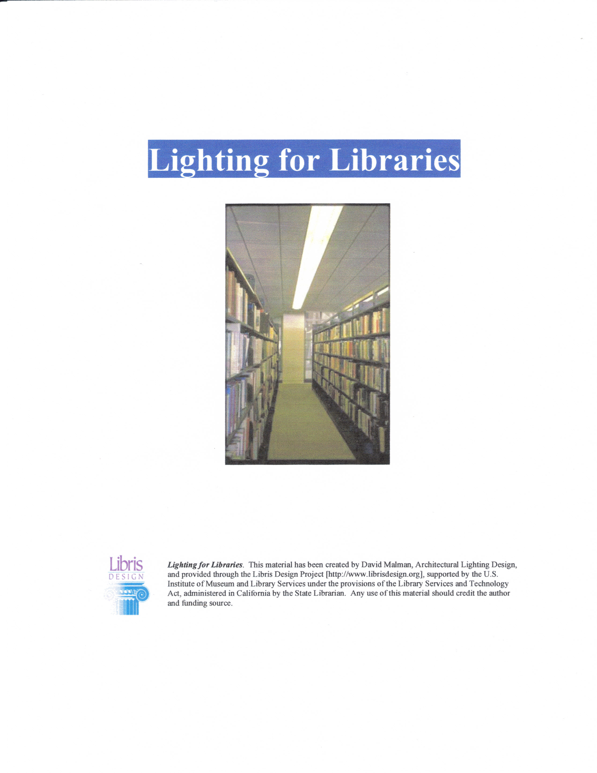

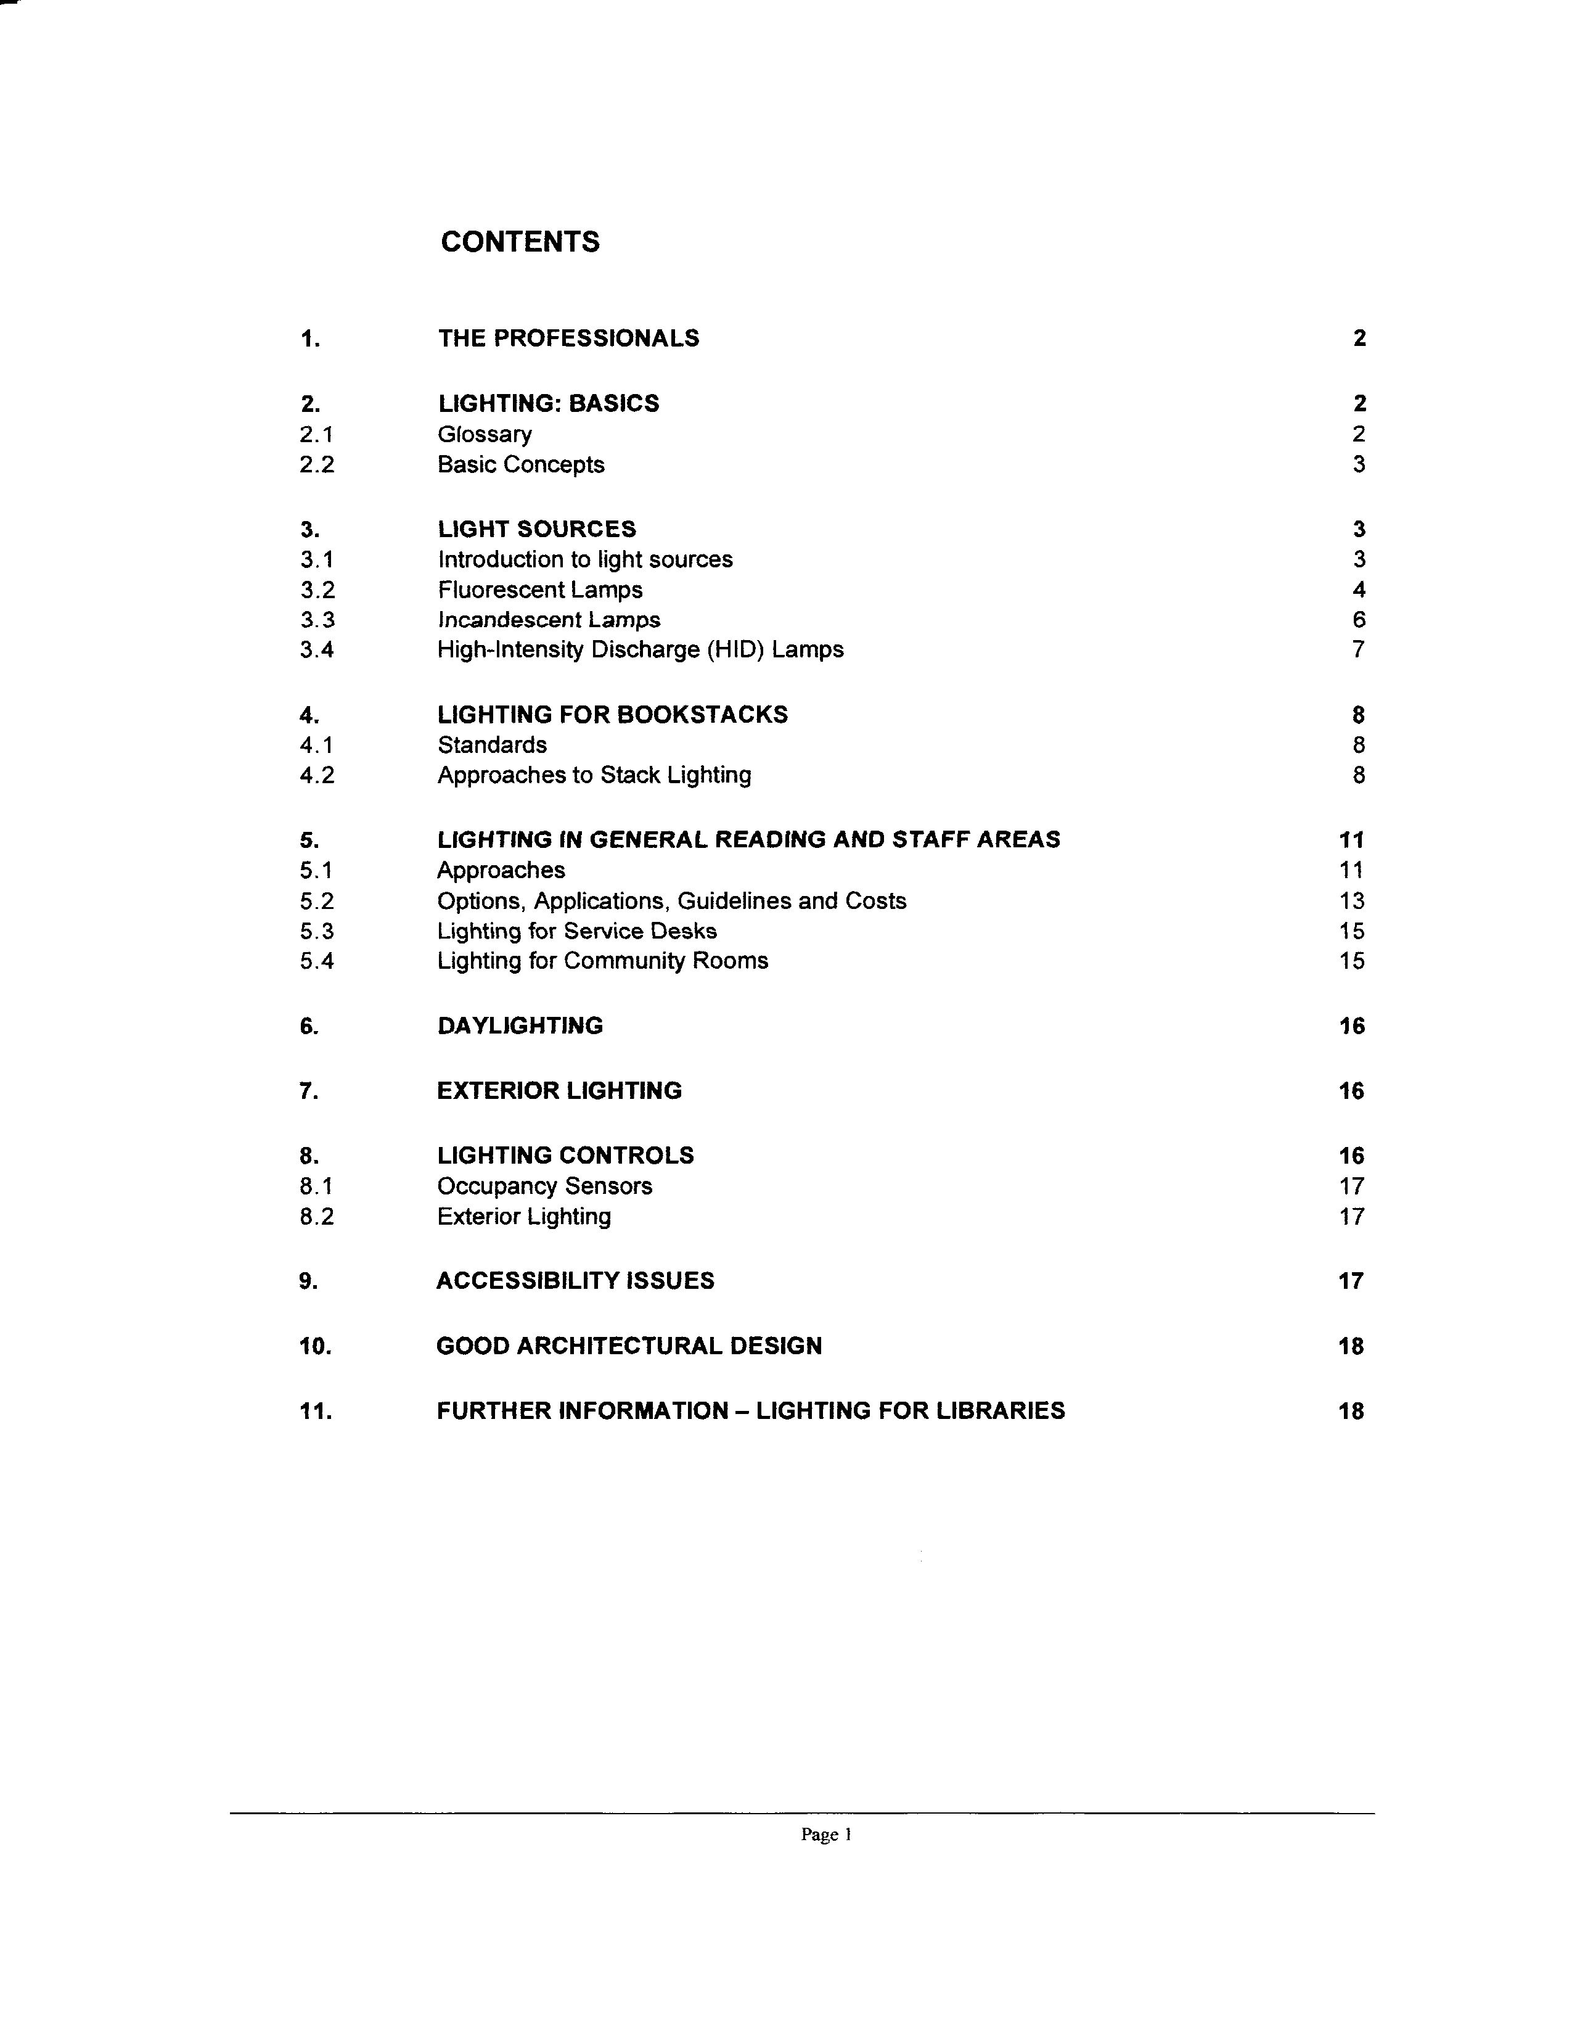

Public Access Computers

Technology is continually changing and because of this fact, planning space for public electronic workstation space is difficult. Another section of the curriculum goes into specific detail about the space and wiring requirements for computers. What follows is a general list of questions or other things to be aware of regarding Public Access Computers (PACs).

- Public Access Computer Workstations can be physically placed anywhere in the library with adequate wiring and usually consist of a CPU, monitor, keyboard, mouse, and access to a printer. OPAC-only workstations are dedicated to searching the library’s online public access catalog. PAC workstations can be used to search the OPAC, but may also provide access to in-house and remote electronic and Internet resources and applications software.
- The computer use policy should be available to users. Sometimes it is displayed at or near public computers. Sometimes the entire policy is not posted, but is made available at the desk. Some libraries require signing an acceptable use policy
- Does the library charge for printing and if so, how much per copy? Is this information clearly displayed?
- Is library staff trained to help library users with their computer-related questions? Are staff members familiar with the computer use policy and aware of how much assistance to provide library users? What competencies are expected of library staff?
- A secure wiring closet that houses network infrastructure devices is a necessity. Here are two real-life examples of what not to do. A newly constructed library housed its computer wiring closet in the utility room next to the water heater and the furnace, clearly not an ideal location. The second example involved a library that decided to locate its wiring closet in the public restroom. Imagine how easy it would be for someone to destroy the library’s entire network by pulling a few wires. In this case, the library scrapped those plans and moved the wiring closet to a more secure area.
- Is wireless access available? Can you use your own laptop computer in the library?
- The building should have enough circuits and electrical outlets and network drops for present and future needs. Surge protection, antivirus software, and firewall security is essential.

Let’s look briefly at a sample technology policy to see the kinds of information that one library included in its plan. Note that the policy was last revised in late December 2003 and is due for revision again. Refer to Teaching Aid – Library Building #7: Sample Technology Plan.

Walworth-Seely Public Library

Technology Plan

- Technology, in the broadest sense, is fundamental to the delivery of contemporary library service. In order to provide access to electronic resources in the most convenient and efficient way, network infrastructure, computers and other peripherals are necessary. These need to be in good working order and powerful enough to provide patrons and staff the tools to work effectively. By having our infrastructure in up-to-date, good working order, we will be meeting our vision, mission and service responses.

- The staff will have the necessary applications to do their work:
- Internet-based state-of-the-art integrated library system software, currently OWWL system with Workflows staff and iBistro clients.
- User friendly browser, currently Internet Explorer
- Up to date operating system, currently Win 93se and XP
- General office applications: Office Pro, primarily Word and Excel, Publisher
- As computers are updated, the operating systems and applications will be updated accordingly.

- Patrons will have applications that allow them to access and use all resources of the library.
- Web based OPAC, currently iBistro
- User friendly browser, currently Internet Explorer
- Up to date operating system, currently Win 98se and XP
- CD-rom resources, e.g. Encarta
- Word processing program, currently Word in Office Pro
- Others as demand occurs

- The library is connected to the Internet via a cable modem with a managed VPN (Virtual Private Network) environment that is supported by Pioneer Library System as a part of our membership in OWWL.
- Cable modem with 2 Mb downstream/256Kb upstream bandwidth
- Firewall
- Internal wiring is Category 5 or better with 24 port.
- Time Warner is the vendor for the managed VPN and RoadRunner cable modem Internet.

5. Peripherals
- Server: holds Follet system for reference to previous patron and item databases, networks printers to circulation desk
- Printers: color printers available for all computers except OPAC’s (on-line public access computers) and workroom
- Black only laser printer is attached to the workroom printer
- Receipt printers are attached to circulation machines to allow for printed receipts of materials borrowed and fees paid
- Barcode scanners are attached to circulation, workroom and director’s machines for ease in circulation and processing materials

6. Current hardware by function, software loaded, age
1. Circulation: flat screens, XP, Workflows, circulation 1 has Excel purchased from Gateway in 2003, receipt printers purchased through Pioneer in 2002, networked to the workroom’s, director’s and Internet printers
- 2. 2 OPACS: Win 98se, Ibistro, purchased thru QwikNet, 1999
- 3. 1 word processor: Win 95, Office Pro, Publisher, pre 1998 purchase
- 4. Internet 1,3, 4: Win 98se, IE, Adobe, 1999 purchase
- 5. Internet 2: flat screen, XP, IE, Office XP, early 2003 purchase
- 6. Multimedia: Win 98se, IE, reference CD-roms
7. Workroom: flat screen, XP, networked to server, Workflows, Office Pro, Follett, QuickBooks, 2003 purchase
8. Director: new cpu 2002 purchase, Win 98 se, networked to server, Workflows, Office Pro, Publisher

7. Security
- 1. Norton anti-virus loaded on server
- 2. Updated on each machine daily
3. Centurian Guard and Deep Freeze are used to protect the hard drives

8. Staff Competencies
1. Computer Operating System
- 1. Open and save files
- 2. Print documents
- 3. Start and shut down machine
- 4. Peripherals/hardware
- 5. Use printers, troubleshooting
- 6. Mouse
- 7. Scanners
2. Software
- Workflows
- iBistro
- Word processing
- Ability to change settings from printed instructions or via phone
- Move, resize windows
- Scroll through document
- Open file, close, save
3. Information Retrieval Skills
1. Boolean Searching
2. Key word vs. Subject
3. Use of subscription databases available
4. Internet
1. Use of browsers: IE, Netscape
2. Search engines
3. Databases
4. E-mail: familiarity with web-based clients, open, close, send, open attachments
5. Familiarity with domains (.org, .com, .edu, etc.)
6. Able to evaluate sites

9. Future needs
- Upgrade and replacement path: The Walworth-Seely Public Library is committed to keeping its computers capable of running the latest versions of software necessary to support technology-based library services.
- This includes but is not limited to latest version of web browsers and common plug-ins, and the OWWL Workflows client.
- When necessary and cost-effective, machines will be upgraded as software demands. An underlying operating principle is to plan to replace computers on a 3-year cycle, except where upgrades will achieve the same result. The library will work with Pioneer Library Systems to determine future requirements of all programs provided and supported by Pioneer.

Walworth-Seely Public Library, Board of Trustees
Policy adopted: 10/08/97
Policy reviewed: 06/11/98
Policy revised: 12/18/03
Children’s Area

Next we’ll visit the Children’s area. Even the smallest public library sets aside space for children. Sometimes it’s as small as a corner in a one-room library; sometimes it takes up 30 to 40% of a facility. A library’s long-range plan identifies the role children’s services play in meeting community needs. And an attractive children’s area attracts new library users and provides the atmosphere that helps create lifelong learners and library supporters.

What makes a children’s area inviting?

- Staff who understand, respect, and love children.
- Exciting materials in a variety of formats.
- A bright, colorful color scheme.
- Child-size tables and chairs.
- Comfy cushions or beanbags.
- Attractive displays.

What other ideas do you have?

Refer to Teaching Aid – Library Building #8: Physical Facilities and Recommendations on Furniture and Equipment for Children.

In 1994, the New York Library Association published The Key to the Future: Revised Minimum Standards for Youth Services in Public Libraries in New York State written by a committee of children’s specialists. Many of the standards included in the 1994 title are still relevant today.

Physical Facilities
Standard # 32: The children’s area should have specialized furniture and equipment suitable for use by children.

► While libraries are aware of their responsibilities to those with physical disabilities under the Americans with Disabilities Act, they must also be aware of the special physical needs of all children using their facilities.

► Libraries offering services for babies and toddlers should provide changing tables in restrooms. All librarians should provide child-size furniture, shelving and bathroom fixtures in the children’s area. A child-safe environment will include proper electrical fittings, furniture which has softened or rounded surfaces, and doors which can be opened by the youngest independent users.

► All libraries should provide separate shelving and seating areas for children. Where finances and space permit, specialized equipment should be provided, e.g., carpeting or cushions for seating, separate age-appropriate areas for preschoolers and parents, and quiet study spaces for older students.

► A separate room for children’s programs and meetings should be provided if possible. In facilities which share meeting space, special provision for children’s programs should be made, such as smaller chairs or cushions for seating.

► The library staff should be able to easily monitor the safety of children from their workstations. Clear sight-lines or supplementary viewing devices for hidden areas are essential. This is important for defusing disciplinary problems where children congregate or where strangers to the children’s room may cause a problem.

► Signage should clearly direct library users to the children’s area. It should be both written and symbolic so that non-readers can easily discern its meaning.

► With the increasing traffic of very young children in the library, other architectural safety design issues must be kept in mind. Potential safety hazards include steep stairs, high or narrow banisters, low railings, high drinking fountains, equipment such as security gates, table corners, etc., at child’s neck or eye levels, slippery floors, and more. Children’s librarians should be consulted at every stage of design or redesign for the children’s area to insure a child-safe environment.

Recommendations on Furniture and Equipment for Children

- Library and school supply and furniture catalogs routinely offer tables in heights ranging from 25” up, with matching chairs. At least some of the tables in the children’s areas should be in this short range, with some regular “adult-sized” tables for older children.
- Shelving and display furniture come in a variety of sizes and configurations.
- The children’s room design should make allowance for the large formats used in picture book collections. Shelving for picture books should be at least 12” deep and allow for at least 14” in height.
- Small format books and board books can also be displayed or shelved on “standard” shelving.
- Overall stack height in the picture book area should be in the 42” range so that young readers may select books themselves.
- Standard shelving for the remainder of the collection (allowing for 9” tall books) is sufficient, but it is recommended that they be no more than 60” high, again to allow for ease of access by young readers.
- Special display furniture may include the following: paperback and magazine shelving, cassette, video, DVD or CD racks, software display units, picture book display tables, or other specialty display furniture. Allowance should be made for both shorter browsers and for the larger formats of picture and oversized books.
- Bulletin boards, standard signage, and display cases should be easily visible to children. Signage should be designed using clear, simple fonts, and where possible, symbols to facilitate understanding.
- Storage should also be planned in the children’s area for seasonal storage for materials most in demand at particular times of the year and also props, puppets, craft materials, etc.

By now, Libris Design is an old friend. Here’s a sample found in the “Library Collection Storage” document that addresses the shelving capacity for children’s print materials.
http://www.librisdesign.org/docs/LibraryCollectionStorage.pdf

Refer to Teaching Aid – Library Building #9: Shelving Capacity for Children’s Materials.

[PDF] Library Collection Storage
File Format: PDF/Adobe Acrobat - View as HTML
Table 2. Capacity Schedule for Children’s Print Materials ... children’s materials
are typically shelved on 42” and 66” high units and adult and young adult ...
www.librisdesign.org/docs/LibraryCollectionStorage.pdf - Similar pages
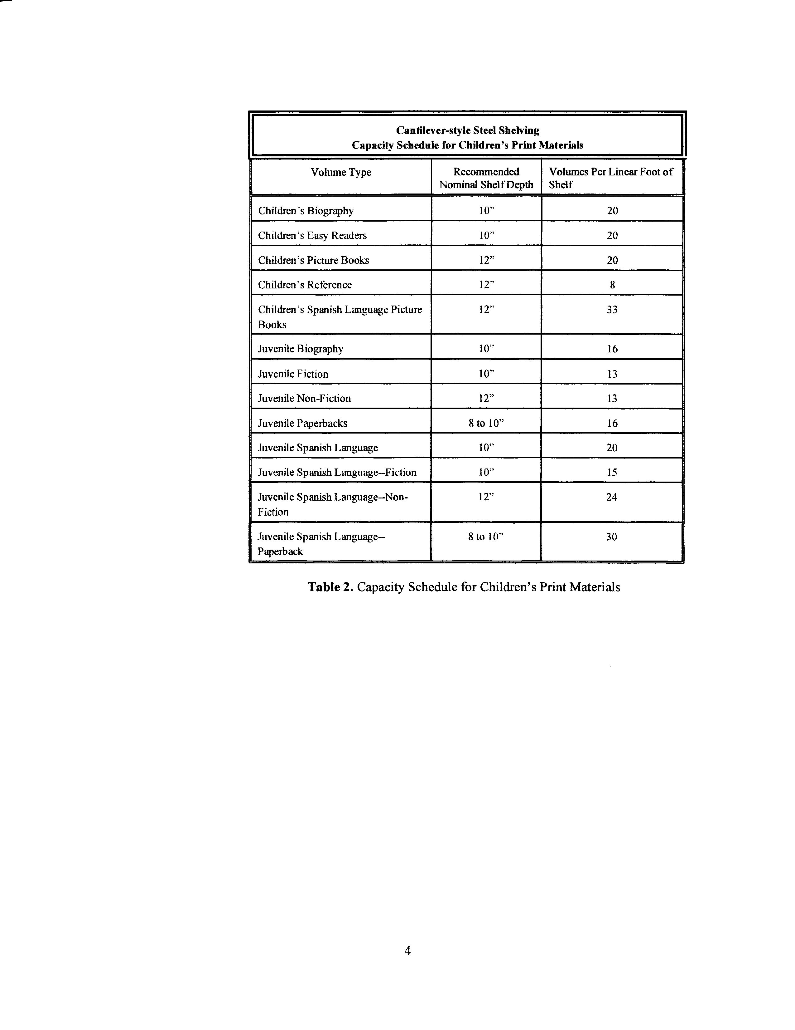

Teen Area

As we continue our tour of the library, do you see any place where teens are to be found? Or is there a feeling that this is not a place where teens are welcome?

Teen specialists Kimberly Bolan and Lisa C. Wemett wrote an article in the December 1999 issue of VOYA entitled “Makeover Madness: Tips for Revamping Your Young Adult Area.” Here are some of their observations and suggestions:

- It is important that the young adult area be easily identified.
- What kind of signage directs you to the teen area?
- Teens are social creatures, so don’t place your YA space next to the quiet study area.
- Teens also want physical distance from the children’s area.
- The arrangement of materials must be clear and logical.
- Are materials available in a variety of formats? Is face-out merchandizing employed?
- Are materials grouped by genre (horror, science fiction, etc.)?
- Are walls, pillars, and ceilings used effectively for merchandizing purposes?
- Is there privacy? Can teens socialize without disturbing other library users?
- What kind of furniture is available and how many people can be seated simultaneously?
- Is there group seating? Is there comfortable, lounge-style seating as well as places to do homework?
- What is the color scheme and general feel of the space? Is it welcoming and contemporary?
- Are there OPACs in or near the teen area?
- Is library staff friendly, welcoming and respectful of teens?

The Key to the Future: Revised Minimum Standards for Youth Services in Public Libraries of New York State also addressed the issues of physical facilities for teens in standard # 42.

Physical Facilities
Standard # 42: Every public library should have a clearly identified separate area designated for young adults.

A young adult area should not segregate teens from the rest of the library, but should be a focal point that makes them aware of materials available to them, enhances their comfort, and conveys that they are desirable patrons in the library.

It is both practically and psychologically important to house the young adult collection adjacent to the adult area. The young adult section should be placed near a staffed area to allow for assistance and supervision without making the section appear to be under scrutiny.

The young adult area should be physically accessible to all adolescents, easily visible and identifiable, and functional and flexible in design. It should have study tables, sufficient shelving for young adult materials, space designated for display purposes, and attractive, multi-purpose furniture which is comfortable and durable. Areas for leisure reading, studying, and socializing should be included.

Facilities for lighted exhibit cases, bulletin board or poster space, and computers should be considered when the area for teens is designed. Magazine racks and listening stations with headphones should be available in this area.

Young adult programming should have access to the library’s programming space.

Staff Work Space

Most staff work areas require a computer with access to the local or wide-area network as well as to the Internet. Some staff work areas will be behind the scenes (offices, acquisitions and technical processing, etc.) while other areas (reference, children’s, check-in/check-out etc.) will be readily available to the public. Library staff will need to evaluate patterns of usage and determine what tasks will be performed, how much space is needed, and how many staff will work at each service point. For example, if two staff members are always on duty at the circulation desk, they will need one or two computers to check out materials. They will need space for the return of materials, an area for materials waiting to be re-shelved, and an area for materials on hold. The Connecticut State Library’s Library Space Planning Guide recommends an average space allocation of 150 square feet per work area. In this example, an ideal circulation area would be 300 square feet.

In some cases, providing library service requires a level of confidentiality. Ideally a library should be designed to provide some degree of privacy between the user and library staff when needed.

Library staff should also have a lounge in a place away from the public. This area should include some comfortable seating and kitchen facilities such as a microwave, refrigerator, and coffee pot so that library staff can eat their meals or take a break and return to work refreshed.

Equipment

What kinds of equipment can a library user expect to find at their local library? New York State minimum standards require that all public libraries have:

- a telephone
- a photocopier
- a microcomputer and printer
- a telefacsimile machine
- other equipment necessary to facilitate access to information.

The standards were written in the early 1990’s and have not been revised since then. Thus the terms “microcomputer” and “telefacsimile machine” may appear to be slightly anachronistic.

As well as the above, some libraries may make available to their users equipment such as:
- Microfilm or microfiche reader/printer
- Ellison or similar die-cut machine
- Typewriter (believe it or not)
- Digital camera
- Laptop computers
- Media projector
- DVD or Video Cassette Player

It is essential that policies for use of library equipment are in place and reviewed regularly. Questions to ask when developing an equipment policy include:

- What pieces of equipment may be used by the public?
- Is age a factor for use of certain equipment?
- Does the library have a “Computer Use Policy” that is separate from a “Use of Equipment Policy”?
- Is there a charge for the use of certain types of equipment? For instance, is there a charge for the use of the copier or the printer? Is there a charge for use of the fax machine, either for an incoming or outgoing fax?
- Can staff use library equipment for their own personal use? Is there a charge?
- Can exceptions to the policy be considered and if so, how will exceptions be granted?
- How often should staff and the Board review the policy?

Security

Some libraries may decide to install security devices, such as video surveillance cameras, display case protection, burglary protection, or collection security. A number of libraries in New York State are home to special collections, paintings, drawings, sculpture, first editions, or other valuable possessions. Protecting the library’s resources is essential.

- Collection security helps ensure that no materials leave the library without being checked out. A system contains a security device that is placed on the materials as well as a detection device that is typically located at all library exits.
- Burglary protection includes sensors to detect an intrusion, alarms, and notifications to the appropriate authorities.
- Display case protection can be as straightforward as a lock on the case or as elaborate as an alarm.

Here, too, security policies, procedures, and plans are needed. Areas to consider when developing a policy include:

- Entry and exit procedures
- Meeting room registration
- Special collections
- Entry key management procedures
- Personal belonging restrictions

Libris Design offers detailed instruction about library security at
http://www.librisdesign.org/docs/LibrarySecurity.pdf

Let’s take a look at the table of contents and a portion of the security policies section.

Refer to Teaching Aid – Library Building #10: Library Security.

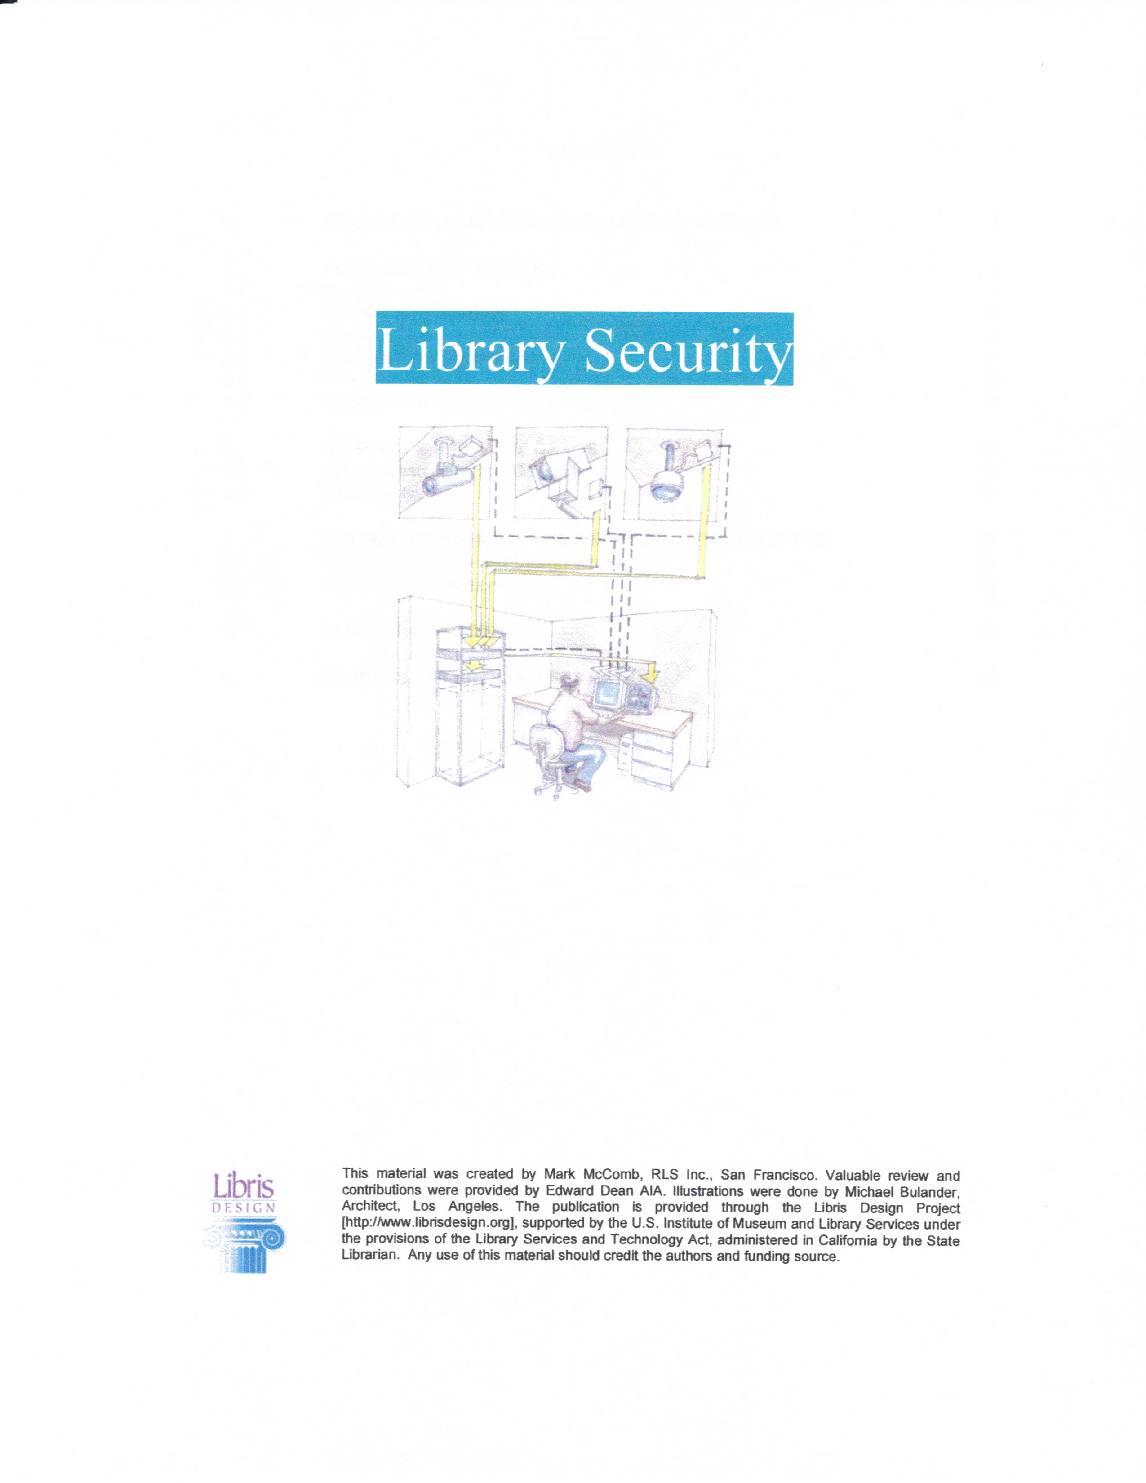

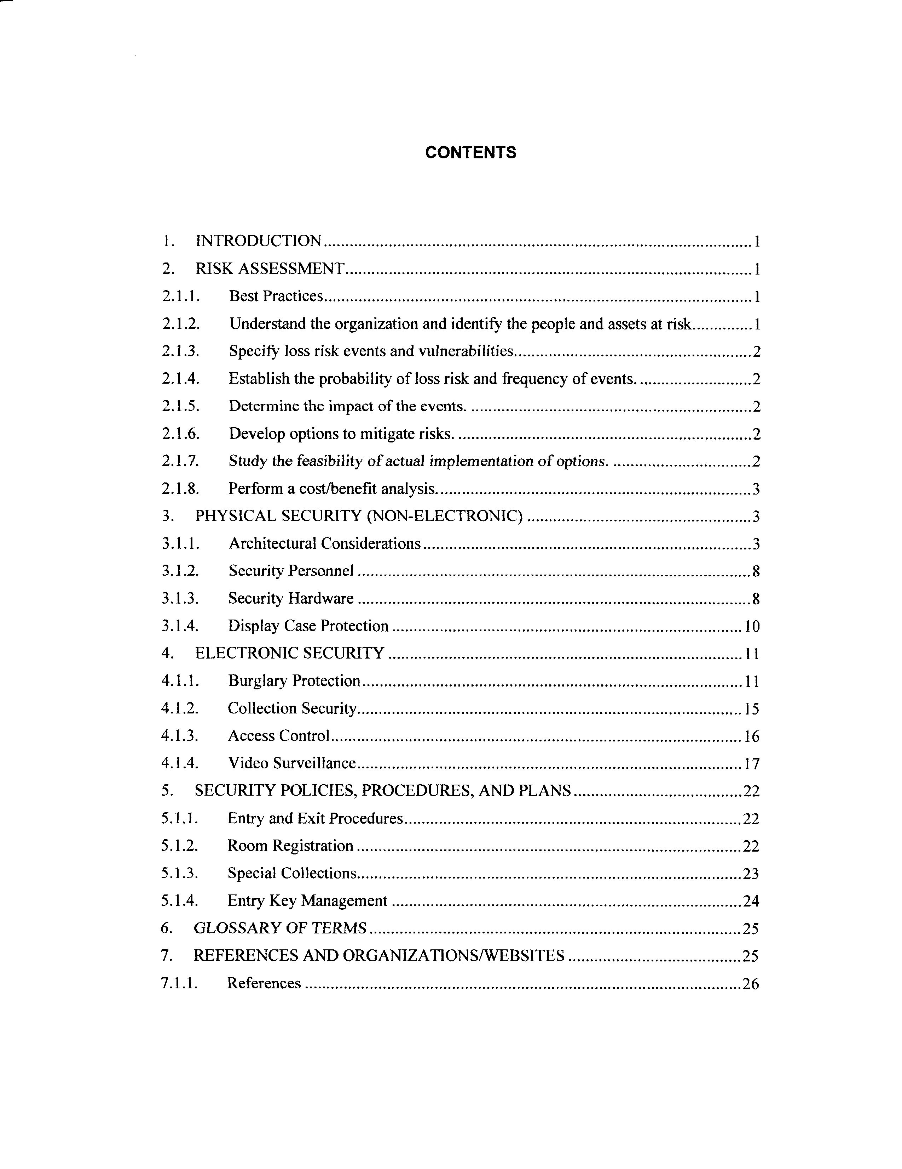

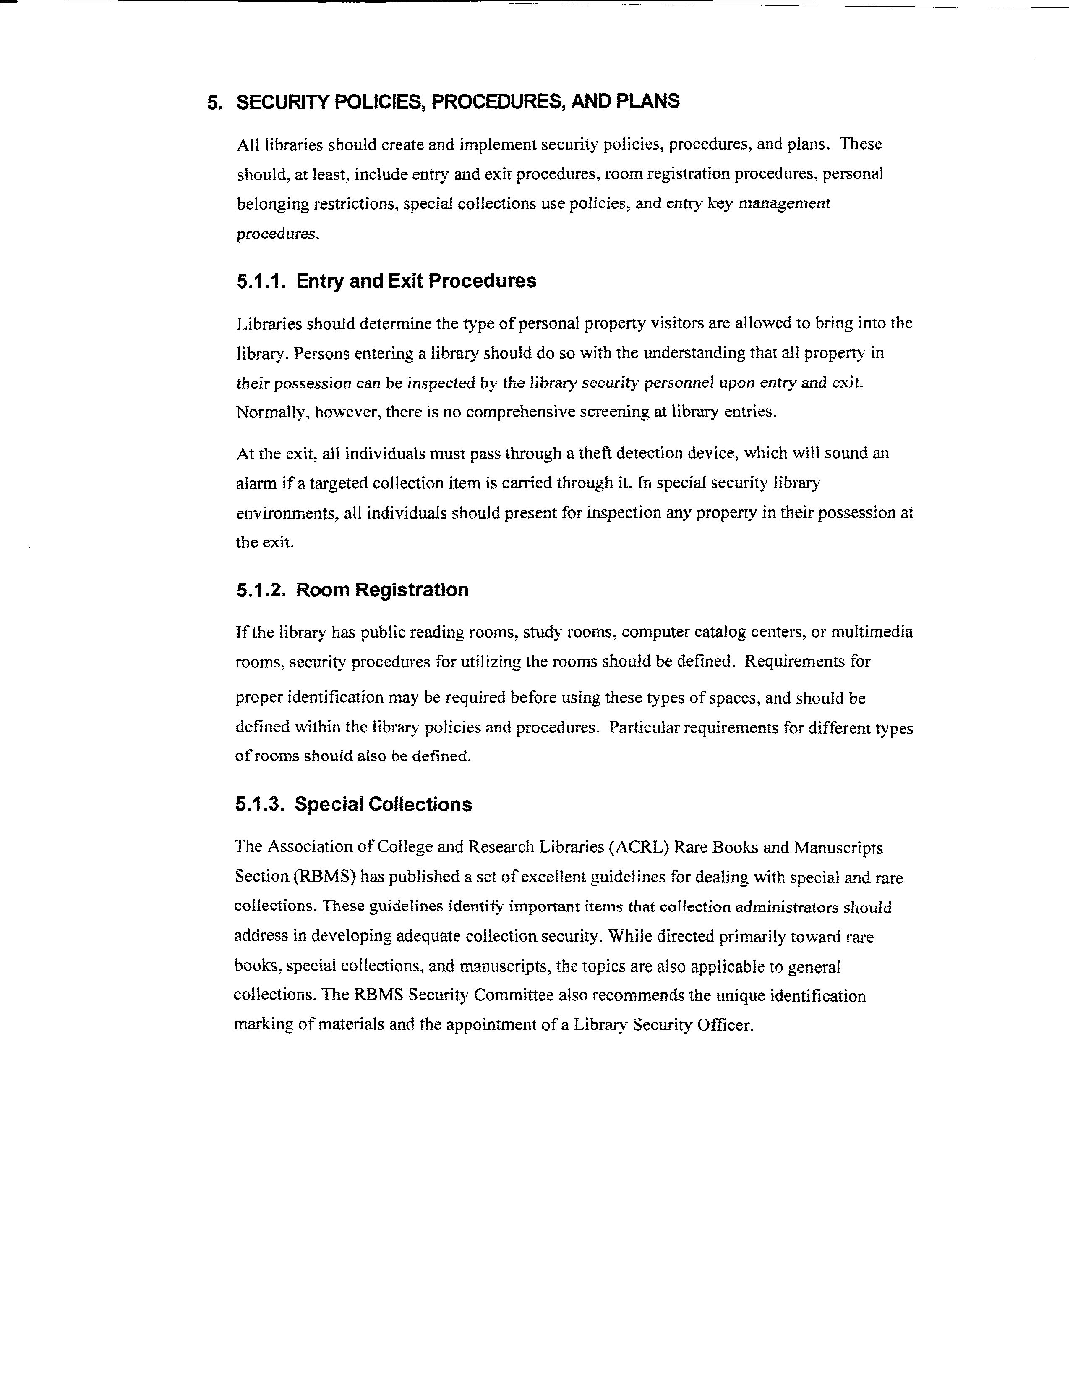

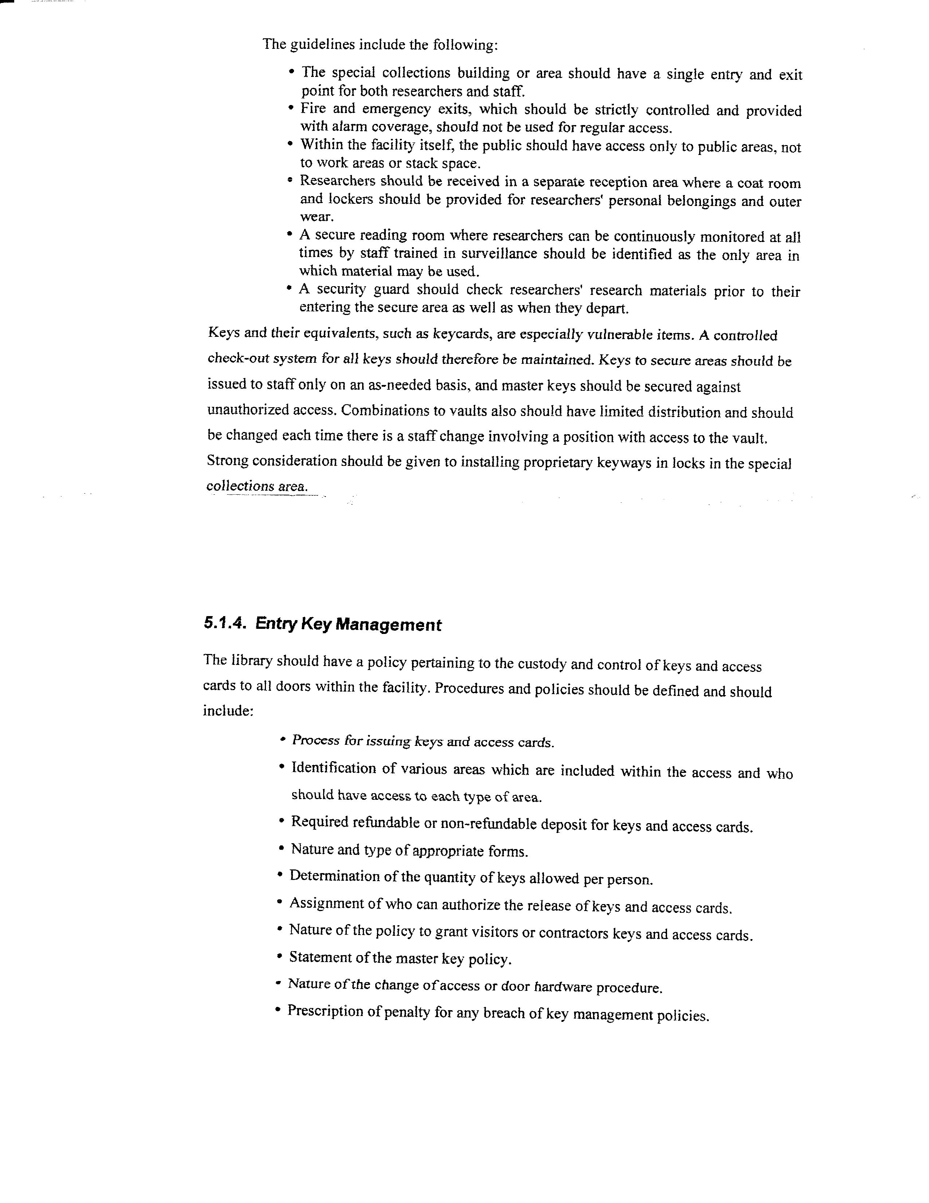

Disaster Planning and Emergency Contacts

What does library staff do when the roof starts to leak? Circuit breakers blow? A blizzard covers the sidewalks with a foot of snow? A library user requires medical attention? The library has a fire? A burglary has occurred and a computer and printer have been stolen?

Dealing with Emergency Situations:

- All staff should receive instruction about how to handle emergencies.
- Procedures must be developed so that staff knows who to call or contact first in the case of emergency.
- Staff should receive training in basic first aid and know where the first aid kit is located. Sometimes this training is available through the local Red Cross office or from a local ambulance unit. The library director should develop a timetable for offering this training on a recurring basis.
- Similarly, staff must receive instruction about what to do if they discover a forced entry. Contact your local police or sheriff’s department to see if they offer training on workplace safety.
- If the library has a security system, staff must be instructed not to enter the building if the alarm is sounding.
- All staff should know where fire extinguishers are located and how to use them.
- An emergency evacuation plan should be discussed with staff annually and should also be part of orientation for new staff. A diagram of the building that shows emergency exits should be displayed in several areas of library. A meeting place for staff to gather outside of the building should be established in the event of an emergency evacuation.

The library Board of Trustees should develop a disaster plan that is reviewed on a regular basis. An emergency contacts list should be included in the plan and as a stand-alone listing. Clear-cut procedures must be in place to handle situations like break-ins. A sample disaster plan is included below after the emergency contacts list and additional information and links to other disaster plans may be found in the Resource List.

The following list of emergency contacts should be shared with all staff and be included at the front of the library procedures notebook and/or posted prominently for staff to consult.

Refer to Teaching Aid – Library Building #11: Sample Disaster Policy and Teaching Aid – Library Building #12: Emergency Contacts Checklist.
EMERGENCY CONTACTS

Telephone or cell phone number
9-1-1
Sheriffs Department
Local Police
Fire Department
Ambulance
Director’s Home
Assistant Director’s Home
Board President
Library System Office
Security Alarm Company
Computer Repair/Networking
Copier Maintenance
Grounds Maintenance
Lawn Service
Snow Plowing
Electrician
Plumbing
Heating and Air Conditioning
General Repairs
Roofing Company
Locks
Hazardous Materials
Elevator Repair
Insurance Company
Other

BLOOMFIELD PUBLIC LIBRARY

DISASTER POLICY Adopted April 11, 2005

Avoidance/Preparation
- Library staff will secure the building at closing time. Upon exiting the building the security alarm will be activated. Library staff will de-activate the alarm when entering the building.
- Staff should be familiar with the location, type and application of the fire extinguishers in the building. The fire extinguishers will be checked by a fire extinguisher maintenance professional on an annual basis.
- The town/village code enforcement officer will make periodic inspections of the building.
- All staff should be made aware that 911 is the all-purpose emergency number to be used in event of an emergency that requires immediate assistance from the fire department, police or serious medical emergencies.
- The work paths and exit paths will be kept clear of any clutter or storage materials.
- Staff need to be aware of the physical condition of the library, reporting any leaks, running water, broken glass or anything out of the ordinary to the library manager or a library trustee.
- A supply of garbage bags, paper towels, latex gloves and other cleaning supplies will be kept for any initial, small cleanups.
- The Library Board of Trustees shall conduct an annual walk-thru of the library building and grounds to evaluate the condition of the building and note any hazardous conditions.
- A copy of records critical to the operation of the library shall be stored off-site and updated periodically. Records pertaining to the circulation, item holdings and patron databases will be stored at the Pioneer Library System. A copy of personnel records will be maintained at the East Bloomfield town hall. A copy of current library board records will be maintained off-site.

Emergency Contact List:
A list of contact numbers for building and computer/networking emergencies is maintained on the bulletin board in the manager’s office and posted in the staff work area.
Emergency Closing

Emergencies or catastrophes, including, but not limited to, extreme weather, utility failure, demonstration, bomb threat, fire, explosion, or terrorism may require closing the library.

The primary consideration in any emergency or catastrophe is the safety of all persons in the building and on the property. The library cooperates fully with public safety agencies and emergency service providers.

The Library Manager or the staff person in charge at the time of the emergency will determine when to close the library during an emergency or catastrophe.

Emergency Evacuation Procedures

Remember: R - A - C – E

RESCUE: Remove any person(s) in immediate danger

ALARM: Sound the alarm

CONFINE: Confine the area (by closing the doors)

EVACUATE: Initiate evacuation procedures

RESCUE
Staff member who discovers the fire begins evacuation procedures by announcing (loudly but calmly) that there is a fire in the library and that everyone must leave the building.

Staff members will clear main library area, program room, staff workroom area, and bathrooms.

ALARM
Staff members will pull the fire alarm located over the copy machine

CONFINE
When practicable, staff members will close interior doors to contain the fire.

EVACUATE
Staff members will assist patrons to the closest usable exit depending on the location of the fire.
- Front Entrance
- Emergency Exit in Young Adult Area
- Staff Entrance
Initial Procedures in a disaster
- If fire or water damage has occurred:
- Advise the Library Manager or President of the Library Board (or another board member if president not available) of the situation
- In winter, turn the heat to 50 degrees. (Keys to the thermostats are maintained on the window ledge of the director’s office.)
- Open doors and windows if air outside is cool and dry but not freezing. If electricity is functional, use electric fans to expel humid air from the building. There are fans connected to each thermostat. Wear rubber gloves and remove any materials from puddles of water on floors. DO NOT TURN UP THE HEAT. This will prevent mold and mildew damage as much as possible.

- If vandalism has occurred, but no fire or water damage:
- Advise the Library Manager or President of the Library Board (or another board member if president not available).
- Take a visual assessment of the damage. On paper, document what you see. Do not touch anything in the area of the damage until directed by the Library Manager or Board member. They will make the call to the police to investigate the situation.

- The Library Manager may call the Pioneer Library System to apprise them of the situation and request their assistance.

Health emergencies
Staff members should exercise caution when administering first aid of even a minor nature because of the safety of the injured individual and the potential liability of the staff member. Without specialized training it is not advisable for staff to undertake more than keeping the sick or injured patron comfortable and protected from needless disturbance until medical help can be obtained. Since each case is unique, staff members should use their own judgment to do what is prudent and reasonable. 911 should be called immediately in the event of any serious problem. No medication should ever be dispensed to the public.

Bomb Threats
Keep the caller on the line as long as possible. Ask the caller to repeat the message and try to write down every word spoken by the person. If the caller does not indicate the location of the bomb or the time of possible detonation, ASK FOR THIS INFORMATION. Pay particular attention to peculiar background noises such as motors running, background music and any other sounds which may indicate the location from which the call is originating.

Listen closely to the voice (male, female), voice quality (calm, excited), accents and speech impediments. Immediately after the caller hangs up, call 911. Clear the building. The police will handle the actual bomb search.

Bloomfield Public Library
Voice - 585.657.6264
Fax – 585.657.6038

EMERGENCY LIST

Copier
Business Methods Inc.
427.2222

Computers/Network
K. Iraci, B. Winkler, or
C. Contant
Pioneer Library system – 394.8260
After-hours OWWL critical care:
585-394-7976
or
1st Priority
1.315.548.2000

Electrical Problems
P. Driscoll
657.6741

General Maintenance
J. Henehan
657.4897 (H)
657.7319 (Village)

HVAC
Halco Plumbing & Heating 1.315.946.6200 (use first)
or
Isaac Heating 546.1400

Lawn Mowing
George Duvall (Amy)
657.5397

Locksmith
Ontario Lock & Key
396.9920

Pioneer Library System
394.8260
J. Morris – PLS Director (789.9571 – home)
B. Morris – PLS Asst. Director
(589.4290 – home)

Plumbing
J. Buell
657.7818

Bloomfield Public Library
Accident/Incident Report

Date _____________________________ Time ____________________________

Staff Member (s) ______________________________________________________

Name(s) of individuals involved _________________________________________

Address(es) & Telephone Number(s) ________________________________________

Name(s), Address(es), Telephone Number(s) of non-staff witnesses _______________

Describe what happened and what action was taken:

Were police, fire department, or ambulance called? __________________________
If yes, give specifics: (time of call, time of arrival, action taken)

Was insurance company notified? (Perego-Lobdell @394.5544)

Additional comments or statements:

Director notified: _____________________________________________________

Signature _____________________________________________________________
Approved June 14, 1999 BPL Incident Report
Reviewed and Revised April 11, 2005

